Оглавление
Introduction 8
Heat transfer 8
Relation of heat transfer to thermodynamics 10
Modes of heat transfer 14
A look ahead 37
Введение 38
Теплообмен 38
Связь теплообмена с термодинамикой. 41
Виды теплообмена 45
Заглядывая вперед 70
Improving Aerospace Engines with Advanced Materials 71
HOT AND HOTTER 71
ART OF BRAZING 72
INVESTMENT CASTING 73
BRIGHT FUTURE 75
Усовершенствование аэрокосмических двигателей при помощи передовых материалов. 76
Горячее и горячее. 76
Искусство пайки. 77
Литье по выплавляемым моделям 79
СВЕТЛОЕ БУДУЩЕЕ 81
THE FUTURE OF ROCKETS 82
ELECTRIC PROPULSION 83
DEEP SPACE 1 84
HYBRID FUELS AND THE CANDLESTICK ROCKET 87
WANT TO BE A ROCKET SCIENTIST? 88
Будущее ракетных систем. 90
Электрическая силовая установка. 91
Deep Space 1. 92

Гибридные топлива и горючее из воска. 94
Хотите быть такими же умными как ракетчики. 95
Lock up your carbon 97
Don't junk CO2 turn it into bottles and glue 100
Не выбрасывайте углерод. 102
Улавливание углерода идет полным ходом. Сможет ли это спасти мир? 102
"Не выбрасывайте CO2, сделайте из него бутылки и клей" 105
And If All Else Fails 107
Если все попытки окажутся неудачными. 110
Proving It 113
A crowded manifest tests SpaceX’s mettle in satellite launch sector 113
Испытание 122
SpaceX’s и их амбиции в секторе коммерческих запусков и государственных заказов 122
Russian Rockets 133
ISS is unaffected by Crimea sanctions and international saber-rattling 133
Frank Morring, Jr. Washington 133
Российские ракеты 136
Глоссарий 139
Библиография 169

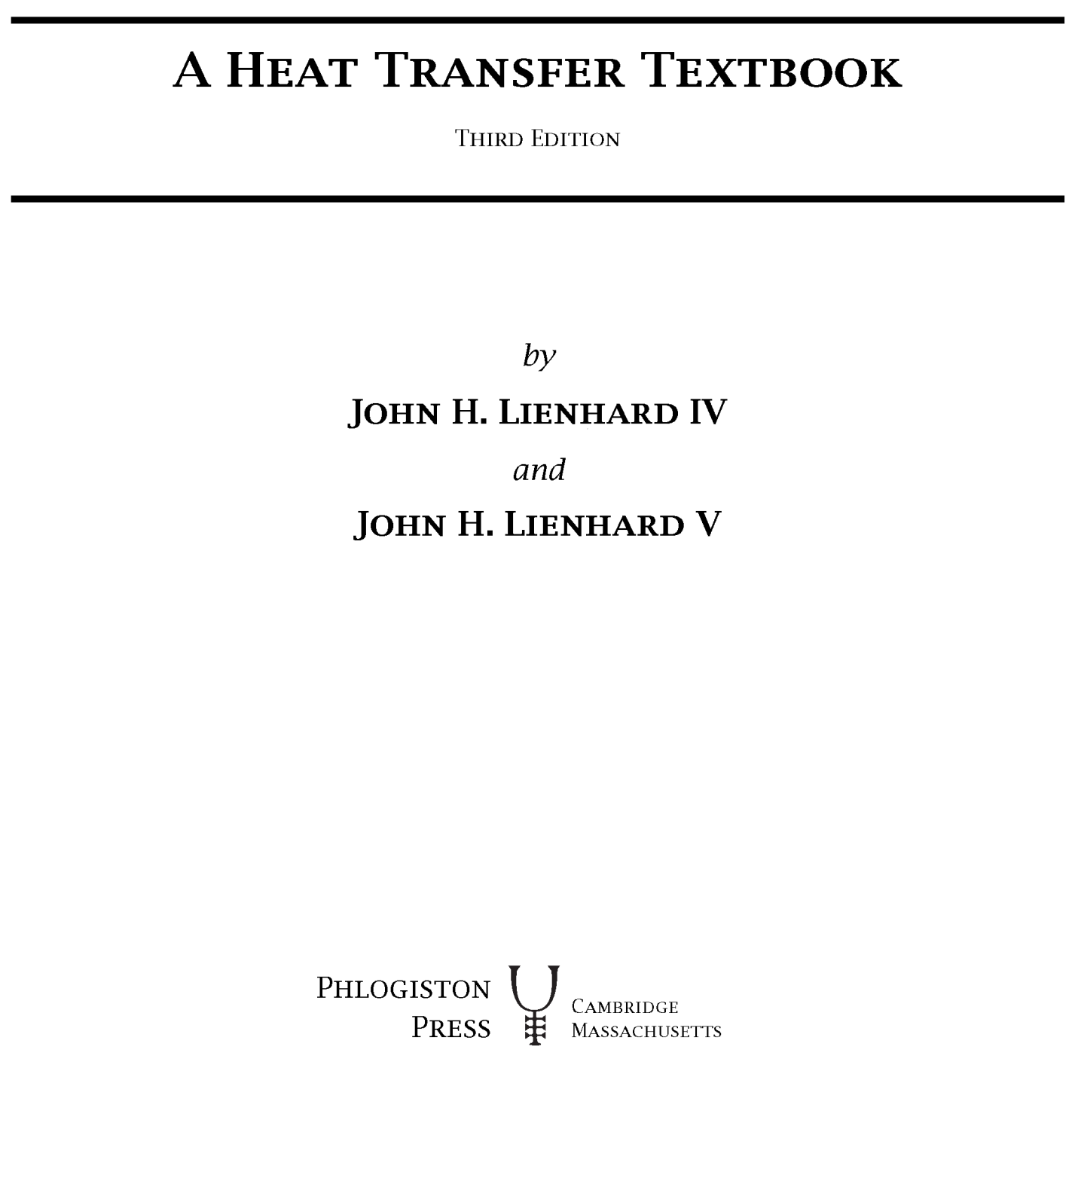

Introduction
The radiation of the sun in which the planet is incessantly plunged, penetrates the air, the earth, and the waters; its elements are divided, change direction in every way, and, penetrating the mass of the globe, would raise its temperature more and more, if the heat acquired were not exactly balanced by that which escapes in rays from all points of the surface and expands through the sky. The Analytical Theory of Heat, J. Fourier

Heat transfer
People have always understood that something flows from hot objects to cold ones. We call that flow heat. In the eighteenth and early nineteenth centuries, scientists imagined that all bodies contained an invisible fluid which they called caloric. Caloric was assigned a variety of properties, some of which proved to be inconsistent with nature (e.g., it had weight and it could not be created nor destroyed). But its most important feature was that it flowed from hot bodies into cold ones. It was a very useful way to think about heat. Later we shall explain the flow of heat in terms more satisfactory to the modern ear; however, it will seldom be wrong to imagine caloric flowing from a hot body to a cold one.
The flow of heat is all-pervasive. It is active to some degree or another in everything. Heat flows constantly from your bloodstream to the air around you. The warmed air buoys off your body to warm the room you are in. If you leave the room, some small buoyancy-driven (or convective) motion of the air will continue because the walls can never be perfectly isothermal. Such processes go on in all plant and animal life and in the air around us. They occur throughout the earth, which is hot at its core and cooled around its surface. The only conceivable domain free from heat flow would have to be isothermal and totally isolated from any other region. It would be “dead” in the fullest sense of the word — devoid of any process of any kind.
The overall driving force for these heat flow processes is the cooling (or leveling) of the thermal gradients within our universe. The heat flows that result from the cooling of the sun are the primary processes that we experience naturally. The conductive cooling of Earth’s center and the radiative cooling of the other stars are processes of secondary importance in our lives.
The life forms on our planet have necessarily evolved to match the magnitude of these energy flows. But while “natural man” is in balance with these heat flows, “technological man”¹ has used his mind, his back, and his will to harness and control energy flows that are far more intense than those we experience naturally. To emphasize this point we suggest that the reader make an experiment.

Experiment 1.1
Generate as much power as you can, in some way that permits you to measure your own work output. You might lift a weight, or run your own weight up a stairwell, against a stopwatch. Express the result in watts (W). Perhaps you might collect the results in your class. They should generally be less than 1 kW or even 1 horsepower (746 W). How much less might be surprising.
Thus, when we do so small a thing as turning on a 150 W light bulb, we are manipulating a quantity of energy substantially greater than a human being could produce in sustained effort. The energy consumed by an oven, toaster, or hot water heater is an order of magnitude beyond our capacity. The energy consumed by an automobile can easily be three orders of magnitude greater. If all the people in the United States worked continuously like galley slaves, they could barely equal the power output of even a single city power plant.

Our voracious appetite for energy has steadily driven the intensity of actual heat transfer processes upward until they are far greater than those normally involved with life forms on earth. Until the middle of the thirteenth century, the energy we use was drawn indirectly from the sun using comparatively gentle processes — animal power, wind and water power, and the combustion of wood. Then population growth and deforestation drove the English to using coal. By the end of the seventeenth century, England had almost completely converted to coal in place of wood. At the turn of the eighteenth century, the first commercial steam engines were developed, and that set the stage for enormously increased consumption of coal. Europe and America followed England in these developments.
*Some anthropologists think that the term Homo technologicus (technological man) serves to define human beings, as apart from animals, better than the older term Homo sapiens (man, the wise). We may not be as much wiser than the animals as we think we are, but only we do serious sustained

The development of fossil energy sources has been a bit like Jules Verne’s description in Around the World in Eighty Days in which, to win a race, a crew burns the inside of a ship to power the steam engine. The combustion of nonrenewable fossil energy sources (and, more recently, the fission of uranium) has led to remarkably intense energy releases in power-generating equipment. The energy transferred as heat in a nuclear reactor is on the order of one million watts per square meter.
A complex system of heat and work transfer processes is invariably needed to bring these concentrations of energy back down to human proportions. We must understand and control the processes that divide and diffuse intense heat flows down to the level on which we can interact with them. To see how this works, consider a specific situation. Suppose we live in a town where coal is processed into fuel-gas and coke. Such power supplies used to be common, and they may return if natural gas supplies ever dwindle. Let us list a few of the process heat transfer problems that must be solved before we can drink a glass of iced tea.

- A variety of high-intensity heat transfer processes are involved with combustion and chemical reaction in the gasifier unit itself.
- The gas goes through various cleanup and pipe-delivery processes to get to our stoves. The heat transfer processes involved in these stages are generally less intense.
- The gas is burned in the stove. Heat is transferred from the flame to the bottom of the teakettle. While this process is small, it is intense because boiling is a very efficient way to remove heat.
- The coke is burned in a steam power plant. The heat transfer rates from the combustion chamber to the boiler, and from the wall of the boiler to the water inside, are very intense.
- The steam passes through a turbine where it is involved with many heat transfer processes, including some condensation in the last stages. The spent steam is then condensed in any of a variety of heat transfer devices.
- Cooling must be provided in each stage of the electrical supply system: the winding and bearings of the generator, the transformers, the switches, the power lines, and the wiring in our houses.
- The ice cubes for our tea are made in an electrical refrigerator. It involves three major heat exchange processes and several lesser ones. The major ones are the condensation of refrigerant at room temperature to reject heat, the absorption of heat from within the refrigerator by evaporating the refrigerant, and the balancing heat leakage from the room to the inside.
- Let’s drink our iced tea quickly because heat transfer from the room to the water and from the water to the ice will first dilute, and then warm, our tea if we linger.

A society based on power technology teems with heat transfer problems. Our aim is to learn the principles of heat transfer so we can solve these problems and design the equipment needed to transfer thermal energy from one substance to another. In a broad sense, all these problems resolve themselves into collecting and focusing large quantities of energy for the use of people, and then distributing and interfacing this energy with people in such a way that they can use it on their own puny level.
We begin our study by recollecting how heat transfer was treated in the study of thermodynamics and by seeing why thermodynamics is not adequate to the task of solving heat transfer problems.

Relation of heat transfer to thermodynamics

The First Law with work equal to zero

The subject of thermodynamics, as taught in engineering programs, makes constant reference to the heat transfer between systems. The First Law of Thermodynamics for a closed system takes the following form on a
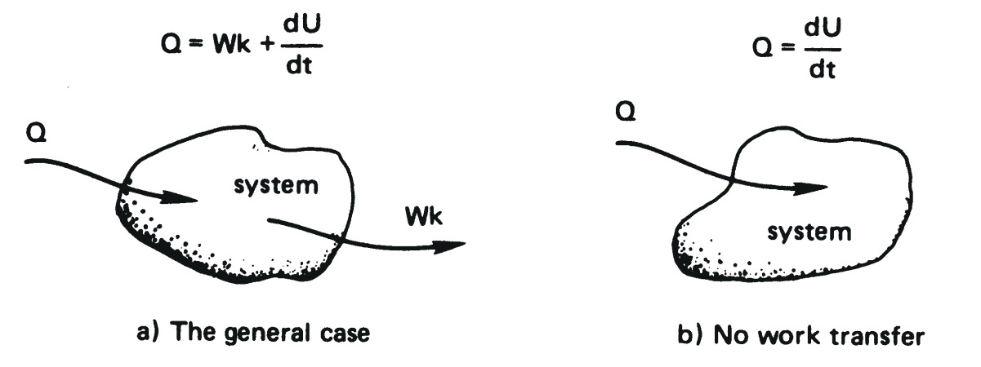
Figure 1.1 The First Law of Thermodynamics for a closed system.
rate basis:
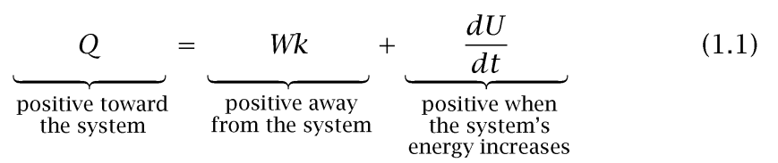
where Q is the heat transfer rate and Wk is the work transfer rate. They may be expressed in joules per second (J/s) or watts (W). The derivative dU/dt is the rate of change of internal thermal energy, U, with time, t. This interaction is sketched schematically in Fig. 1.1a.
The analysis of heat transfer processes can generally be done without reference to any work processes, although heat transfer might subsequently be combined with work in the analysis of real systems. If p dV work is the only work occuring, then eqn. (1.1) is

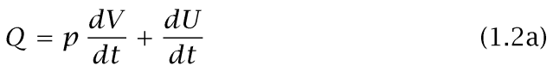

This equation has two well-known special cases:

Constant pressure process:
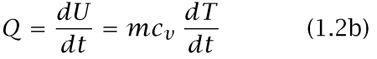
Constant volume process:
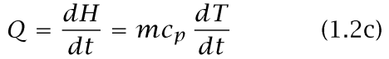

where H = U + pV is the enthalpy, and c_{v} and c_{p} are the specific heat capacities at constant volume and constant pressure, respectively.
When the substance undergoing the process is incompressible (so that V is constant for any pressure variation), the two specific heats are equal: c_{v} = c_{p} = c. The proper form of eqn. (1.2a) is then

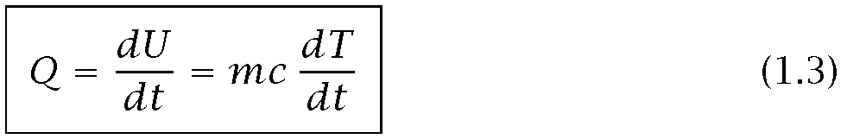

Since solids and liquids can frequently be approximated as being incompressible, we shall often make use of eqn. (1.3).
If the heat transfer were reversible, then eqn. (1.2a) would become²

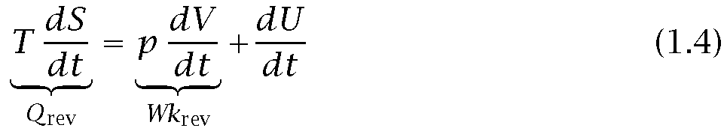
That might seem to suggest that Q can be evaluated independently for inclusion in either eqn. (1.1) or (1.3). However, it cannot be evaluated using T dS, because real heat transfer processes are all irreversible and S is not defined as a function of T in an irreversible process. The reader will recall that engineering thermodynamics might better be named thermostatics, because it only describes the equilibrium states on either side of irreversible processes.

Since the rate of heat transfer cannot be predicted using T dS, how can it be determined? If U(t) were known, then (when Wk = 0) eqn. (1.3) would give Q, but U(t) is seldom known a priori.

The answer is that a new set of physical principles must be introduced to predict Q. The principles are transport laws, which are not a part of the subject of thermodynamics. They include Fourier’s law, Newton’s law of cooling, and the Stefan-Boltzmann law. We introduce these laws later in the chapter. The important thing to remember is that a description of heat transfer requires that additional principles be combined with the First Law of Thermodynamics.

Reversible heat transfer as the temperature gradient vanishes

Consider a wall connecting two thermal reservoirs as shown in Fig. 1.2. As long as T₁ > T₂, heat will flow spontaneously and irreversibly from 1 to 2. In accordance with our understanding of the Second Law of Thermodynamics, we expect the entropy of the universe to increase as a consequence of this process. If T₂ —► T₁, the process will approach being quasistatic and reversible. But the rate of heat transfer will also approach zero if there is no temperature difference to drive it. Thus all real heat transfer processes generate entropy.
Now we come to a dilemma: If the irreversible process occurs at steady state, the properties of the wall do not vary with time. We know that the entropy of the wall depends on its state and must therefore be constant. How, then, does the entropy of the universe increase? We turn to this question next.

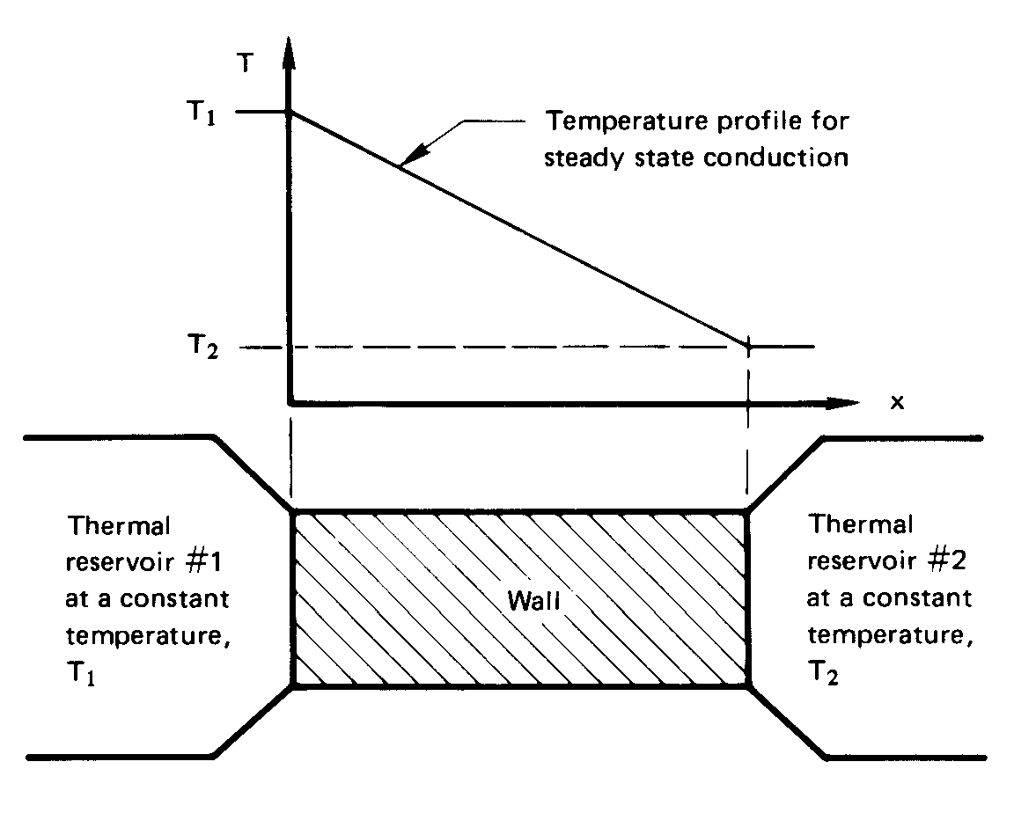
Figure 1.2 Irreversible heat flow between two thermal reservoirs through an intervening wall.

Entropy production

The entropy increase of the universe as the result of a process is the sum of the entropy changes of all elements that are involved in that process. The rate of entropy production of the universe, S_{Un}, resulting from the preceding heat transfer process through a wall is

² T = absolute temperature, S = entropy, V = volume, p = pressure, and “rev” denotes a reversible process.

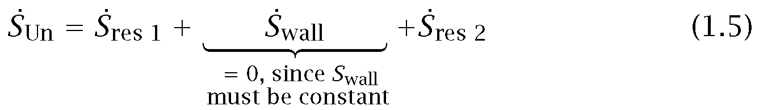

where the dots denote time derivatives (i.e., ẋ = dx/dt). Since the reservoir temperatures are constant,

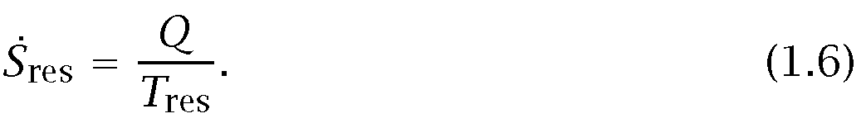

Now Q_{res 1} is negative and equal in magnitude to Q_{res 2}, so eqn. (1.5) becomes

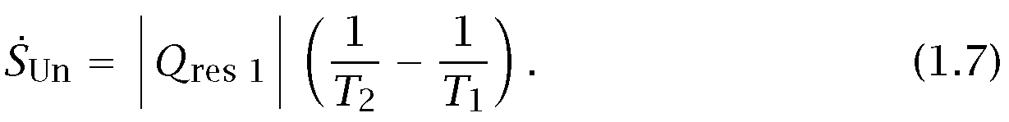

The term in parentheses is positive, so S_{Un} > 0. This agrees with Clausius’s statement of the Second Law of Thermodynamics.
Notice an odd fact here: The rate of heat transfer, Q, and hence S_{Un}, is determined by the wall’s resistance to heat flow. Although the wall is the agent that causes the entropy of the universe to increase, its own entropy does not changes. Only the entropies of the reservoirs change.

1.3 Modes of heat transfer

Figure 1.3 shows an analogy that might be useful in fixing the concepts of heat conduction, convection, and radiation as we proceed to look at each in some detail.

Heat conduction

Fourier’s law. Joseph Fourier (see Fig. 1.4) published his remarkable book Theorie Analytique de la Chaleurin 1822. In it he formulated a very complete exposition of the theory of heat conduction.

He began his treatise by stating the empirical law that bears his name: the heat flux,³ q (W/m²), resulting from thermal conduction is proportional to the magnitude of the temperature gradient and opposite to it in sign. If we call the constant of proportionality, к, then

the constant, к, is called the thermal conductivity. It obviously must have the dimensions W/m·K, or J/m·s·K, or Btu/h·ft·°F if eqn. (1.8) is to be dimensionally correct.

The heat flux is a vector quantity. Equation (1.8) tells us that if temperature decreases with x, q will be positive—it will flow in the x-direction. If T increases with x, q will be negative—it will flow opposite the x- direction. In either case, q will flow from higher temperatures to lower temperatures. Equation (1.8) is the one-dimensional form of Fourier’s law. We develop its three-dimensional form in Chapter 2, namely:

Let the water be analogous to heat, and let the people be analogous to the
heat transfer medium. Then:

Case 1 The hose directs water from (W) to (B) independently of the medium.
This is analogous to thermal radiation in a vacuum or in most gases.

Case 2 In the bucket brigade, water goes from (W) to (B) through the medium.
This is analogous to conduction.

Case 3 A single runner, representing the medium, carries water from (W)
to (B) . This is analogous to convection.

Figure 1.3 An analogy for the three modes of heat transfer.
Figure 1.4 Baron Jean Baptiste Joseph Fourier (1768-1830). Joseph Fourier lived a remarkable double life. He served as a high government official in Napoleonic France and he was also an applied mathematician of great importance. He was with Napoleon in Egypt between 1798 and 1801, and he was subsequently prefect of the administrative area (or “Department”) of Isere in France until Napoleon’s first fall in 1814. During the latter period he worked on the theory of heat flow and in 1807 submitted a 234-page monograph on the subject. It was given to such luminaries as Lagrange and Laplace for review. They found fault with his adaptation of a series expansion suggested by Daniel Bernoulli in the eighteenth century. Fourier’s theory of heat flow, his governing differential equation, and the now- famous “Fourier series” solution of that equation did not emerge in print from the ensuing controversy until 1822. (Etching from Portraits et Histoire des Hommes Utiles, Collection de Cinquante Portraits, Societe Montyon et Franklin 1839-1840).

³The heat flux, q, is a heat rate per unit area and can be expressed as Q/A, where A is an appropriate area.

Example 1.1
The front of a slab of lead (k = 35 W/m·K) is kept at 110°C and the back is kept at 50°C. If the area of the slab is 0.4 m² and it is 0.03 m thick, compute the heat flux, q, and the heat transfer rate, Q.

Solution. For the moment, we presume that dT/dx is a constant equal to (T_{back} - T_{front})/(x_{back} - X_{front}); we verify this in Chapter 2. Thus, eqn. (1.8) becomes

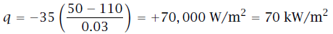

and

In one-dimensional heat conduction problems, there is never any real problem in deciding which way the heat should flow. It is therefore sometimes convenient to write Fourier’s law in simple scalar form:

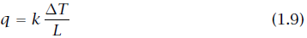

where L is the thickness in the direction of heat flow and q and ∆T are both written as positive quantities. When we use eqn. (1.9), we must remember that q always flows from high to low temperatures.

Thermal conductivity values. It will help if we first consider how conduction occurs in, for example, a gas. We know that the molecular velocity depends on temperature. Consider conduction from a hot wall to a cold one in a situation in which gravity can be ignored, as shown in Fig. 1.5. The molecules near the hot wall collide with it and are agitated by the molecules of the wall. They leave with generally higher speed and collide with their neighbors to the right, increasing the speed of those neighbors. This process continues until the molecules on the right pass their kinetic energy to those in the cool wall. Within solids, comparable processes occur as the molecules vibrate within their lattice structure and as the lattice vibrates as a whole. This sort of process also occurs, to some extent, in the electron “gas” that moves through the solid. The processes are more efficient in solids than they are in gases. Notice that

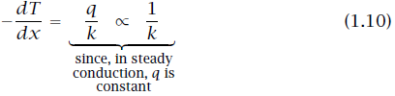

Figure 1.5 Heat conduction through gas separating two solid walls.

Thus solids, with generally higher thermal conductivities than gases, yield smaller temperature gradients for a given heat flux. In a gas, by the way, k is proportional to molecular speed and molar specific heat, and inversely proportional to the cross-sectional area of molecules.

This book deals almost exclusively with S.I. units, or Systeme International d’Unites. Since much reference material will continue to be available in English units, we should have at hand a conversion factor for thermal conductivity:

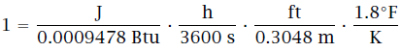
Thus the conversion factor from W/m·K to its English equivalent, Btu/h·ft ·°F, is
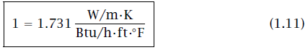

Consider, for example, copper—the common substance with the highest conductivity at ordinary temperature:
The range of thermal conductivities is enormous. As we see from Fig. 1.6, к varies by a factor of about 10⁵ between gases and diamond at room temperature. This variation can be increased to about 10⁷ if we include the effective conductivity of various cryogenic “superinsulations.” (These involve powders, fibers, or multilayered materials that have been evacuated of all air.) The reader should study and remember the order of magnitude of the thermal conductivities of different types of materials. This will be a help in avoiding mistakes in future computations, and it will be a help in making assumptions during problem solving. Actual numerical values of the thermal conductivity are given in Appendix A (which is a broad listing of many of the physical properties you might need in this course) and in Figs. 2.2 and 2.3.

Example 1.2
A copper slab (k = 372 W/m·K) is 3 mm thick. It is protected from corrosion on each side by a 2-mm-thick layer of stainless steel (к = 17 W/m·K). The temperature is 400°C on one side of this composite wall and 100° C on the other. Find the temperature distribution in the copper slab and the heat conducted through the wall (see Fig. 1.7).

Solution. If we recall Fig. 1.5 and eqn. (1.10), it should be clear that the temperature drop will take place almost entirely in the stainless steel, where к is less than 1/20 of к in the copper. Thus, the copper will be virtually isothermal at the average temperature of (400+100)/2 = 250°C. Furthermore, the heat conduction can be estimated in a 4 mm slab of stainless steel as though the copper were not even there. With the help of Fourier’s law in the form of eqn. (1.8), we get

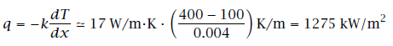

The accuracy of this rough calculation can be improved by considering the copper. To do this we first solve for ∆T_{s}._{s}. and ∆T_{Cu} (see Fig. 1.7). Conservation of energy requires that the steady heat flux through all three slabs must be the same. Therefore,

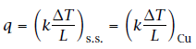

Figure 1.6 The approximate ranges of thermal conductivity of various substances.(All values are for the neighborhood of room temperature unless otherwise noted.)

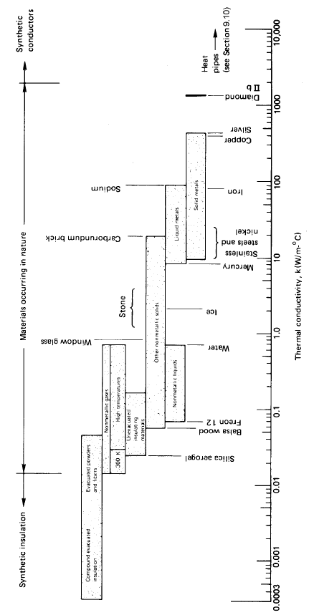

Figure 1.7 Temperature drop through a copper wall protected by stainless steel (Example 1.2).

but
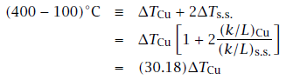
Solving this, we obtain ∆T_{Cu} = 9.94 K. So ∆T_{s}._{s}.= (300 - 9.94)/2 = 145 K. It follows that T_{Cu}, _{left} = 255°C and T_{Cu}, _{right} = 245°C.

The heat flux can be obtained by applying Fourier’s law to any of the three layers. We consider either stainless steel layer and get
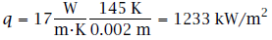
Thus our initial approximation was accurate within a few percent. ■

One-dimensional heat diffusion equation. In Example 1.2 we had to deal with a major problem that arises in heat conduction problems. The problem is that Fourier’s law involves two dependent variables, T and q. To eliminate q and first solve for T, we introduced the First Law of Thermodynamics implicitly: Conservation of energy required that q was the same in each metallic slab.

The elimination of q from Fourier’s law must now be done in a more general way. Consider a one-dimensional element, as shown in Fig. 1.8.

From Fourier’s law applied at each side of the element, as shown, the net heat conduction out of the element during general unsteady heat flow is

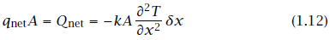

To eliminate the heat loss Q_{net} in favor of T, we use the general First Law statement for closed, nonworking systems, eqn. (1.3):

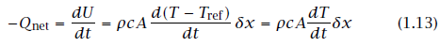
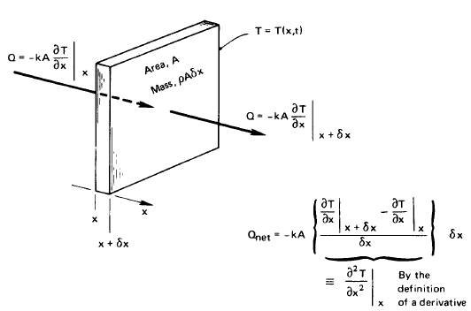
Figure 1.8 One-dimensional heat conduction through a differential element.

where ρ is the density of the slab and c is its specific heat capacity.⁴ Equations (1.12) and (1.13) can be combined to give

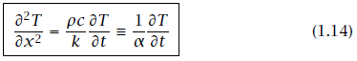

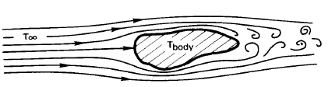
Figure 1.9 The convective cooling of a heated body.
This is the one-dimensional heat diffusion equation. Its importance is this: By combining the First Law with Fourier’s law, we have eliminated the unknown Q and obtained a differential equation that can be solved for the temperature distribution, T(x,t). It is the primary equation upon which all of heat conduction theory is based.
The heat diffusion equation includes a new property which is as important to transient heat conduction as k is to steady-state conduction. This is the thermal diffusivity, α:

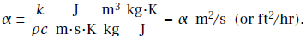
The thermal diffusivity is a measure of how quickly a material can carry heat away from a hot source. Since material does not just transmit heat but must be warmed by it as well, α involves both the conductivity, k, and the volumetric heat capacity, ρc.

⁴The reader might wonder if c should be c_{p} or c_{v}. This is a strictly incompressible equation so c_{p} = c_{v} = c. The compressible equation involves additional terms, and this particular term emerges with c_{p} in it in the conventional rearrangements of terms.
Heat Convection
The physical process. Consider a typical convective cooling situation. Cool gas flows past a warm body, as shown in Fig. 1.9. The fluid immediately adjacent to the body forms a thin slowed-down region called a boundary layer. Heat is conducted into this layer, which sweeps it away and, farther downstream, mixes it into the stream. We call such processes of carrying heat away by a moving fluid convection.

In 1701, Isaac Newton considered the convective process and suggested that the cooling would be such that
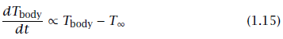
where T∞ is the temperature of the oncoming fluid. This statement suggests that energy is flowing from the body. But if the energy of the body is constantly replenished, the body temperature need not change. Then with the help of eqn. (1.3) we get, from eqn. (1.15) (see Problem 1.2),
This equation can be rephrased in terms of q = Q/A as
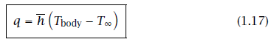
This is the steady-state form of Newton’s law of cooling, as it is usually quoted, although Newton never wrote such an expression.

The constant h is the film coefficient or heat transfer coefficient. The bar over h indicates that it is an average over the surface of the body. Without the bar, h denotes the “local” value of the heat transfer coefficient at a point on the surface. The units of h and $\overline{h}$ are W/m²·K or J/s·m²·K. The conversion factor for English units is:

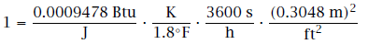
or

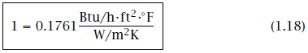
It turns out that Newton oversimplified the process of convection when he made his conjecture. Heat convection is complicated and h can depend on the temperature difference T_{body} - T∞ $≡$∆T. In Chapter 6 we find that h really is independent of ∆T in situations in which fluid is forced past a body and AT is not too large. This is called forced convection.

When fluid buoys up from a hot body or down from a cold one, h varies as some weak power of ∆T —typically as ∆T ^{1/4} or ∆T ^{1/3}. This is called free or natural convection. If the body is hot enough to boil a liquid surrounding it, h will typically vary as ∆T ².

For the moment, we restrict consideration to situations in which Newton’s law is either true or at least a reasonable approximation to real behavior.

We should have some idea of how large h might be in a given situation. Table 1.1 provides some illustrative values of h that have been

Table 1.1 Some illustrative values of convective heat transfer coefficients

Situation h, W/m²K
Natural convection in gases
• 0.3 m vertical wall in air, ∆T = 30°C 4.33
Natural convection in liquids
• 40 mm O.D. horizontal pipe in water, ∆T = 30°C 570
• 0.25 mm diameter wire in methanol, ∆T = 50°C 4,000
Forced convection of gases
• Air at 30 m/s over a 1 m flat plate, ∆T = 70°C 80
Forced convection of liquids
• Water at 2 m/s over a 60 mm plate, ∆T = 15°C 590
• Aniline-alcohol mixture at 3 m/s in a 25 mm I.D. tube, ∆T = 80°C 2,600
• Liquid sodium at 5 m/s in a 13 mm I.D. tube at 370°C 75,000
Boiling water
• During film boiling at 1 atm 300
• In a tea kettle 4, 000
• At a peak pool-boiling heat flux, 1 atm 40, 000
• At a peak flow-boiling heat flux, 1 atm 100, 000
• At approximate maximum convective-boiling heat flux, under
optimal conditions 10⁶
Condensation
• In a typical horizontal cold-water-tube steam condenser 15,000
• Same, but condensing benzene 1, 700
• Dropwise condensation of water at 1 atm 160,000

observed or calculated for different situations. They are only illustrative and should not be used in calculations because the situations for which they apply have not been fully described. Most of the values in the table could be changed a great deal by varying quantities (such as surface roughness or geometry) that have not been specified. The determination of h or $\overline{h}$ is a fairly complicated task and one that will receive a great deal of our attention. Notice, too, that $\overline{h}$ can change dramatically from one situation to the next. Reasonable values of h range over about six orders of magnitude.

Example 1.3
The heat flux, q, is 6000 W/m² at the surface of an electrical heater. The heater temperature is 120°C when it is cooled by air at 70°C. What is the average convective heat transfer coefficient, $\overline{h }$? What will the heater temperature be if the power is reduced so that q is 2000 W/m2?

Solution.
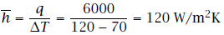

If the heat flux is reduced, $\overline{h }$ should remain unchanged during forced convection. Thus

so
Lumped-capacity solution. We now wish to deal with a very simple but extremely important, kind of convective heat transfer problem. The problem is that of predicting the transient cooling of a convectively cooled object, such as we showed in Fig. 1.9. With reference to Fig. 1.10, we apply our now-familiar First law statement, eqn. (1.3), to such a body:

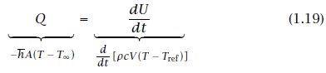
where A and V are the surface area and volume of the body, T is the temperature of the body, T = T(t), and T_{ref} is the arbitrary temperature at which U is defined equal to zero. Thus⁵

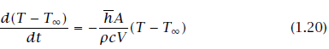

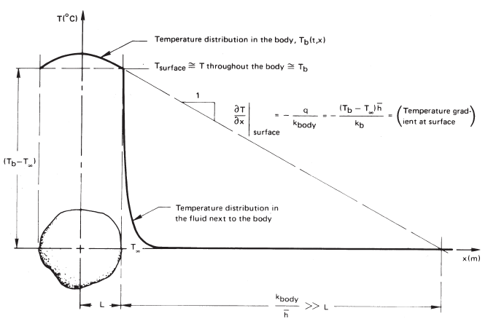

Figure 1.10 The cooling of a body for which the Biot number, $\overline{h}$L/k_{b}, is small.

The general solution to this equation is
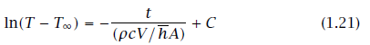

The group pcV/ $\overline{h}$A is the time constant, T. If the initial temperature is T(t = 0) $≡$ T_{i}, then
C = ln(T_{i} - T_{x}), and the cooling of the body is given by

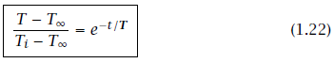

All of the physical parameters in the problem have now been “lumped" into the time constant. It represents the time required for a body to cool to 1/e, or 37% of its initial temperature difference above (or below) T∞.
The ratio t/T can also be interpreted as

⁵Is it clear why (T -T_{ref}) has been changed to (T -T_{x}) under the derivative? Remember that the derivative of a constant (like T_{ref} or T_{m}) is zero. We can therefore introduce (T - T_{x}) without invalidating the equation, and get the same dependent variable on both sides of the equation.

Notice that the thermal conductivity is missing from eqns. (1.22) and (1.23). The reason is that we have assumed that the temperature of the body is nearly uniform, and this means that internal conduction is not important. We see in Fig. 1.10 that, if L/(k_{b}/ $\overline{h}$) <<1, the temperature of the body, T_{b}, is almost constant within the body at any time. Thus
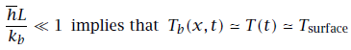

and the thermal conductivity, k_{b}, becomes irrelevant to the cooling process. This condition must be satisfied or the lumped-capacity solution will not be accurate.

We call the group $\overline{h}$L/k_{b} the Biot number⁶, Bi. If Bi were large, of course, the situation would be reversed, as shown in Fig. 1.11. In this case Bi = $\overline{h}$L/k_{b} >> 1 and the convection process offers little resistance to heat transfer. We could solve the heat diffusion equation

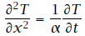

subject to the simple boundary condition T(x, t) = T∞ when x = L, to determine the temperature in the body and its rate of cooling in this case. The Biot number will therefore be the basis for determining what sort of problem we have to solve.

To calculate the rate of entropy production in a lumped-capacity system, we note that the entropy change of the universe is the sum of the entropy decrease of the body and the more rapid entropy increase of the surroundings. The source of irreversibility is heat flow through the boundary layer. Accordingly, we write the time rate of change of entropy of the universe, dS_{Un}/dt = $\dot{S}$_{Un}, as

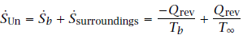
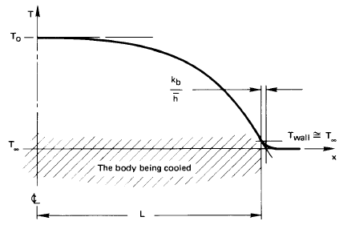
Figure 1.11 The cooling of a body for which the Biot number, $\overline{h}$L/k_{b}, is large.

or
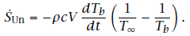

We can multiply both sides of this equation by dt and integrate the right- hand side from T_{b}(t = 0) $≡$ T_{b0} to T_{b} at the time of interest:

⁶Pronounced Bee-oh. J.B. Biot, although younger than Fourier, worked on the analysis of heat conduction even earlier—in 1802 or 1803. He grappled with the problem of including external convection in heat conduction analyses in 1804 but could not see how to do it. Fourier read Biot’s work and by 1807 had determined how to analyze the problem. (Later we encounter a similar dimensionless group called the Nusselt number, Nu = hL/k_{fluid}. The latter relates only to the boundary layer and not to the body being cooled. We deal with it extensively in the study of convection.)

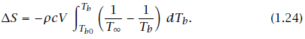

Equation 1.24 will give a positive ∆S whether T_{b} >T∞ or T_{b} < T∞ because the sign of dT_{b} will always opposed the sign of the integrand.

Example 1.4
A thermocouple bead is largely solder, 1 mm in diameter. It is initially at room temperature and is suddenly placed in a 200°C gas flow. The heat transfer coefficient $\overline{h}$ is 250 W/m²·K, and the effective values of k, ρ, and c are 45 W/m·K, 9300 kg/m³, and c = 0.18 kJ/kg·K, respectively. Evaluate the response of the thermocouple.

Solution. The time constant, T, is

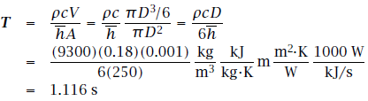

Therefore, eqn. (1.22) becomes

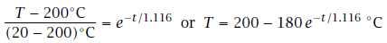

This result is plotted in Fig. 1.12, where we see that, for all practical purposes, this thermocouple catches up with the gas stream in less than 5 s. Indeed, it should be apparent that any such system will come within 95% of the signal in three time constants. Notice, too, that if the response could continue at its initial rate, the thermocouple would reach the signal temperature in one time constant.

This calculation is based entirely on the assumption that Bi << 1 for the thermocouple. We must check that assumption:

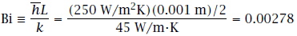

This is very small indeed, so the assumption is valid. ■

Experiment 1.2
Invent and carry out a simple procedure for evaluating the time constant of a fever thermometer in your mouth.

Radiation
Heat transfer by thermal radiation. All bodies constantly emit energy by a process of electromagnetic radiation. The intensity of such energy flux depends upon the temperature of the body and the nature of its surface. Most of the heat that reaches you when you sit in front of a fire is radiant energy. Radiant energy browns your toast in an electric toaster and it warms you when you walk in the sun.

Objects that are cooler than the fire, the toaster, or the sun emit much less energy because the energy emission varies as the fourth power of absolute temperature. Very often, the emission of energy, or radiant heat transfer, from cooler bodies can be neglected in comparison with convection and conduction. But heat transfer processes that occur at high temperature, or with conduction or convection suppressed by evacuated insulations, usually involve a significant fraction of radiation.
Experiment 1.3
Open the freezer door to your refrigerator. Put your face near it, but stay far enough away to avoid the downwash of cooled air. This way you cannot be cooled by convection and, because the air between you and the freezer is a fine insulator, you cannot be cooled by conduction. Still your face will feel cooler. The reason is that you radiate heat directly into the cold region and it radiates very little heat to you. Consequently, your face cools perceptibly.

Figure 1.12 Thermocouple response
to a hot gas flow.

Table 1.2 Forms of the electromagnetic wave spectrum

Characterization | Wavelength, λ
Cosmic rays | < 0.3 pm
Gamma rays | 0.3-100 pm
X rays | 0.01-30 nm
Ultraviolet light | 3-400 nm
Visible light | 0.4-0.7 μm | Thermal Radiation
Near infrared radiation | 0.7-30 μm | 0.1-1000 μm
Far infrared radiation | 30-1000 μm
Millimeter waves | 1-10 mm
Microwaves | 10-300 mm
Shortwave radio & TV | 300 mm-100 m
Longwave radio | 100 m-30 km

The electromagnetic spectrum. Thermal radiation occurs in a range of the electromagnetic spectrum of energy emission. Accordingly, it exhibits the same wavelike properties as light or radio waves. Each quantum of radiant energy has a wavelength, λ, and a frequency, v, associated with it.

Figure 1.13 Cross section of a spherical hohlraum. The hole has the attributes of a nearly perfect thermal black body.

The full electromagnetic spectrum includes an enormous range of energy-bearing waves, of which heat is only a small part. Table 1.2 lists the various forms over a range of wavelengths that spans 17 orders of magnitude. Only the tiniest “window” exists in this spectrum through which we can see the world around us. Heat radiation, whose main component is usually the spectrum of infrared radiation, passes through the much larger window—about three orders of magnitude in λ or v.

Figure 1.14 The distribution of energy incident on a translucent slab.

Black bodies. The model for the perfect thermal radiator is a so-called black body. This is a body which absorbs all energy that reaches it and reflects nothing. The term can be a little confusing, since such bodies emit energy. Thus, if we possessed infrared vision, a black body would glow with “color” appropriate to its temperature. Of course, perfect radiators are “black” in the sense that they absorb all visible light (and all other radiation) that reaches them.

It is necessary to have an experimental method for making a perfectly black body. The conventional device for approaching this ideal is called by the German term hohlraum, which literally means “hollow space”. Figure 1.13 shows how a hohlraum is arranged. It is simply a device that traps all the energy that reaches the aperture.

What are the important features of a thermally black body? First consider a distinction between heat and infrared radiation. Infrared radiation refers to a particular range of wavelengths, while heat refers to the whole range of radiant energy flowing from one body to another. Suppose that a radiant heat flux, q, falls upon a translucent plate that is not black, as shown in Fig. 1.14. A fraction, , of the total incident energy, called the absorptance, is absorbed in the body; a fraction, ρ, called the reflectance, is reflected from it; and a fraction, τ, called the transmittance, passes through. Thus

This relation can also be written for the energy carried by each wavelength in the distribution of wavelengths that makes up heat from a source at any temperature:

All radiant energy incident on a black body is absorbed, so that _{b} or _{λb}= 1 and ρ_{b} = τ_{b} = 0. Furthermore, the energy emitted from a black body reaches a theoretical maximum, which is given by the Stefan- Boltzmann law. We look at this next.

The Stefan-Boltzmann law. The flux of energy radiating from a body is commonly designated e(T) W/m². The symbol e_{λ} (λ, T) designates the distribution function of radiative flux in λ , or the monochromatic emissive power:
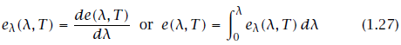
Thus
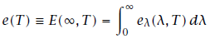

The dependence of е(Т) on Т for a black body was established experimentally by Stefan in 1879 and explained by Boltzmann on the basis of thermodynamics arguments in 1884. The Stefan-Boltzmann law is
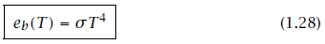
where the Stefan-Boltzmann constant, σ, is 5.670400 $×$ 10 ⁻⁸ W/m²·K⁴ or 1.714$×$ 10~⁻⁹ Btu/hr·ft²·°R⁴, and T is the absolute temperature.

e_{λ} vs. λ. Nature requires that, at a given temperature, a body will emit a unique distribution of energy in wavelength. Thus, when you heat a poker in the

Figure 1.15 Monochromatic emissive power of a black body at several temperatures—predicted and observed.

fire, it first glows a dull red—emitting most of its energy at long wavelengths and just a little bit in the visible regime. When it is white-hot, the energy distribution has been both greatly increased and shifted toward the shorter-wavelength visible range. At each temperature, a black body yields the highest value of e_{λ} that a body can attain.

The very accurate measurements of the black-body energy spectrum by Lummer and Pringsheim (1899) are shown in Fig. 1.15. The locus of maxima of the curves is also plotted. It obeys a relation called Wien’s law:
About three-fourths of the radiant energy of a black body lies to the right of this line in Fig. 1.15. Notice that, while the locus of maxima leans toward the visible range at higher temperatures, only a small fraction of the radiation is visible even at the highest temperature.

Predicting how the monochromatic emissive power of a black body depends on λ was an increasingly serious problem at the close of the nineteenth century. The prediction was a keystone of the most profound scientific revolution the world has seen. In 1901, Max Planck made the prediction, and his work included the initial formulation of quantum mechanics. He found that

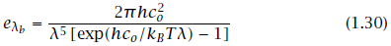
where c_{o} is the speed of light, 2.99792458 $×$ 10⁸ m/s; h is Planck’s constant, 6.62606876x10~³⁴ J·s; and к_{в} is Boltzmann’s constant, 1.3806503$×$ 10~²³ J/K.
Radiant heat exchange. Suppose that a heated object (1 in Fig. 1.16a) radiates only to some other object (2) and that both objects are thermally black. All heat leaving object 1 arrives at object 2, and all heat arriving at object 1 comes from object 2. Thus, the net heat transferred from object 1 to object 2, Q_{net}, is the difference between Q_{1 to2} = A₁e_{b}(T₁) and Q _{2 to 1} = T₂)

If the first object “sees” other objects in addition to object 2, as indicated in Fig. 1.16b, then a view factor (sometimes called a configuration factor or a shape factor), F₁₋₂, must be included in eqn. (1.31):

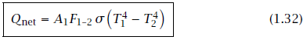

We may regard F₁₋₂ as the fraction of energy leaving object 1 that is intercepted by object 2.

Example 1.5
A black thermocouple measures the temperature in a chamber with black walls. If the air around the thermocouple is at 20°C, the walls are at 100°C, and the heat transfer coefficient between the thermocouple and the air is 75 W/m²K, what temperature will the thermocouple read?

Solution. The heat convected away from the thermocouple by the air must exactly balance that radiated to it by the hot walls if the system is in steady state. Furthermore, F₁₋₂ = 1 since the thermocouple (1) radiates all its energy to the walls (2):

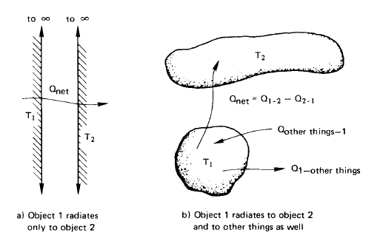

Figure 1.16 The net radiant heat transfer from one object to another.

or, with T_{tc} in °C,

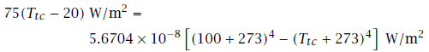

since T for radiation must be in kelvin. Trial-and-error solution of this equation yields T_{tc} = 28.4°C. ■

We have seen that non-black bodies absorb less radiation than black bodies, which are perfect absorbers. Likewise, non-black bodies emit less radiation than black bodies, which also happen to be perfect emitters. We can characterize the emissive power of a non-blackbody using a property called emittance, ε:

where 0 < ε < 1. When radiation is exchanged between two bodies that are not black, we have

where the transfer factor, $F_{1-2}$, depends on the emittances of both bodies as well as the geometrical “view”.

Example 1.6
Suppose that the thermocouple in Example 1.5 was not black and had an emissivity of ε = 0.4. Further suppose that the walls were not black and had a much larger surface area than the thermocouple. What temperature would the thermocouple read?

Solution. Q_{net} is now given by eqn. (1.34) and Ft-2 can be found with eqn. (1.35):

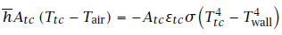
or
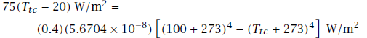

Trial-and-error yields T_{tc} = 23.5°C.

Radiation shielding. The preceding examples point out an important practical problem than can be solved with radiation shielding. The idea is as follows: If we want to measure the true air temperature, we can place a thin foil casing, or shield, around the thermocouple. The casing is shaped to obstruct the thermocouple’s “view” of the room but to permit the free flow of the air around the thermocouple. Then the shield, like the thermocouple in the two examples, will be cooler than the walls, and the thermocouple it surrounds will be influenced by this much cooler radiator. If the shield is highly reflecting on the outside, it will assume a temperature still closer to that of the air and the error will be still less. Multiple layers of shielding can further reduce the error.
Radiation shielding can take many forms and serve many purposes. It is an important element in superinsulations. A glass firescreen in a fireplace serves as a radiation shield because it is largely opaque to radiation. It absorbs heat radiated by the fire and reradiates that energy (ineffectively) at a temperature much lower than that of the fire.

Experiment 1.4
Find a small open flame that produces a fair amount of soot. A candle, kerosene lamp, or a cutting torch with a fuel-rich mixture should work well. A clean blue flame will not work well because such gases do not radiate much heat. First, place your finger in a position about 1 to 2 cm to one side of the flame, where it becomes uncomfortably hot. Now take a piece of fine mesh screen and dip it in some soapy water, which will fill up the holes. Put it between your finger and the flame. You will see that your finger is protected from the heating until the water evaporates.
Water is relatively transparent to light. What does this experiment show you about the transmittance of water to infrared wavelengths?

1.4 A look ahead
What we have done up to this point has been no more than to reveal the tip of the iceberg. The basic mechanisms of heat transfer have been explained and some quantitative relations have been presented. However, this information will barely get you started when you are faced with a real heat transfer problem. Three tasks, in particular, must be completed to solve actual problems:
- The heat diffusion equation must be solved subject to appropriate boundary conditions if the problem involves heat conduction of any complexity.
- The convective heat transfer coefficient, h, must be determined if convection is important in a problem.
- The factor F₁₋₂ or F1-2 must be determined to calculate radiative heat transfer.

Any of these determinations can involve a great deal of complication, and most of the chapters that lie ahead are devoted to these three basic problems.

Before becoming engrossed in these three questions, we shall first look at the archetypical applied problem of heat transfer-namely, the design of a heat exchanger. Chapter 2 sets up the elementary analytical apparatus that is needed for this, and Chapter 3 shows how to do such design if h is already known. This will make it easier to see the importance of undertaking the three basic problems in subsequent parts of the book.

Введение
Излучение Солнца, постоянно действующее на нашу планету, проходит сквозь воздух, землю и воду; оно расходится, всячески изменяет свое направление, и, проникая в земной шар все больше и больше увеличивало бы его температуру. Если бы, конечно, не то тепло, которое испускается в виде лучей из всех точек земной поверхности и распространяется дальше по небу. Аналитическая теория тепла, Ж. Фурье

Теплообмен

Люди всегда понимали, что что-то протекает от горячих предметов к холодным. Мы называем это тепловым потоком. В восемнадцатом и в начале девятнадцатого века, ученые представляли себе, что все тела содержат в себе невидимую жидкость, названную тогда калорической. Ей были присвоены различные свойства, некоторые из которых оказались весьма противоречивыми самой природе (например, собственный вес, который не может быть ни создан, ни разрушен). Но наиболее важной особенностью было то, что она текла от горячих тел к холодным. Это был весьма успешный подход к изучению теплоты. Позднее мы предложим более приемлемое для современного уха определение теплового потока; однако, будет на редкость неправильным представить жидкость текущую от горячего тела к холодному.

Тепловой поток пронизывает все. Он присутствует везде и остается активным в той или иной степени. От ваших кровеносных сосудов в окружающий воздух непрерывно исходит тепловой поток. Теплые воздушные слои от вашего тела в свою очередь нагревают комнату в которой вы находитесь. Если вы покинете комнату в ней будут присутствовать движения воздуха вызванные архимедовыми силами (или конвективными), из-за того, что стены не являются абсолютно изотермическими. Подобные процессы происходят на протяжении жизни всех растений и животных, и в окружающей нас атмосфере. Они повсеместны внутри земного шара, который является горячим в ядре и все сильнее остывает ближе к поверхности. Возможная область, лишенная всякого теплового потока должна быть полностью изотермически изолирована от любой другой области. Ее по праву можно считать "мертвой", не имеющей никаких процессов различного рода.

Общей движущей силой тепловых процессов является охлаждение, и стремление к равенству температурных градиентов в пределах нашей вселенной. Нам жизненно необходимо то тепло, которое мы получаем в результате охлаждения Солнца. Теплопроводное охлаждение центра Земли и лучистое охлаждение других звезд играют второстепенную роль в нашей жизни.

Множество форм жизней на нашей планете развились полностью в соответствии с этими энергетическими потоками. В то время, как " человек естественный" находится в балансе с ними, "человек технологический"¹ использовал свой ум, смекалку и силу воли, чтобы подчинить и контролировать эти энергетические потоки, способные значительно на многое. Чтобы убедиться в этом предлагаем читателю провести опыт.

Эксперимент 1.1
Совершите любую работу, прилагая к ней все свои усилия, и определите вашу собственную производительность труда. Вы можете поднять груз или пробежаться по лестничной клетке, фиксируя время, и предварительно измерив собственную массу. Полученный результат выразите в ваттах (Вт). Может быть, вы могли бы собрать значения у всей вашей группы учащихся. Эти результаты, как правило, будут менее 1 кВт или даже 1 лошадиной силы (749 Вт). Насколько меньше, это может показаться удивительным. Таким образом, когда мы выполняем столь незначительную вещь как включение лампочки на 150 Вт, мы управляем таким количеством энергии, которое существенно больше той, на которую способен человек. Энергия потребляемая духовкой, тостером или бойлером, на порядок больше наших возможностей. Энергия, потребляемая автомобилем может быть числом на три порядка больше. Если бы даже, все население Соединенных штатов постоянно работало бы, напоминая рабов, они едва могли бы сравниться по мощности даже с одной городской электростанцией.

*Некоторые антропологи считают термин Homo technologicus (человек технологический), выделяющий человека среди животного мира, более подходящим, нежели термин Homo sapiens (человек разумный). Так как мы не можем быть более разумнее остальных животных, коими мы привыкли себя считать. Это всего лишь громкое заявление.

Наш неуемный аппетит к энергопотреблению, неуклонно привел к росту реальных процессов теплопереноса, теперь они превосходят те, что производят обычные формы жизни на земле. До середины тринадцатого века использовались сравнительно примитивные виды энергий, заключенные в ветре, воде, прирученных животных и выделяющуюся при сгорание древесины. В то время прирост населения и уничтожение лесов привело англичан к использованию угля. К концу семнадцатого века, Англия почти полностью перешла от использования древесины к углю. На рубеже восемнадцатого века были разработаны первые коммерческие тепловые двигатели, что предшествовало резкому увеличению потребления угля. Европа и Америка шли по стопам Англии в этой вехе развития.
Развитие ископаемых источников энергии немного походило на один из эпизодов романа Жюля Верна "Вокруг света за восемьдесят дней". Судоэкипажу пришлось сжечь палубу для победы в гонке. Сжигание невозобновляемых ископаемых источников энергии (а с недавнего времени и деление урана) позволило добиться интенсивного тепловыделения в энергоустановках. Мощность теплового потока в ядерном реакторе составляет порядка одного миллиона ватт на метр квадратный.

Неизменно требуется сложная система процессов переноса тепла и работы, чтобы вернуть такую концентрацию энергии к человеческим пропорциям. Мы должны понимать и контролировать процессы, которые делят и рассеивают интенсивные тепловые потоки на те, с которыми мы сможем взаимодействовать в дальнейшем. Для того чтобы понять как это работает, рассмотрим наглядный пример. Представим, что мы живем в городе, где уголь перерабатывается в топливный газ и кокс. Подобные источники энергии были широко распространены ранее, но они могут возобновиться, если поставки природного газа прекратятся. Рассмотрим ряд проблем теплообмена которые должны быть решены для того, чтобы мы смогли выпить чашечку холодного чая.

- Множество процессов теплообмена большой интенсивности в результате горения и химических реакций в самой газовой камере.
- Газ проходит стадии очистки и перекачки, прежде чем доберется до наших газовых плит. Процессы теплообмена на этих стадиях играют не столь важную роль.
- Горящий газ нагревает нижнюю часть чайника, но тепло быстро переходит от чайника к воде. Так как интенсивное кипение эффективный метод отвода теплоты.
- Кокс сгорает в ТЭЦ. Скорость теплообмена между камерой сгорания, стенками котла, и водой очень велики.
- Пар проходит через турбину, где опять же множество процессов теплообмена, включая конденсацию на заключительных ступенях. Отработавший пар затем конденсируют в одном из множества теплообменных устройств.
- На каждом этапе должно обеспечиваться охлаждение систем электропитания: обмотки и подшипников генератора, трансформатора, переключателей, линий электропередач и электропроводки в наших домах
- Ледяные кубики для нашего чая производятся в электрическом холодильнике. Здесь присутствуют три основных процесса теплообмена и несколько второстепенных. Основное это конденсация хладагента при комнатной температуре для отвода тепла, поглощение тепла изнутри холодильника с испарением хладагента, и регулирование теплоты просачивающуюся от комнаты во внутрь
- Давайте выпьем наш чай со льдом без промедлений, потому, что теплообмен между комнатой и водой, водой и льдом, сначала расплавит лед, а затем согреет наш чай, если мы задержимся.

Общество, построенное на энергетических технологиях, сталкивается с массой проблем в области теплообмена. Наша цель, изучить принципы теплообмена, найти решение этих проблем и сконструировать необходимое оборудование осуществляющее перенос тепловой энергии. В общем понимании, все эти проблемы сводятся к накоплению и сосредоточению большого запаса энергии, дальнейшего распределения и организации доступа к нему населения таким образом, чтобы любой смог использовать её на благо собственных нужд.
Приступая к изучению нашего курса, вспомним то, как рассматривали теплообмен в разделе термодинамики и убедимся, почему термодинамика не позволяет решить проблемы теплообмена.

Связь теплообмена с термодинамикой.

Первый закон без совершенной работы

В предмете термодинамики, как преподается в технических программах, постоянно упоминается о теплообмене между системами. На основании этого, первый закон термодинамики принимает следующую форму:
Рис 1.1 Первый закон термодинамики для закрытой системы. а) общий случай, б) при отсутствии теплообмена.

где Q подводимая тепловая мощность Wk отводимая тепловая мощность. Они могут быть выражены в джоулях на секунду (Дж/с) или в ваттах (Вт). Производная dU/dt является скоростью изменения внутренней тепловой энергии, U, в зависимости от времени, t. Эта зависимость схематично изображена на рис. 1.1a.
Анализ процессов теплообмена в целом, может быть проведен отдельно от рабочих процессов, а может быть и объединен для анализа реальных систем. Если p dV работа, то при ее совершенной работе, уравнение (1.1) будет выглядеть следующим образом.

Это уравнение имеет два широко известных частных случая:

При изохорном процессе:

При изобарном процессе:

где H = U + pV энтальпия, cv и cp удельные теплоемкости при постоянном объеме и давлении соответственно.
Если в ходе процесса вещество несжимаемо (так, что V не меняется при различных значениях давления), то удельные теплоемкости равны: cv = cp = c. Тем самым соответствующая форма уравнения (1.2a), имеет вид:

Так как твердые тела и жидкости являются практически несжимаемыми средами, мы будем часто использовать формулу (1.3).
Если теплообмен обратимый, то ур.(1.2a) перепишется 2

Можно предположить, что Q который может быть определен независимо из уравнений (1.1) или (1.3). Тем не менее, не может быть определен при помощи T dS, поскольку все реальные процессы теплообмена необратимы и S не определена как функция от T в необратимых процессах. Читатель вспомнит, что техническую термодинамику, было бы лучше назвать термостатикой, потому что в ней описываются лишь равновесные состояния по обе стороны от необратимых процессов.
Так как интенсивность теплообмена не может быть оценена при помощи T dS, то как же его определить? Если U(t)известна, то (когда Wk = 0) ур. (1.3) даст нам Q, но U(t)редко известна априори.

Ответ в том, что новый набор физических принципов должен быть выведен для определения Q. Эти принципы являются законами переноса, и никак не являются частью такой дисциплины, как термодинамика. Они включают в себя закон Фурье, закон охлаждения Ньютона и закон Стефана-Больцмана. Позднее мы сделаем вывод этих законов в этой главе. Важно помнить, что для описания теплообмена требуются дополнительные правила в сочетании с первым законом термодинамики.

² T = абсолютная температура, S = энтропия, V = объем, p = давление, и приставкой “rev” обозначаются обратимые процессы.

Обратимый теплообмен в отсутствии градиента температур

Рассмотрим стенку соединяющую два нагретых тела, как показано на рисунке 1.2. До тех пор, пока T1 > T2, тепло будет передаваться от первого тела ко второму, самопроизвольно и необратимо. Согласно второму закону термодинамики в следствии этого процесса энтропия окружающей среды должна увеличиться. Если T2 —► T1, то процесс будет квазистатическим и обратимым. Но передачи тепла не произойдет, если не будет разницы температур. Таким образом все процессы теплообмена, сопровождаются изменением энтропии.
Теперь мы оказались в сложной ситуации: Если необратимый процесс является стационарным, то свойства стенки не изменяются со временем. Мы знаем что энтропия стенки зависит от его состояния, а следовательно должна быть постоянной. Так, как же увеличивается энтропия окружающей среды. Далее мы перейдем к этому вопросу.

Рисунок 1.2 Необратимый тепловой поток в проводящей стенке между двумя нагретыми телами.

Прирост энтропии

Увеличение энтропии окружающей среды это совокупность изменений всех элементов участвующих в этом процессе. Прирост энтропии в окружающей среде, S_{Un}, в результате переноса тепла через стенку,

где точками обозначены производные по времени (т.е., ẋ = dx/dt). Поскольку температуры тел постоянны,

Теперь Q_{res 1} отрицательно и равно по значению Q_{res 2}, тем самым ур. (1.5) приобретает вид

Так как выражение в скобках положительно, то и S_{Un} > 0. Это соответствует постулату Клаузиуса о втором законе термодинамики.
Обратите внимание на не учтенный факт: Скорость передачи тепла Q, и следовательно S_{Un}, определяется термическим сопротивлением стенки. Несмотря на то, что стенка является причиной из-за которой увеличивается энтропия окружающей среды, его собственная энтропия остается постоянной. Изменяется лишь энтропия двух тел.

1.3 Виды теплообмена

Представленный рисунок 1.3 будет полезным для большего понимания таких явлений как теплопроводность, конвекция и излучение, в то время пока мы будем их изучать подробнее.

Теплопроводность
Закон Фурье. Жозеф Фурье (см. рис. 1.4) опубликовал свою замечательную книгу Theorie Analytique de la Chaleurin в 1822 г. В ней он изложил полную теорию теплопроводности.

В своей научной работе он обосновал эмпирический закон теплопроводности, носящий его имя: плотность теплового потока,³ q (W/m²), прямо пропорционален градиенту температур и противоположен по абсолютному значению. Обозначим коэффициент пропорциональности, к, и назовем ее коэффициентом теплопроводности.

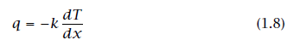

Очевидно, что он имеет размерность W/m·K, or J/m·s·K, or Btu/h·ft·°F согласно уравнению. (1.8).

Плотность теплового потока является векторной величиной. Уравнение (1.8) указывает на то, что если температура области x понижается, то q положителен и направлен в сторону x. Если T в области x увеличивается, то q отрицателен и направлен противоположно от x. В любом случае q будет исходить из горячей области в область более холодную. Уравнение (1.8) представляет собой закон Фурье для одномерного случая. Уравнение для трехмерного случая мы раскрываем в Главе 2, а именно:

³Плотность теплового потока, q, это тепловая мощность соотнесенная на единицу площади и может быть представлена формулой Q/A где, A соответствующая область.
Представим воду в качестве теплоты, а людей как теплообменную среду. то:

Случай 1 Вода поступает (W) в (B) не зависимо от среды.
Это аналогично тепловому излучению в вакууме или в большинства газах.

Случай 2 Цепочка людей передают ведра с водой от (W) к (B).
Это аналог теплопроводности.

Случай 3 Отдельный бегун, являющийся теплоносителем направляется от (W) к (B) .
Это аналогично конвекции.

Рисунок 1.3 Примеры для трех видов теплообмена.

Рисунок 1.4 Барон Жан Батист Жозеф Фурье (1768-1830). Жозеф Фурье вел удивительную двойную жизнь. Он являлся высшим правительственным чиновником в наполеоновской Франции, в тоже время был знаменитым прикладным математиком. Он пробыл вместе с Наполеоном в Египте с 1798 г. по 1801 г., впоследствии занимал пост префекта административного округа (или "Департамента") Изер во Франции до первого отречения Наполеона в 1814 г. В следующие периоды его жизни он работал над теорией теплового потока и в 1807 г. представил 234-страничную монографию по этой теме. Она была представлена таким светилам науки как Лагранж и Лаплас. Которые были не согласны с использованием разложения функции в ряд предложенный Даниилом Бернулли в восемнадцатом веке. Теория распространения тепла Фурье, его основное дифференциальное уравнение и широко-известный на сегодняшний день "Ряд Фурье" являющийся решением этого уравнения не появлялся в печати до 1822 г. из-за долгой полемики. (Гравюра из Portraits et Histoire des Hommes Utiles, Collection de Cinquante Portraits, Societe Montyon et Franklin 1839-1840).

Пример 1.1
Одна сторона свинцовой пластины (k = 35 W/m·K) имеет температуру 110°C, а другая 50°C. Если пластина имеет грань площадью 0.4 m² и толщину 0.03 m, определите плотность теплового потока, q, и тепловой поток через пластину, Q.

Решение. В данный момент, мы предпологаем что, dT/dx является константой равной (T_{back} - T_{front})/(x_{back} - X_{front}); мы удостоверимся в этом в Главе 2. Таким образом ур. (1.8) становится

и

В одномерных задачах теплопроводности, обычно не возникает трудностей с решением и выбором направлении теплового потока. Поэтому будет удобней, если записать закон Фурье в скалярном виде:

где L толщина тела в направлении теплового потока, q и ∆T записываются в виде положительных величинам. При использовании ур. (1.9), следует помнить, что q всегда движется от высоких температур к низким.

Значения коэффициента теплопроводности. Будет полезнее, если мы сначала рассмотрим теплопроводность в газе в качестве примера. Мы знаем что скорость молекул зависит от температуры. Рассмотрим случай передачи тепла от горячей стенки к холодной в ситуации, в которой силой тяжести можно пренебречь, как показано на рис. 1.5. Молекулы вблизи горячей стенки сталкиваются с ней, и взаимодействуют с ее молекулами. Взаимодействуя, они приобретают высокую скорость, и встречаясь с соседним молекулами справа увеличивают скорость последних. Этот процесс будет продолжаться до тех пор, пока молекулы справа не передадут свою кинетическую энергию молекулам холодной стенки. В пределах твердого вещества происходят сопоставимые процессы, молекулы колеблются в своей решетчатой структуре, как и решетка, колеблется в целом. В некоторой степени, процессы подобного рода протекают и в электронном "газе" который проходит сквозь твердое вещество. Процесс более интенсивен в твердых телах нежели в газах. Заметьте это.

Таким образом, в твердых веществах в которых, как правило, коэффициент теплопроводности больше чем газах, при одинаковых плотностях теплового потока температурные градиенты меньше. В газе, кстати, k пропорционален скорости движения молекул и удельной молярной теплоемкости, и обратно пропорционален площади поперечного сечения молекул.

Рисунок 1.5 Теплопередача между двумя стенками разделенных газом.

Данная книга почти полностью представлена в системе СИ или Международной системе единиц (Systeme International d’Unites).Так как до сих пор много доступного справочного материала в основу которых заложена британская единица, мы должны иметь под рукой множитель для перевода коэффициента теплопроводности из одной системы единиц, в другую:

Таким образом коэффициент для перехода из W/m·K к английскому эквиваленту, Btu/h·ft ·°F, будет иметь значение

Рассмотрим в качестве примера такой распространенный металл, как медь, имеющую самую высокую теплопроводность при обычной температуре:
Значения коэффициентов теплопроводности различных веществ имеют очень широкие пределы. Как видно из рисунка 1.6, разница к некоторых газов и алмаза при комнатной температуре составляет порядка 10⁵. Это число может быть увеличено до 10⁷, если мы добавим сюда эффективную проводимость некоторых криогенных высококачественных изоляторов. (Они включают в себя порошки, волокна, многослойные материалы, которые были полностью лишены воздуха.) Читатель должен изучить и запомнить порядок величин коэффициентов теплопроводностей различных материалов. Это поможет избежать ошибок в предстоящих вычислениях, и даст предположения при решении задач. Известные числовые значения коэффициентов теплопроводности представлены в Приложении А (в нем, также представлен широкий список теплофизических свойств веществ, которые пригодятся в данном курсе) и на рис. 2.2 и 2.3.

Пример 1.2
Медная пластина A (k = 372 W/m·K) имеет толщину 3 mm. На пластину с обеих сторон нанесено антикоррозионное покрытие из нержавеющей стали толщиной 2 mm (к = 17 W/m·K). Температура на одной из сторон этой композиционной стенки 400°C, а на другой 100° C. Найдите температурный профиль в медной пластине и теплопроводность через стенку. (смотри Fig. 1.7).

Решение. Если вспомнить рис. 1.5 и ур. (1.10), станет очевидным что, перепад температуры будет происходить почти исключительно в нержавеющей стали, так как к нержавеющей стали в 20 раз меньше чем у меди. Тем самым медь будет фактически изотермической, при средней температуре (400+100)/2 = 250°C. Кроме этого теплопроводность может рассматриваться как в случае стенки из нержавеющей стали, толщиной 4 mm, словно отсутствует медная пластина. Применяя закон Фурье в виде ур. (1.8), получаем

Точность расчета будет выше, если учитывать медь. Для этого нам нужно определить ∆T_{s}._{s}. и ∆T_{Cu} (смотри рис. 1.7). Для выполнения закона сохранения энергии необходимо, чтобы тепловой поток через тройную стенку был одинаков. Следовательно,

но

Рисунок 1.7 Перепад температур в медной пластине помещенной меж пластин из нержавеющей стали. (Пример 1.2).

Решив данную систему уравнений, получим ∆T_{Cu} = 9.94 K. Тем самым ∆T_{s}._{s}.= (300 - 9.94)/2 = 145 K. Отсюда следует, что T_{Cu}, _{left} = 255°C и T_{Cu}, _{right} = 245°C.

Плотность теплового потока через всю стенку может быть получен по закону Фурье, для этого достаточно посчитать его в одной из трех пластин. Посчитав его в стальной пластине, получим

Таким образом погрешность в первом случае составила лишь несколько процентов. ■

Рисунок 1.6 Приблизительные диапазоны теплопроводности различных веществ. (Все значения приняты при комнатной температуре, если не указано иных.)

Одномерное уравнение теплопроводности. В примере 1.2 мы имели дело с основной проблемой возникающей в задачах теплопроводности. Проблема в том, что закон Фурье включает в себя две зависимые переменные T и q. Для того, чтобы сперва определить T, мы дополнительно используем первый закон термодинамики и исключаем q: закон сохранении энергии требует чтобы qбыло одинаково в каждой из металлических пластин.

Исключение q из уравнения Фурье должно быть сделано в более общем виде. Рассмотрим одномерный элемент, как показано на рис. 1.8.

Рисунок 1.8 Одномерная теплопроводность через дифференциальный элемент.

Применяя закон Фурье к каждой из сторон элемента, как показано, получаем теплоту затраченную на нагрев элемента нестационарным тепловым потоком

Чтобы исключить тепловые потери Q_{net} в пользу T, мы используем первый закон термодинамики для закрытых систем, система работу не совершает, ур. (1.3):

где ρплотность пластины и c удельная теплоемкость.⁴ Уравнения (1.12) и (1.13) могут быть приравнены, получим

⁴Читателю может показаться странным использования обозначения c вместо c_{p} или c_{v}. Это уравнение строго для несжимаемой, среды поэтому c_{p} = c_{v} = c. Уравнение для сжимаемой среды задействует дополнительные члены, и эти частные члены используются с c_{p} , обычно со строгой их перестановкой.
Рисунок 1.9 Конвективное охлаждение нагретого тела.
Это одномерное уравнение теплопроводности. Его значение заключается в следующем: Объединив первый закон термодинамики с закон Фурье, мы исключили неизвестную Q и получили дифференциальное уравнение, решив которую можно найти распределение температур, T(x,t). Это основное уравнение на котором основана вся теория теплопроводности.

Уравнение теплопроводности включает в себя новую характеристику, которая также важна для нестационарной теплопроводности, как kдля стационарной. Это коэффициент температуропроводности, α:

Коэффициент температуропроводности есть мера того, насколько быстро материал способен отводить тепло от горячего источника. Так как материал не только передает тепло, но и сам нагревается в процессе, α включает в себя не только коэффициент теплопроводности но и объемную теплоемкость, ρc.

Конвекция
Физический процесс. Рассмотрим простейший пример конвективного охлаждения. Нагретое тело установлено внутри потока холодного газа как показано на рис. 1.9. В непосредственной близости обтекаемого тела и потока образуется тонкая область с замедленной скоростью течения жидкости, называемая пограничным слоем. Тепло предается от тела в пограничный слой, затем уносится и перемешивается вместе с потоком. Процессы подобного рода отвода теплоты движущейся жидкостью называются конвекцией.

Исаак Ньютон, изучавший конвективные процессы, в 1701 г. предположил, что охлаждение тел происходит по следующей зависимости:
где T∞ температура набегающей жидкости. Эта формулировка означает энергия отводится от тела. Но, если постоянно подводить энергию к телу, её температура не изменится. Используя ур. (1.3) и (1.15) мы получим (смотри задачу 1.2),
Это уравнение можно переписать для выражения q = Q/A как,
Это, так называемая, стационарная форма закона теплоотдачи Ньютона, хотя он её никогда не рассматривал.

Постоянная h в выражении представляет собой "пленочный" коэффициент, или коэффициент теплоотдачи. Верхнее подчеркивание h указывает на то, что это усредненная по всей поверхности тела величина, h без подчеркивания обозначает "локальное" значение коэффициента теплоотдачи в точке принадлежащей поверхности. Единица измерения h и $\overline{h}$ W/m²·K или J/s·m²·K. Коэффициент для перехода в английские единицы будет иметь значение:

или

Оказывается, что Ньютон крайне упростил процесс конвекции в своей гипотезе. Конвективный теплообмен сложен, и h может зависеть от перепада T_{body} - T∞ $≡$∆T. В главе 6 мы приходим к выводу, что h действительно не зависит от ∆T в случаях, когда тело принудительно обтекается потоком и значение ∆T не столь велико. Этот процесс называется вынужденной конвекцией.

В случае, когда поток восходит от более нагретого тела или нисходит от холодного тела, h изменяется при небольших ∆T —как правило ∆T ^{1/4} или ∆T ^{1/3}. Этот процесс называется свободной или естественной конвекцией. Если тело будет достаточно горячим, чтобы началось кипение жидкости, h будет изменяться при ∆T ².

На сей момент, мы ограничимся примерами, в которых закон Ньютона однозначен, либо случаями приближенными в разумных пределах к реальности.

Нам следует иметь некоторое представление о том, насколько велико значения h в конкретной ситуации. В таблице 1.1 приведены некоторые значения h полученных экспериментально или рассчитанных для различных ситуаций.

Таблица 1.1 Некоторые значения коэффициентов теплоотдачи
Случаи h, W/m²K
Свободная конвекция в газах
• Вертикальная стенка высотой 0.3 m, ∆T = 30°C 4.33
Свободная конвекция в жидкостях
• Горизонтальная труба с внешним диаметром 40 mm в воде, ∆T = 30°C 570
• Проволока диаметром 0.25 mm в метаноле, ∆T = 50°C 4,000
Вынужденная конвекция в газах
• Воздушный поток, со скоростью 30 m/s,проходящий над плоской пластиной длиной 1 m, ∆T = 70°C 80
Вынужденная конвекция в жидкостях
• Поток воды, со скоростью 2 m/s, проходящий над пластиной длиной 60 mm, ∆T = 15°C
590
• Спиртово-анилиновая смесь, со скоростью потока 3 m/s, в трубе с внутренним 2,600
диаметром 25 mm, ∆T = 80°C
• Жидкий натрий, со скоростью потока 5 m/s в трубе с внутр. диаметром 13 mm
при 370°C
75,000
Кипящая вода
• Пленочный режим при 1 atm 300
• В чайнике 4, 000
• Тепловой поток при развитом кипение в объеме, 1 atm 40,000
• Тепловой поток при развитом кипение в потоке, 1 atm 100,000
• Приблизительно наибольший тепловой поток при конвективном кипении 10⁶
Конденсация
• Конденсация пара на трубу с протекающей в ней холодной водой 15,000
• Сходный случай, но с конденсацией бензола 1, 700
• Капельная конденсация воды при 1 atm 160,000

Приведенные примеры, не должны быть использованы для расчетов, так как условия для которых они применимы описаны не полностью. Большинство значений в таблице могут варьировать в зависимости от различных факторов (таких как шероховатость поверхности или геометрии), которые не были указаны. Определение h или $\overline{h}$ является достаточно сложной задачей, которая требует особого внимания. Заметьте также, что $\overline{h}$ может стремительно меняться от одного случая к другому. Разумные значения h лежат в пределах отличающихся более чем на шесть порядков.

Пример 1.3
Плотность теплового потока на поверхности электрического нагревателя, q, равна 6000 W/m² . Нагреватель температурой 120°C отдает теплоту окружающему воздуху температурой 70°C. Каковым будет средний коэффициент конвективной теплоотдачи, $\overline{h }$? Как изменится температура нагревателя если уменьшить её мощность до q=2000 W/m²?

Решение.

Если тепловой поток уменьшается, $\overline{h }$будет неизменным при вынужденной конвекции. Таким образом

значит

Решение при сосредоточенной емкости. Теперь нам бы хотелось разобраться с очень простой, но чрезвычайно важной задачей конвективной теплоотдачи. Задача заключается в описании конвективного охлаждения тела при переменном режиме, такого как показано на рисунке 1.9. Ссылаясь на рис. 1.10, применим, к телу уже знакомый нам первый закон термодинамики к телу ур. (1.3).

где A и V площадь поверхности и объем тела, T температура тела, T = T(t), и T_{ref} произвольная температура, при которой U обращается в ноль. Таким образом⁵ формула приобретает вид

Общее решение этого уравнения

Группа величин pcV/ $\overline{h}$A временная константа, T. Если начальная температура T(t = 0) $≡$ T_{i}, то
C = ln(T_{i} - T_{x}), и охлаждение тела определяется

⁵Стоит прояснить, почему (T -T_{ref}) был заменен на (T -T_{x}) под производной. Помните, что производная от константы (такого как T_{ref} или T_{m}) равна нулю. Таким образом можно ввести (T - T_{x}), не нарушая уравнение, и получить одинаковые переменные с обеих сторон уравнения.

Рисунок 1.10 Охлаждение тела, с малым числом Био, $\overline{h}$L/k_{b}.

Все физические параметры данной задачи были представлены во временной константе. Она представляет собой, время, необходимое, чтобы охладить тело до 1/e, или 37% от его исходной разности температур выше (или ниже) T∞.
Отношение t/T также может быть представлено, как

Обратите внимание на то, что коэффициент теплопроводности отсутствует в ур. (1.22) и (1.23). Это объясняется тем, что температура тела практически однородна, поэтому следует пренебрегать внутренней проводимостью тела. Из рис. 1.10 видно, что если L/(k_{b}/ $\overline{h}$) <<1, температура тела, T_{b},практически постоянна в любой момент времени. Таким образом
коэффициент теплопроводности, k_{b}, не играет существенной роли в процессе охлаждения. Это условие должно выполняться, иначе решение при сосредоточенной емкости не будет таким точным.

Соотношение $\overline{h}$L/k_{b} называется числом Био⁶, Bi. Если Bi большое число, то ситуация будет совсем иной, как показано на рис. 1.11. В этом случае Bi = $\overline{h}$L/k_{b} >> 1 и конвекция предполагает наличие небольшого сопротивления для теплопроводности. Мы могли бы решить уравнение теплопроводности

⁶ Bee-oh. J.B. Biot, хотя и был моложе чем Фурье, работал над анализом тепловой проводимости раньше его,1802 или 1803 г. Он столкнулся в том числе и с проблемой наружной конвекции, в тепловых исследованиях проводимости в 1804, но не объяснил её природы. Прочитав труды Био, Фурье в 1807 г. смог проанализировать эту проблему. (Позднее мы столкнемся с аналогичной безразмерной величиной, называемой числом Нуссельта, Nu = hL/k_{fluid}. Последнее относится только к пограничному слою, а не к телу охлаждения. При изучении конвекции мы будем часто с ним сталкиваться.)

при простых граничных условиях T =T(x, t) = T∞ при x = L, чтобы определить температуру в теле и его скорость охлаждения. Поэтому число Био будет основой для определения, какого именно рода задач нам предстоит решить. T

Для того чтобы рассчитать прирост энтропии за элементарный промежуток времени в системе при сосредоточенной емкости, отметим что, изменение энтропии окружающей среды, есть сумма уменьшения энтропии тела и более быстрого роста энтропии вокруг него. Источником необратимости служит тепловой поток через пограничный слой. Согласно этому, запишем формулу изменения энтропии окруж. среды, dS_{Un}/dt = $\dot{S}$_{Un},

Рисунок 1.11 Охлаждение тела, с большим числом Био, $\overline{h}$L/k_{b}.

или

Мы можем умножить обе части этого уравнения на dt и интегрировать правую часть уравнения от T_{b}(t = 0) $≡$ T_{b0} до T_{b} интересующего нас времени:

В уравнение 1.24 получим положительную величину ∆S так как T_{b} >T∞ or T_{b} < T∞,знак dT_{b} всегда будет противоположен знаку подынтегральной функции.

Пример 1.4
Спай термопары диаметром 1 mm при комнатной температуры помещается в поток газа с температурой 200°C. Коэффициент теплоотдачи $\overline{h}$ равен 250 W/m²·K, и действительные значения k, ρ, и c, 45 W/m·K, 9300 kg/m³, и c = 0.18 kJ/kg·K, соответственно. Оценить значения показаний термопары.

Решение. Время T константа ,

Таким образом ур. (1.22) становится

Этот результат представлен на рисунке 1.12, где мы видим,что для всех практических целей температуры на термопаре и в потоке выравниваются меньше чем за 5 s. Действительно, должно быть очевидным, что любая подобная система, через время равное трем временным константам покажет значение равное 95% от температуры потока. Заметьте также, что если продолжить записывать сигнал на при начальной скорости, термопара достигнет температуры сигнала за время равное одной временной константе.

Этот расчет основан исключительно на предположении, что Bi << 1 Для термопары. Мы должны убедиться в предположении:

Это очень малая величина, так что сделанные предположения верны. ■

Эксперимент 1.2
Придумайте и проведите простую процедуру для оценки постоянной времени медицинского термометра.

Рис 1.12 Термопара в потоке горячего газа

Излучение
Теплообмен излучением. Все тела непрерывно излучают энергию путем электромагнитного излучения. Интенсивность энергетического потока зависит от температуры тела и от природы его поверхности. Большую часть тепла, которая достигает вас, когда вы сидите перед костром вы получаете за счет лучистой энергии. Лучистая энергия обжаривает ваши тосты в электрическом тостере, и согревает вас в солнечный день.

Объекты которые холоднее чем огонь, тостер или солнце излучают гораздо меньше энергии, так как энергия излучения зависит от абсолютной температуры, в четвертой степени. Очень часто, излучением энергии или лучистым теплообменом можно пренебречь по сравнению с конвекцией и теплопроводностью. Но процессы теплообмена протекающие при высоких температурах, или в условиях вакуума где отсутствует конвекция, обычно учитывают значительную долю излучения.

Эксперимент 1.3
Откройте дверцу морозильной камеры вашего холодильника. Приблизьте ваше лицо как можно ближе к нему, но чтобы избежать потока охлажденного воздуха. Таким образом вы уменьшите как конвекцию, так и теплопроводность за счет воздушного пространства выступающего в роли изолятора между вами и морозильником. Тем не менее вы будете ощущать холод. Причина в том что вы излучаете тепло в холодную область морозильной камеры, который в свою очередь излучает крайне малое количество теплоты. За счет чего ваше лицо заметно охлаждается.

Таблица 1.2 Спектр электромагнитных волн

Характеристика | Длина волны, λ
Космические лучи | < 0.3 pm
Гамма-лучи | 0.3-100 pm
Рентгеновские лучи | 0.01-30 nm
Ультрафиолетовое излуч. | 3-400 nm
Видимый свет | 0.4-0.7 μm | Тепловое излучение
Ближнее ИК излуч. | 0.7-30 μm | 0.1-1000 μm
Дальнее ИК излуч | 30-1000 μm
Миллиметровые волны | 1-10 mm
Микроволны | 10-300 mm
Коротковолновое радио, TV | 300 mm-100 m
Длинноволновое радио | 100 m-30 km

Электромагнитный спектр. Тепловое излучение происходит в диапазоне электромагнитного спектра излучения энергии. Соответственно, оно обладает теми же свойствами как свет и радиоволны. Каждый квант лучистой энергии имеет длину волны, λ, и частоту, v, связанной с ним.
Полный электромагнитный спектр включает в себя огромный диапазон энергетических несущих волн, перенос тепла характерно лишь для некоторых из них. В таблице 1.2 перечислены различные формы в диапазоне длин волн, который охватывает 17 порядков. Существует крошечное "окно"
через которое мы видим мир вокруг нас. Основной компонент излучения, как правило это спектр инфракрасного излучения, проходит через окно, которое намного больше, величины λ or v отличаются на три порядка.

Рисунок 1.13 Поперечный разрез сферического хольраума, отверстие которого обладает свойствами близкими к свойствам абсолютного черного тела.

Черные тела. Моделью абсолютного теплового излучателя является, так называемое черное тело. Это тело поглощает всю энергию, достигаемую его и ничего не отражает. Данный термин может быть несколько запутанным, так как подобные тела излучают энергию. Тем самым, если бы мы, имели инфракрасное видение, мы увидели бы что черное тело накалено цветом, соответствующим его температуре. Конечно абсолютные тепловые излучатели называется "черными", по той причине, что они полностью поглощают падающий на них видимый свет (и все остальные виды излучений).

Рисунок 1.14 Рассеивание тепла падающего на прозрачную пластину.

Для проведения экспериментов, необходимо изготовить абсолютно черное тело. Простейшим устройством, в должной мере удовлетворяющим идеальной модели , является хольраум, что с немецкого языка, дословно, означает "полое пространство". На рисунке 1.13 показано его устройство. Это несложное устройство, которое поглощает всю энергию падающее на его отверстие.

Какими же наиболее важными особенностями обладает тепловое черное тело. Для начала рассмотрим различия между теплом и инфракрасным излучением. Инфракрасное излучение относится лишь к конкретному диапазону длин волн, в то время как тепло относится к целому ряду лучистых энергий, передающихся от одного тела к другому. Предположим, что радиационный тепловой поток, q, падает на полупрозрачную пластину, не являющуюся черным телом, как показано на рис. 1.14. Коэффициент, , называемый поглощательной способностью, определяет энергию поглощенную телом, коэффициент ρназывают отражательной способностью, и коэффициент τ, пропускательной способностю.

Это соотношение можно записать для энергии, переносимой каждой длиной волны, из длин волн передающих тепло от источника при любой температуре.

Всякое излучение энергии падающее на черное тело поглощается, так что _{b} или _{λb}= 1 и ρ_{b} = τ_{b} = 0. Кроме этого энергия излучаемая самим телом имеет, теоретически наибольшее значение, определяемое законом Стефана-Больцмана, которое рассматривается ниже.

Рисунок 1.15 Монохроматическая мощность излучения черного тела при различных температурах, спрогнозированные и полученные путем наблюдений.

Закон Стефана-Больцмана. Поток тепла, излучаемого телом, обычно обозначается как e(T) W/m². Символ e_{λ} (λ, T) обозначает плотность распределения излучения по λ , или монохроматическую мощность излучения:
Тем самым

Зависимость е(Т) от Т for a абсолютно черного тела было установлено экспериментально Стефаном в 1879 г. и доказано Больцманом при помощи основных термодинамических законов в 1884 г. Закон Стефана-Больцмана выглядит следующим образом.

где, σ, постоянная Стефана-Больцмана равная 5.670400 $×$ 10 ⁻⁸ W/m²·K⁴ или 1.714$×$ 10~⁻⁹ Btu/hr·ft²·°R⁴, и T абсолютная температура тела.

e_{λ} vs. λ. Природа излучений такова, что при заданной температуре, излучение будет иметь уникальное распределение энергии по длинам волн. Таким образом если, нагревать кочергу на пламени он станет темно-красного света, и будет излучать большую часть своей энергии за счет длинных волн, и лишь малую часть за счет волн видимого спектра. Когда же она раскалена добела распределение энергии для обеих длин волн заметно увеличивается, но смещается в сторону более коротких волн видимого диапазона. Для каждой температуры абсолютно черное тело имеет наибольшее значение e_{λ} , которого могут достичь тела.

На рисунке 1.15 показаны очень точные измерения энергетического спектра абсолютно черного тела по Луммеру и Прингсхейму. На ней также проведена линия через максимумы кривых. Она подчиняется зависимости названному законом смещения Вина

Лишь четверть энергии излучения черного тела лежит слева от этой линии см. рис.1.15. Обратите внимание на то, что в то время, как максимумы кривых смещаются в область видимого спектра с повышением температуры, лишь малая часть излучения находится в видимой области спектра, даже при самых высоких температурах.

К концу девятнадцатого века, определение зависимости между монохроматической мощностью излучения черного тела и λ становилось все большей проблемой. Решение данной проблемы стало краеугольным камнем одной из самых значительных научных революций которых видел мир. В одной из таких работ Макса Планка появилась первоначальная формулировка квантовой механики. Он обнаружил, что

где c_{o} скорость света, 2.99792458 $×$ 10⁸ m/s; h постоянная Планка, 6.62606876x10~³⁴ J·s; и к_{в} постоянная Больцмана, 1.3806503$×$ 10~²³ J/K.

Радиационный теплообмен. Предположим, что нагреваемый объект (1 на рис. 1.16a) излучает тепло только на какой-то другой объект (2) и оба объекта являются термически черными. Все тепло излучаемое первым объектом переходит ко второму объекту, как и тепло которое исходит от второго объекта и переходит к первому. Тем самым полная теплота переданная от тела 2 к телу 1, Q_{net,} есть разница между Q_{1 to2} = A₁e_{b}(T₁) и Q _{2 to 1} = T₂)

Если первый объект помимо второго объекта "видит" другие объекты как показано на рис.1.16b то, коэффициент видимости (иногда называемый коэффициентом конфигурации или формфактором), F₁₋₂, может быть включен в ур. (1.31):

Мы можем рассматривать F₁₋₂ как долю энергии, которая покидает тело 1 и перехватывается телом 2.

Пример 1.5
Черная термопара измеряет температуру в камере с черными стенами. Если воздух вокруг термопары при 20°C, а стены имеют температуру 100°C, и коэффициент теплоотдачи между термопарой и воздухом равен 75 W/m²K, какую температуру покажет термопара?

Решение. Тепло, отводимое от термопары конвекцией воздуха должна быть равна, той теплоте которая передается термопаре от стенок в процессе излучения, когда система находится в стационарном состоянии. Кроме того F₁₋₂ = 1 так как термопара (1) излучает всю свою энергию к стенкам камеры (2):

Рисунок 1.16 Лучистый теплообмен от одного объекта к другому

или, с T_{tc} в °C,

так как решение для излучения должно проводиться в градусах Кельвина. Путем последовательных приближений уравнения получим, что T_{tc} = 28.4°C.

Мы рассмотрели что серые тела, не являющиеся черными поглощают меньше излучения, чем черные тела, которые имеют хорошую поглощаемость. Точно так же серые тела излучают меньше энергии чем черные, которые также являются прекрасными излучателями. Для характеристики мощности излучения серых тел, используют термин под названием степень черноты, ε:

где 0 < ε < 1. Для случая когда радиационный теплообмен происходит между двумя серыми телами, имеем

где коэффициент передачи , $F_{1-2}$, зависит от степени черноты обоих тел, а также от геометрии тела.

Выражение для $F_{1-2}$ является наиболее простым и одновременно важным частным случаем для тела, 1, находящейся в гораздо большей по размерам изотермической окружающей, 2:

Пример 1.6
Предположим, что термопара из примера 1.5 не являлась черным телом и имела степень черноты ε = 0.4. Вдобавок предположим, что стены также не были черными и имели намного большую площадь поверхности, чем термопара. Какую температуру покажет термопара?

Решение. Q_{net} в этом случае задается ур. (1.34) и $F_{1-2}$ может быть найдена с помощью ур. (1.35):

или

Решая итерационным методом получим, что T_{tc} = 23.5°C.

Защита от радиационного излучения. Предыдущие примеры указывают на важную практическую задачу, которая может быть решена при помощи радиационной защиты. Идея заключается в следующем: для точного измерения температуры воздуха необходимо установить вокруг термопары экран или разместить термопару внутри оболочки из тонкой алюминиевой фольги. Которая должна отгородить от внешних излучений, но не блокировать потоки воздуха вокруг термопары. В этом случае защитный экран термопара будут иметь более низкую температуру чем стенки и термопары из двух предыдущих примеров. Хороший наружный отражатель обеспечит более точное измерение температуры воздуха. Несколько слоев защиты дополнительно увеличит точность измерений.

Защита от излучений бывает различных видов и предназначений. Они являются неотъемлемой частью высококачественных изоляторов. Стеклянная заслонка в камине служит в качестве радиационной защиты, так как в своем большинстве хорошо отражает излучения. Она поглощает тепловое излучение, и попускает эту энергию(неэффективно) при значительно более низких температурах, чем у огня.

Эксперимент 1.4
Приблизьте палец к пламени на 1-2 cm так, чтобы становилось горячо. Желательно, чтобы в пламени образовывалось много сажи. Свеча, керосиновая лампа или резак с богатой топливной смесью будет так же хорошо работать. Чистое голубое пламя не подойдет, так как оно не излучает много тепла. Теперь возьмите кусок сетки, и окуните его в мыльную воду так, чтобы она заполнила ее отверстия. Расположите ее между вашим пальцем и пламенем. Вы почувствуете как ваш палец будет защищен от нагрева , пока вода полностью не испарится.
Вода является относительно прозрачным для света. Какой результат покажет эксперимент о прозрачности воды в инфракрасном диапазоне?

1.4 Заглядывая вперед
Пройденный к этому времени этап не является даже верхушкой айсберга. Нами были рассмотрены основные механизмы передачи тепла и представлены некоторые их количественные соотношения. Тем не менее эта информация будет лишь стартовой, когда вы столкнетесь с реальными задачами теплообмена. Для решения актуальных задач необходимо соблюдений трех условий:
- Уравнение теплопроводности должно быть решено с учетом граничных условий, для задач любой сложности теплопроводности.
- Должен быть определен коэффициент отдачи, если конвекция присутствует в задаче.
- Факторы F₁₋₂ или $F_{1-2}$ должны быть вычислены для излучения.

В каждом из них могут появиться серьезные затруднения, и большинство следующих глав посвящены этим трем задачам.

Прежде чем приступить к этим трем вопросам, рассмотрим сначала основную задачу прикладного теплообмена, это проектирование теплообменников. В главе 2 представлены необходимые элементарные аналитические методы расчета, глава 3 посвящена изготовлению самой конструкции аппаратов, если заранее известен h. Это поможет понять важность этих трех проблем в последующих частях книги.

Improving Aerospace Engines with Advanced Materials
Ceramics and Metal Alloys Survive High Temperatures
Edited by Elizabeth Engler Modic, Senior Editor
Advanced ceramics and high performance superalloys are playing an important role in improving aerospace engines, as aerospace manufacturers look for high-temperature materials that increase performance, improve fuel efficiency, and satisfy safety standards, while lowering manufacturing costs.
Brazing and investment casting, two ancient arts that have been adapted for use in repairing and manufacturing aerospace engines, make use of ceramic’s extreme heat resistance, in addition to its other unique wear and corrosion resistance, light weight, and electrical and heat insulation. New high performance metal brazing alloys are being used for high temperature braze repairs and for sealing ceramic-to-metal pressure sensor and temperature sensor components.

HOT AND HOTTER
To achieve greater engine fuel efficiencies, engines are running at higher and higher temperatures and must be cooled with more intricate cooling schemes, requiring the casting of complex cooling passages. Stronger and stronger metal alloys are being used in the casting process, and a core material must be able to withstand the extremely high temperatures used to pour these alloys.
Gas turbine engine efficiency is largely determined by turbine temperature, since the less cooling air used the more air available for propulsion. Increasing temperature capability of the turbine is therefore key to improving engines. Since engines run hotter as processing temperature is increased, there is a need for demanding materials to put together the engines.

Seeking ways to lower cost and emissions, and increase fuel economy and performance, engine designers have been turning more and more to advanced ceramics and high-temperature metal materials. The ability of these materials to withstand heat is key to making engine improvements and Morgan Technical Ceramics plays an important role in the following areas:
- Maintenance repair and overhaul (MRO) of engines;
- Design and manufacture of ceramic- to-metal assemblies used in engine monitoring applications; and
- Manufacturing critical aerospace engine components, particularly engine turbine blades and vanes.

ART OF BRAZING

Brazing alloys are used for metal-to-metal bonding in engine MRO, assembly of aerospace components, and repair of micro-cracks. They are also used for ceramic-to-metal assemblies requiring joining by metalizing ceramic surface and brazing of components, including pressure and temperature sensors, thermocouple housings, and fire detection feedthrus.

Brazing is a term used for high temperature joining at temperatures above 600°C, and it has a long and storied history. It is actually an ancient art, used more than 5,000 years ago to make jewelry and statuary. Before 1,000 BC, iron was forge- welded for tools, weapons, and armor; however, the high temperatures required for modern welding processes became possible only with the development of electric power in the 19th century.

In a general sense, brazing is a joining process that relies on the wetting flow and solidification of a brazing filler material to form a metallurgical bond, a strong structural bond, or both, between materials. The process is unique in that this metallurgical bond is formed by melting the brazing filler only; the components being joined do not melt.

Research into the development of advanced brazing materials for aerospace engine component repair has given rise to both precious and non-precious alloys. Precious alloys (for example, gold, silver, platinum, and palladium) are used mainly in original equipment manufacturers’ assemblies for vanes, nozzles, sensors, and igniters. Non-precious alloys are used in MRO and are constantly evolving as better and more heat-efficient alloys are developed.

A number of new brazing alloys are available for use in aerospace engine repair and reassembly. For example, Morgan Technical Ceramics’ Wesgo Metals business (MTC-Wesgo Metals) supplies Nioro, a low erosion alloy that allows the base material to retain its properties and is a good choice for repairing fuel systems and compressors.

Another example of the superalloys available for high temperature braze repair applications are pre-sintered preforms (PSPs), a customized blend of the superalloy base and a low melting braze alloy powder in either a plate form, specific shape, paste, or paint. PSPs are used extensively for reconditioning, crack repair, and dimensional restoration of such aerospace engine components as turbine blades and vanes. Thin areas and crack healing are done with paste and paints, while preforms are used for dimensional restoration.

With turbine temperatures reaching up to 1,300°C (2,350°F) and the presence of hot corrosive gases, aerospace engine components experience considerable erosion and wear. The pre-sintered preforms are customized to fit the shape of the component and then tack-welded into place and brazed. PSPs are offered in various compositions and shapes — including curved, tapered, and cylindrical — as well as paste and paint. They save time and money — and extend the life of engine components by up to 300% — making it a more reliable and cost-effective method than traditional welding, which requires post-braze machining or grinding. Brazing allows whole components to be heated in a vacuum furnace, reducing distortions and increasing consistency, resulting in a high quality repair process.
PSP plate thicknesses range from 0.010" (0.300mm) to 0.200" (5.000mm). In addition to plates, Morgan Technical Ceramics-Wesgo Metals business supplies PSPs in pastes, ideal for filling oxidation corrosion fatigue cracks and paints, but are best suited for deep, narrow micro-cracks. As new superalloys are developed and used by original equipment manufacturers’ assemblies, MTC-Wesgo Metals follows along with a new non-precious PSP for use in MRO of that component.

Advanced ceramics are ideally suited for aerospace applications that provide a physical interface between different components, due to their ability to withstand the high temperatures, vibration, and mechanical shock typically found in aircraft engines. For example, the Morgan Technical Ceramics- Alberox business provides aerospace engine pressure and temperature monitoring sensors, thermocoupling housings, and fire detection feedthrus constructed from a variety of metal components and high purity alumina ceramic. Ceramic-to- metal components are sealed to metals by the high performance brazing alloys, providing an extremely reliable seal.

INVESTMENT CASTING

Investment casting is a key process used in the production of aerospace engine blades, and high quality ceramic cores have emerged as the material of choice for use in the investment casting process. Investment casting of new super engine alloy materials enables the development of more intricate designs that perform better in engines. Operating temperatures have increased from about 400°C to 1,100°C, and along with that change has been an evolution in materials that meet the demand for surviving higher temperatures.
Investment casting, also known as lost wax (or cire-perdue) casting, is yet another age old process, this one reliably traced back to at least 4,000 BC. Its earliest use was for idols, ornaments, and jewelry, using natural beeswax for patterns, clay for the molds, and manually-operated bellows for stoking furnaces. Originally, investment casting meant casting metal into a mold produced by surrounding, or investing, an expendable pattern with a refractory slurry coating that sets at room temperature, after which the wax or plastic pattern is removed through the use of heat prior to filling the mold with liquid metal.

The ancient investment process has received a significant modern makeover, which began during World War II when the process was seriously adopted for engineering aircraft components. Modern investment casting techniques stem from the development of a shell process using wax patterns, known as the investment X process. This method enveloped a completed and dried shell in a vapor degreaser. and the vapor permeated the shell to dissolve and melt the wax. This process has evolved over the years into the current process of melting out the virgin wax in an autoclave or furnace.
Fused silica ceramic cores are used in investment airfoil casting of blades and vanes for rotating and static parts of aerospace engines. The process is used primarily with chrome bearing steel alloys. Advanced ceramics with controlled material properties allow component designers to make special cooling channels that keep engines from overheating. Ceramic cores are capable of producing thin cross sections and holding tight tolerances, which help produce accurate internal passageways. The ceramic cores are strong enough to withstand the wax injection step in the investment casting process. While the casting is poured the ceramic core remains stable, yet is readily leached using standard foundry practices once the casting has cooled.

For example, Morgan Technical Ceramics Certech business (MTC-Certech) has developed a ceramic core with its proprietary P52 material, which exhibits greater dimensional accuracy while maintaining tight tolerances without distortion. The cores remain stable at high temperatures and does not prematurely deform, which is important given the extremely high temperatures required for engine component production. The cores can be chemically dissolved after the casting has cooled, leaving the clean air passage replica needed in today’s efficient turbine engines.
MTC-Certech developed a proprietary injection molding process used to create the ceramic cores faster, allowing high volumes to be manufactured in less time. Also, the cores are less abrasive on the injection molds used, increasing their lifespan. Manufacturers can reduce or eliminate the use of costly platinum pins to hold the ceramic in place and support the core during the casting process, resulting in additional cost savings.

While dimensionally strong, the P52 core material also exhibits improved crush- ability during solidification. This means that it remains rigid and stable through the casting process, but is crushable when it needs to be during the metal solidification process. This is particularly useful for alloys that are prone to hot-tearing (those that exhibit lower core temperature in equiax castings) and/or recrystallization (castings that are involved in directionally solidified or single crystal castings).

BRIGHT FUTURE

Driven by the aerospace industry’s demand for higher performance and lower costs, material scientists and ceramics component manufacturers will continue to develop new materials and processes that take advantage of advanced ceramic materials’ properties, particularly those that let engines run hotter and more efficiently.
Morgan Technical Ceramics Bedford, OH
morgantechnicalceramics.com

Усовершенствование аэрокосмических двигателей при помощи передовых материалов.
Керамические и металлические сплавы устойчивые к повышенным температурам.
Главный редактор Элизабет Энглер Модик.
Высококачественная керамика и металлические сплавы с высокими характеристиками играют важную роль в совершенствовании двигателей аэрокосмических аппаратов, в связи с чем производителям воздушно-космической техники требуются жаростойкие материалы с наибольшими показателями и наиболее эффективные виды топлив, которые должны удовлетворять требованиям безопасности и при этом иметь как можно меньше производственных затрат.
Пайка и литье были известны еще с древнейших времен, но также применяются и при обслуживании и производстве двигателей воздушно-ракетных аппаратов, где необходимы такие уникальные свойства керамики как высокая термостойкость в сочетании с износостойкостью и устойчивостью к коррозии, легким весом и низкой электро- и теплопроводностью. Новейшие высокоэффективные металлические припои применяются для пайки при высокой температуре, и спаивания металлокерамических датчиков давления и деталей датчиков температуры.

Горячее и горячее.
Для достижения наибольшей эффективности топлива, двигателям приходиться работать на все более высоких температурах, тем самым для их охлаждения требуются все более сложные системы с отдельными литыми охлаждающими каналами . Металлы используемые в процессе литья становятся все крепче и крепче, и для их отливки требуются материалы способные выдержать еще более экстремальные температуры.
КПД газотурбинных двигателей во многом определяется температурой турбины, так как воздух охлаждается меньше и используется в большей степени для раскручивания турбины. Стойкость лопаток к повышенным температурам является ключом к увеличению характеристик двигателей. С ростом температур работающих двигателей, растет и температура их обработки, увеличиваются требования к материалам сборки двигателей.
В поиске снижения денежных затрат и вредных выбросов, для повышения экономичности топлива и характеристик двигателя, конструкторам двигателей все чаще приходиться прибегать к современным материалам, таким как керамика и жаростойкие металлы. Жаростойкость этих материалов является ключевым фактором, в модернизации двигателей, и "Morgan Technical Ceramics" играет важнейшую роль в следующих областях:
- Ремонт и техническое обслуживание (ТОиР) двигателей
- Конструирование и изготовление металлокерамических изделий применяемых в устройствах контроли состояния двигателя
- Производство важнейших деталей аэрокосмических двигателей, в частности лопастей и крыльчаток турбины.

Искусство пайки.
Припои применяются для соединения металл-металл при ТОиР двигателя, при сборке деталей воздушно-космического аппарата, и ремонта микротрещин. Они также используются для металлокерамических соединений, когда требуется соединение металлизированных керамических поверхностей и пайка деталей, включая датчиков давления и температуры, корпусов термопар и датчиков воспламенения.
Пайка подразумевает присоединение деталей при высоких температурах, выше 600°C, также она имеет длительную и захватывающую историю. На самом деле пайка является древнейшим видом искусства применявшееся еще более 5000 лет назад до нашей эры для изготовления ювелирных изделий и статуэток. До 1000 до н. э. железо ковалось для инструментов, оружия и брони; однако, высокие температуры, необходимые для современных сварочных процессов стали возможными только с развитием электроэнергии в 19 веке.

В общем понимании, пайка есть процесс присоединения, который основан на нанесении слоя припоя, с последующим его затвердеванием и образованием металлургического соединения, с сильной структурной связью между материалами. Процесс является уникальным, потому что металлургическая связь образуется в процессе плавления припоя, соединяемые материалы не расплавляются.

Исследования проведенные по перспективным припоям для аэрокосмической отрасли привели к появлению как драгоценных, так и не драгоценных видов сплавов. Драгоценные сплавы (например, золото, серебро, платина, палладий) используются в основном у оригинальных производителей оборудования для сборки лопаток, сопел, датчиков и воспламенителей. Недрагоценные сплавы используются в ТОиР и постоянно развиваются, как и жаростойкие сплавы.

Доступен ряд новых припоев для ремонта и восстановления двигателей воздушно-космических аппаратов. Например предприятие Wesgo металлов "Morgan Technical Ceramics" (MTC-Wesgo Metals) поставляет Nioro, эрозионно-стойкий сплав который позволяет основному материалу сохранить свои свойства и является хорошим выбором для починки топливных систем и компрессоров.

Еще один пример сплава со сверхвысокими характеристиками годных для ремонта пайкой при высокой температуре, это пайка при высоких температурах предварительно спеченной заготовкой (ПСЗ), полученная смесь из сверхпрочного основания и легкоплавкого порошкового припоя либо в виде пластины определенной формы, либо в виде пасты или краски. ПСЗ широко применяется для ремонта трещин, восстановления поверхностей таких узлов аэрокосмического двигателя, как лопатки турбины, и лопасти. Участки малой толщины с трещинами заделываются пастой и краской, в то время как применяется специальная заготовка для восстановления поверхностей.

Перепады температур на турбине достигают 1300 °C (2,350°F) и при наличие агрессивных газов, двигатели значительно изнашиваются и подвергаются процессам эрозии. Предварительно спеченные заготовки подобраны так, чтобы соответствовать форме компонентов, а затем соединяются швами и припаиваются. ПСЗ имеют различную композицию и форму в том числе изогнутую, коническую, цилиндрическую, а также пасто- и краскообразную. Они экономят время и деньги, продлевают срок службы компонентов двигателя на 300%- что делает их более надежным и дешевым методом, нежели традиционные виды свариваний, требующие последующей обработки или шлифования шва. Пайка происходит при нагревании всех компонентов в вакуумной печи, что снижает искажения и повышает согласованность, в результате чего достигается ремонт высокого качества.

Пластина ПСЗ имеет толщину в диапазоне от 0,010 "(0.300mm) до 0,200" (5.000mm). Кроме этого, плиты MTC Wesgo Metall в виде пасты идеальны для заполнения участков с коррозионными усталостными трещинами и для окрашивания, но лучше всего подходят для глубоких, узких микротрещин. Как и новые жаропрочные сплавы, они разрабатываются и используются при помощи оригинального оборудования от производителей, МТС Wesgo Metals cktletn следует за новыми недрагоценными ПСЗ для использования его в ТОиР.

Новейшие виды керамик идеально подходят для использования в аэрокосмической отрасли, в авиационных двигателях чаще всего, встречаются те, которые обеспечивают физическую совместимость различных компонент, с их способностью выдерживать высокие температуры, вибрации и механические удары. Например Ceramics- Alberox business обеспечивают двигатели датчиками давления и температуры, корпуса термопар и датчиков воспламенения изготовлены из различных компонентов и алюмооксидной керамики высокой чистоты. Металлокерамические компоненты соединены при помощи высококачественных припоев, обеспечивающих очень надежное их уплотнение.

Литье по выплавляемым моделям
Литье по выплавляемым моделям является основным процессом при изготовлении лопаток двигателей, и высококачественные керамические заполнители сначала появились в качестве одного из материалов при использования литья по выплавляемым моделям. Литье по выплавляемым моделям из новейших материалов для двигателей способствует разработке более сложных конструкций, которые лучше работают в двигателях. Рабочий режим увеличился примерно с 400°C до 1,100°C ,а вместе с этим изменением было совершена эволюция в материалах, которые отвечают требованиям жаростойкости.

Литье по выплавляемым моделям которое, также известный как метод "утраченного воска" (или сир пердю) является еще одним старинным процессом, достоверно известно что оно исходит от 4000 л. до н. э. Ранее его использовали для изготовления идолов, украшения, ювелирные изделия, используя воск для моделей, глину для формы, и ручные меха для разжигания печей. Первоначально литье подразумевало отливание металла в форму из огнеупорного покрытия, в котором перед тем как залить металл был удален воск посредством тепловой обработки.

Древний процесс литья который в нынешнее время сильно изменяется, начиная со времен Второй мировой войны, когда этот процесс стал серьезно применяться для проектирования деталей авиационных машин. Современные методы литья исходят из развития процесса построения оболочки для восковой модели, известный также "X процесс". Этот процесс происходит в сухой оболочке к которой подводиться пар, расплавляющий воск. Этот процесс расплавления усовершенствовался на протяжении многих лет, в процессе плавления чистого воска в котлах или печках.

Керамические сердечники из расплавленного кварца используются для литья крыльев лопаток и направляющих устройств подвижной и неподвижных частей двигателей. Процесс используется, прежде всего для хромистых сталей. Современная керамика с различными контролируемыми свойствами материала, позволяют спроектировать комплектующие для каналов охлаждения специально формы, сохраняющих двигатель от перегрева. Керамические заполнители позволяют изготовить сечения небольшой толщины и обеспечить жесткие допуски, позволяющие изготовлять очень точные внутренние проходы. Керамические заполнители достаточно прочны, чтобы выдержать впрыск воскового состава. Он остается стабильным при отливании и легко отделяется при помощи простых методов, как только отливка затвердеет.

Например Morgan Technical Ceramics Certech business (MTC-Certech) разработала собственный керамический сердечник из материала P52, который обладает большей точностью получаемых размеров при сохранении жестких допусков без искажений. Заполнители остаются стабильными при высоких температурах и не деформируются преждевременно, что очень важно, учитывая крайне высокие температуры, необходимые для производства компонентов двигателя. Заполнители могут химически растворяться после охлаждения отливки, и оставляют точные проходные каналы, необходимые для эффективности сегодняшних газотурбинных двигателей.

МТК-Certech разработала собственный процесс литья под давлением для изготовления керамических заполнителей быстрее, что позволяет выпускать большие объемы за более короткий промежуток времени. Также эти заполнители имеют менее грубую поверхность, что позволяет получить отливки с более долгим сроком службы. Производители могут уменьшить или отказаться от использования дорогих платиновых штифтов для поддержания заполнителей, что в свою очередь к дополнительной экономии.

Несмотря на сохранение своей формы, P52 также обладает улучшенной дробимостью во время затвердевания. Это означает, что он остается жестким и стабильным в процессе отливки, но при необходимости легко разрушается в процессе затвердевания металла. Это особенно полезно для сплавов, которые склонны к образованию горячих трещин (то есть, тем которые имеют пониженную внутреннюю температуру при равноосной отливке) и / или перекристаллизации (отливки, которые участвуют в направленной кристаллизации или для монокристаллических отливок).

СВЕТЛОЕ БУДУЩЕЕ
Требуемый аэрокосмической промышленностью спрос на повышение производительности и снижения затрат, заставляет материаловедов и производителей сырья продолжать разработку новых материалов и процессов которые используют преимущества керамики, в частности, тех, которые позволяют двигателям работать на более высоких температурах и более эффективно.
Morgan Technical Ceramics Бедфорд, штат Огайо
morgantechnicalceramics.com

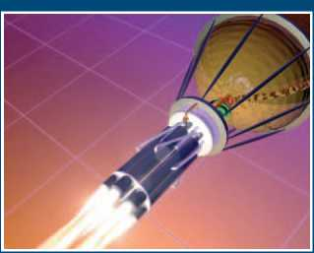
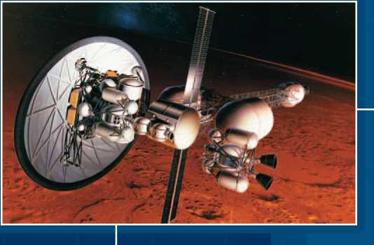
THE FUTURE OF ROCKETS
All rockets work through the principle of action-reaction. Something is ejected at high speed from one end, causing the rocket to move in the opposite direction. This “something” in the rockets we’ve described so far has been a hot gas, produced by burning fuels. But it does not have to be a hot gas. Whatever is being ejected must be done so at a very high speed. When you blow up a balloon and release it, it will fly around the room like a rocket because of the reaction to the air it is expelling—and that air is not even hot, let alone burning.
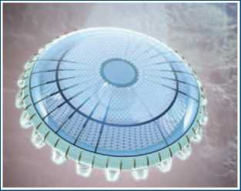
Modern engineers work on rocket systems that Goddard and von Braun would have never dreamed of. Nuclear-thermal rockets (top) may take explorers to Mars. The Pulse Detonation System (middle) is a chemical-fueled descendant of the Orion Project. Rockets may even be powered by microwaves instead of hot gases from burning fuels (bottom).
Back in the 1920s, several scientists, including Hermann Oberth, suggested that matter could be ejected at high speed by electricity. Ionic air filters are a good example of how electric rockets work. Two metal plates are given opposite electrical charges. Air is drawn into one side of the filter and given a positive charge by one of the metal plates. It is then repelled by the positive charge of the second plate, since similar electrical charges repel one another. This creates a stream of air flowing through the filter. This same effect can create a stream of gas flowing from the engine of a rocket. Electric rocket engines are often called ion thrusters because an atom with an electrical charge is called an ion. There have been many different plans for ion rockets since the 1920s, but all work more or less on the same principle. First, a gas is given an electrical charge. Then it is propelled from the nozzle of the rocket by passing it through a grid bearing the same electrical charge as the gas. Engines such as this produce low thrusts, but they also require little fuel. It almost seems as though they can run nonstop indefinitely. So although an ion rocket starts off slowly, its exhaust eventually builds up to tremendous speeds. The actual thrust, however, is very low, so ion engines can be used only in space and not to launch spacecraft from Earth. Ion engines have been successfully tested in space. They have been used on satellites as efficient, low-thrust engines for adjusting the position of the spacecraft. An ion engine was used on a Japanese space probe that made a historic touchdown on an asteroid in 2005. The Hayabusa spacecraft, using the gentle nudges from a NASA-developed ion engine, scooped up samples of the surface of asteroid Itokawa for eventual return to Earth. A soil sample from an asteroid will yield clues about the raw materials that made up the planets and asteroids in their formative years. Even the smallest sample from an asteroid can have huge scientific value.

ELECTRIC PROPULSION
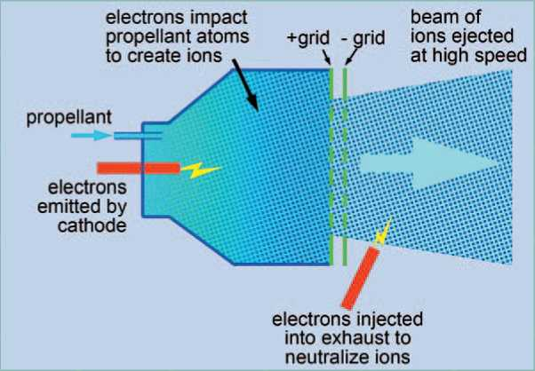
If you rub a balloon against a wool sweater, you will cause atoms on the surface of the balloon to exchange electrons with atoms in the sweater. These atoms then become ions, or atoms with either too many or too few electrons. You can tell that the balloon has been charged with ions (or static electricity) because its negatively charged atoms will be attracted to the positively charged atoms of your body. The balloon will stick to you. Ion engines work in a similar way. Instead of having ions that are simply attracted to one another, ion engines pull ions past plates with opposite charges and out the back of the engine. The ejection of the ions creates thrust, just as the ejection of gases in a regular rocket engine does. The ion engine consists of an ionization device called a cathode. The cathode sends electrons into the propellant. The electrons hit the propellant atoms and remove one or more of their electrons. These atoms have become positive ions. A positively charged plate in the front of the engine pushes these atoms forward. A negatively charged grid in the back of the engine pulls these ions out at great speeds. Just outside the last plate is another cathode that neutralizes the ion beam. Otherwise, it would be attracted right back toward the rocket
In an ion motor, a beam of ionized particles replaces the hot gases of a conventional rocket motor.

DEEP SPACE 1
NASA’s Deep Space 1 space probe was launched on October 24, 1998. During a highly successful primary mission, it tested twelve advanced technologies in space, including ion propulsion. The spacecraft’s ion engine provided about ten times the specific impulse (ratio of thrust to propellant used) of an ordinary liquid-fuel engine. As an extension of its original mission, Deep Space 1 encountered the asteroid Braille and the comet Borrelly. It returned the best images and other data ever obtained from a comet.
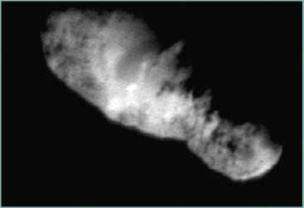
This is the highest resolution photo of the comet that was obtained by Deep Space 1.
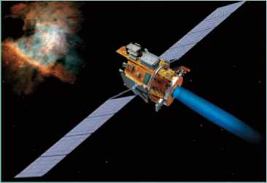
The Deep Space 1 spacecraft used its ion engine to maneuver close enough to Comet Borrelly to obtain detailed photographs of its surface.

Electricity, generated by nuclear power perhaps, could also make a fluid hot enough to vaporize. This is the same way that the electric element on a kitchen range can turn the water in a teakettle into steam. The “steam” from such a rocket—which may be at a temperature of thousands of degrees—can be used to propel it. Scientists at NASA’s Marshall Space Flight Center in Alabama have been working on several unusual forms of rocket propulsion. One obtains its energy from nuclear fusion. Unlike fission, in which an atom is split to release energy, fusion combines two or more atoms to create a heavier atom. It releases tremendous amounts of energy in the process—energy that could propel a spaceship. The creation of fusion energy is so efficient that it would be like driving a car 7,000 miles (11,265 km) on a single gallon (3.8 liters) of gas. This energy could create power for an ion thruster. Also, the superhot plasma created by fusion could be ejected from a nozzle to propel the spaceship directly.
Another exotic source of energy is from antimatter. Antimatter is identical to normal matter, except that the electrical charges of its atomic particles are reversed. A normal proton is positive where an antiproton is negative. When normal matter and antimatter meet, they annihilate each other in a huge burst of energy. If this energy were to be channeled out the back end of a spaceship, it could produce thrust. Although scientists believe that antimatter may exist freely in the universe somewhere, the only samples so far have been produced in laboratories.
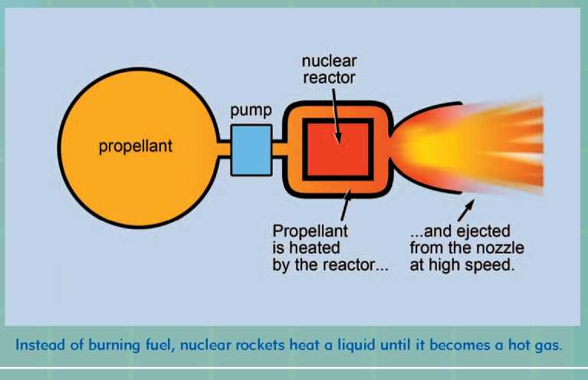
The beauty of matter/antimatter propulsion would be that a tiny amount of matter would produce a vast amount of energy. An antimatter-propelled spaceship could attain huge speeds while having to carry very little fuel. Of course, the main problem facing engineers working with antimatter is how to store a substance that explodes instantly the moment it touches anything.
Other unique rockets use conventional fuels but with radically redesigned engines. The plug nozzle, or aerospike engine, for example, is nothing more than a conventional rocket engine turned wrong side out. The flow of gases from the burning fuel clings to the outside of the curved nozzle. The advantage to the plug nozzle is that an engine can be much shorter than a conventional one. The savings in weight means the rocket can carry more fuel.
Other engineers have concentrated on ordinary rockets that use extraordinary fuels. Different fuels may be more powerful or less expensive to make or safer to store. For example, SpaceShipOne, the first private spaceship ever developed—which made its first flight into space in 2004—employed a rocket motor that burned solid fuel with a liquid oxidizer. The fuel was made of rubber processed from old automobile tires. The oxidizer was nitrous oxide, best known as an anesthetic used by doctors. A rocket engine that uses a solid fuel and a liquid or gaseous oxidizer is called a hybrid rocket. Unlike ordinary solid-fuel motors, such as those that boost the space shuttle, an engine like SpaceShipOne’s can be turned on and off. (Some new solid-fuel motors can be turned on and off at will.)
Many other unusual rockets are either on the drawing board or are being tested. Some of these are based on existing principles and materials, while others have to wait for the development of future technologies—which may or may not come to pass. Either way, the rockets of this century will look as primitive and quaint to future space explorers as Fourth of July skyrockets look to us now.
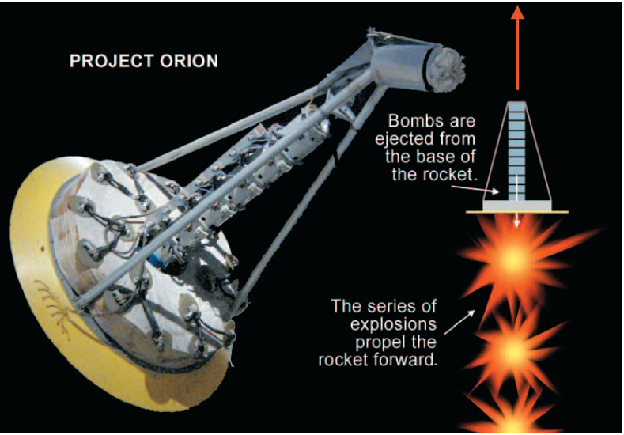

One of the most unusual reaction-propelled spacecraft ever suggested was Project Orion. A series of nuclear bombs were to be ejected through a hole in a huge steel plate. When the bombs detonated, they would force the spacecraft forward. A model (left) was tested by NASA and the Atomic Energy Commission using conventional explosives. But international treaties regarding aboveground nuclear testing, as well as fears about radioactive pollution, put a stop to the project before full-scale testing could begin.
Scientists think that future spacecraft may have antimatter engines. When matter and antimatter particles are combined, they mutually annihilate one another in a tremendous burst of energy—about 10 billion times more powerful than the energy released by ordinary rocket fuels. Such spacecraft are still many years in the future, however. The main problem is that antimatter doesn’t exist in nature. It has to be manufactured. So far, scientists have only been able to create a few particles of antimatter. Also, scientists would have to find a way to store a substance that can’t be allowed to come into contact with ordinary matter.
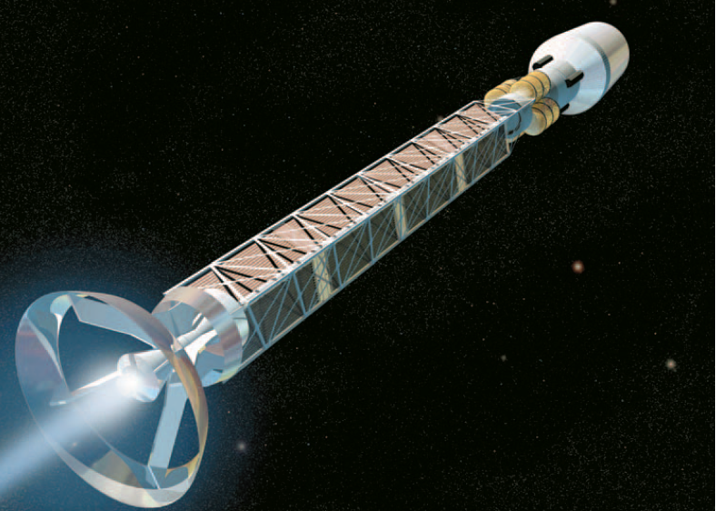

HYBRID FUELS AND THE CANDLESTICK ROCKET
In their search for new rocket fuels, scientists have tried many unusual materials. A recent discovery, however, is one of the most ordinary materials imaginable: candle wax. Scientists figured out a way to make candle wax—or paraffin— burn fast enough to serve as rocket fuel. Unlike the candles on a birthday cake, however, this paraffin burns in the presence of pure oxygen gas. This causes it to burn much hotter and faster.
One of the exciting things about this discovery is that paraffin rocket fuel would be much simpler and safer to work with than the toxic, explosive fuels. An ordinary household candle can be safely carved, melted, and molded. If free from artificial colors or perfumes, it can even be chewed on. In contrast, solid-fuel rockets use materials in which the fuel and oxidizer are mixed together before being packed into the rocket. So the fuel is ready to explode—an unsafe material to work with, as well as environmentally unfriendly.
When ordinary solid fuels burn, they produce many noxious chemicals. When it rains, these compounds find their way into lakes and soils where they can harm plant and animal life. Paraffin, in contrast, burns cleanly. The only gases left behind are water vapor and carbon dioxide.
The other advantage to hybrid fuels such as paraffin—where a solid fuel is combined with a liquid oxidizer—is that they allow for controllable rockets. They can be turned on and off just by turning on and off the flow of oxidizer. Their thrust can be throttled the same way.

WANT TO BE A ROCKET SCIENTIST?
Do you enjoy math and science? Do you have an inquisitive and searching mind? Are you interested in knowing what makes things work? Do you like to solve problems and puzzles? Do you like to create things? Do you enjoy learning? Do you enjoy working with computers? Are you prepared to study hard and do homework? Do you get good grades? These are the questions that NASA asks of students who are interested in working in space science and engineering.
A career in aerospace can be exciting. People in the field are professionals who either work independently or as part of a team. They conduct research and design and develop vehicles and systems for atmospheric and space environments. Individuals who are successful in aerospace careers have the proper educational background, possess good communication skills, and are committed to being part of a team.
If you are interested in this field, consider taking mathematics and science. Courses such as algebra, geometry, trigonometry, calculus, and computer math are important, as are sciences such as biology, chemistry, and physics. English is important too, since ideas need to be understood and communicated accurately.
A high school curriculum that includes these subjects will prepare you for the four to seven years of college study following high school. A bachelor’s degree is the minimum necessary to enter this field. Colleges and universities also offer graduate programs. The master’s program usually takes two years. It takes an additional two to four years to earn a doctorate.
A starting position as an engineer, mathematician, physical scientist, or life scientist usually requires a bachelor’s degree. (NASA prefers those working in the life sciences to have at least a master’s and/or doctoral degree.) Some examples of engineering degrees required for aerospace technology are electrical/electronics, aerospace, and mechanical. Other types of bachelor’s degrees that may lead to aerospace careers are physics, chemistry, geology, meteorology, mathematics, experimental psychology, and biology.
Engineering technicians typically have two-year associate of science degrees. Some will continue for an additional two years to obtain a bachelor’s degree in engineering technology. Others earn bachelor’s degrees in engineering or one of the physical sciences. Some technicians may complete one of the five-year apprenticeship programs offered at NASA field centers.
Once you have received this education, what can you do with it? What kinds of jobs or careers are in the aerospace industry? Probably a lot more than you think. The majority of jobs in aerospace fall into three broad categories: engineers, technicians, and scientists.
Engineers make things work. The work and ideas of engineers make achievements possible. They put power and materials to work. Rockets, spacecraft, and satellites are designed and built by various kinds of engineers. These include chemical, electrical, computer, nuclear, safety, and biomedical engineers, and many others. In the future, engineers will design safer and more efficient spacecraft, space stations, and space colonies.
Technicians are an important part of the aerospace team. They work closely with scientists and engineers. They operate wind tunnels, work in laboratories, construct test equipment, build models, and support many types of research. Technicians and designers are always in demand. The industry also needs writers, artists, and photographers.
Scientists are knowledge seekers, always searching out why things happen. They are inquisitive. They possess a sense of wonder. Nature, Earth, and the universe fascinate the scientist. The scientist asks questions, seeks answers, and expands knowledge. You could be an astronomer, chemist, geologist, physicist, or meteorologist. If you are more interested in the life sciences, biologists, medical doctors, psychologists, and other scientists are needed. Or a degree in math may lead you to become a systems analyst or computer scientist. And you could, of course, be an astronaut, working as a pilot, mission specialist, or payload specialist.

Будущее ракетных систем.
Все ракеты работают по принципу действие-противодействие. Скоростной поток выбрасываемый ракетой позади себя, заставляет ее двигаться в противоположную сторону от потока. Поток, который мы описывали ранее , был ничем иным, как горячий газ, образующийся при сжигании топлива. Впрочем это может быть не только горячий газ. Чтобы это ни было, оно должно иметь очень высокую скорость. Представьте, что вы надули шарик и отпустили его, при этом он будет летать по комнате словно ракета, из-за выходящего из него воздуха, который даже не горячий, не говоря уже собственно про горение.
Современные инженеры работают над ракетными системами, о которых Годдард и фон Браун и мечтать не могли. Ядерные двигатели (верхнее изображение) могут доставить исследователей на Марс. Пульсирующий детонационный двигатель (посередине), представляющий собой потомок проекта "Орион" на химическом топливе. Ракеты могут приводиться в движение даже от микроволн, вместо горячих продуктов сгорания(нижнее изображение).
Вернемся в 1920-ые годы, где несколько ученых, в том числе Герман Оберт предположили, что в высокоскоростной поток можно осуществить при помощи электричества. Ионные воздушные фильтры, являются хорошим примером того, как работают электрические ракеты. Две металлические пластины, заряжаются разноименно. Воздух поступая на одну из сторон фильтра, отдает положительный заряд одной из металлических пластин. Затем отталкивается от второй, положительно заряженной пластины, так как одноименные заряды отталкиваются. Это создает поток воздуха, проходящего через фильтр. Этот же эффект может создать газовый поток, испускающийся ракетным двигателем. Электрические ракетные двигатели, также часто называют ионными, так как электрически заряженный атом называется ионом.
Начиная с 1920-ых годов, было предложено множество разработок по ионным ракетным двигателям, но все они имели сходный принцип действия, без существенных отличий. Во-первых на газ подается электрический заряд. Затем он движется по соплу за счет протекания через решетку, имеющий такой же электрический заряд. Двигатели, подобные этим создают малую тягу, но они также требуют малое количество топлива. Создается впечатление, будто бы они могут работать безостановочно. Хоть ионные ракеты и стартуют медленно, в конечном итоге скорость испускаемого ими газа достигает огромных значений. При этом их тяга очень мала, и пригодна лишь для использования в космическом пространстве, а не для запуска космических аппаратов с Земли.
Ионные двигатели были успешно испытаны в космосе. Они применялись на спутниках, в качестве работающих двигателей малой тяги для регулировки положения космического аппарата. Ионные двигатели использовались на японском космическом зонде, который совершил историческую посадку на астероид в 2005 году. Космический аппарат «Хаябуса» плавными рывками ионного двигателя, разработанного НАСА, собрал образцы грунта астероида Итокава, для последующей доставки ее на Землю. Образцы грунта с астероида помогут понять из какого исходного материала образованы астероиды и планеты одного с ним возраста. Даже самая небольшая проба из астероида может иметь огромное научное значение.

Электрическая силовая установка.
Если потереть воздушный шар об шерстяной свитер, произойдет обмен атомами поверхности шара и свитера. Эти атомы будут ионами, или атомами с множеством или несколькими электронами. Вы можете сказать, что шар зарядится ионами (или статическим электричеством), так как его отрицательно заряженные атомы будут взаимодействовать с положительно заряженным атомами вашего тела. Шар будет прилипать к вам.
Ионные двигатели работают аналогичным образом. Вместо того, чтобы ионы просто притягивались друг к другу, они проходят через пластину заряженную противоположно, и выбрасывается позади двигателя. Выброс ионов создает тягу, подобно газам в привычных нам ракетам.
Ионный двигатель состоит из ионизирующей части, катода. Катод передает электроны рабочему телу. В результате чего атомы рабочего тела сталкиваясь с электронами катода, теряют свои электроны. Эти атомы становятся положительными ионами. Положительно заряженная пластина в передней части двигателя толкает эти атомы вперед. Отрицательно заряженная решетка в задней части двигателя притягивает эти ионы, придавая им огромную скорость. Недалеко от последней пластины установлен другой катод, который нейтрализует пучок ионов. В противном случае они опять станут притягиваться к ракете.
В ионной силовой установке, продукты сгорания обычного ракетного двигателя, заменяются на пучок ионизированных частиц.

Deep Space 1.
Космический аппарат НАСА Deep Space 1 был запущен 24 октября 1998 года. Помимо своей основной миссии, закончившейся успешно на нем испытывали двенадцать передовых космических технологий, включая ионный двигатель. Чей удельный импульс (отношение тяги двигателя к массовому расходу) в десять раз превышает удельный импульс жидкостного ракетного двигателя. Вдобавок ко своей первоначальной миссии Deep Space 1 изучил астероид Брайль и комету Борелли. Он сделал лучшие снимки кометы и получил другие редкие данные.
Deep Space 1 использовал ионные двигатели для маневрирования вблизи кометы Борелли для получения подробных снимков ее поверхности.

Снимок кометы с высочайшим разрешением, полученный Deep Space 1.

Электроэнергия, полученная путем преобразования ядерной энергии также может использоваться для нагревания жидкости и превращения ее в пар. Подобно электрическому элементу на кухонной плите который испаряет воду в чайнике. Пар в подобных ракетах может достигать температуры тысячи градусов, и использоваться для приведения его в движение.

Ученые НАСА космического центра Маршалла в штате Алабама работают над несколькими видами ракетных двигателей необычной формы. Один из них работает на энергии термоядерного синтеза. В отличии от распада, в котором атом делится высвобождая энергию, в процессе синтеза объединяются два и более атомов, чтобы создать более тяжелый атом. При этом высвобождается огромное количество энергии, которое могло бы использоваться для движения ракеты. Термоядерная энергия настолько велика, что вы могли бы проехаться на автомобиле 7000 миль (11265 км) лишь на одном галлоне (3,8 литров) газа. Эта энергия может быть использована для работы как ионного движителя, так и непосредственно для движения космического корабля путем выброса высокотемпературной плазмы полученной в результате синтеза из сопла.

Еще один экзотический источник энергии это антиматерия. Она сходна с обычной материей за исключением того что, ее атомные частицы имеют противоположные электрические заряды. Обычный протон положителен, в то время как антипротон отрицателен. При взаимодействии вещества и антивещества, происходит их аннигиляция, при этом высвобождается громадное количество энергии. Если бы эту энергию удалось перенаправить в хвостовую часть космического корабля, то это создало бы тягу. Хотя ученые и предполгают что антивещество свободно существует во вселенной, в лабораторных условиях до сих пор, были получены лишь ее образцы.

Прелесть пары материя/антиматерия в том что, ее небольшое количество будет производить огромное количество энергии. Заправленные антиматерией корабли смогут достичь огромных скоростей перевозя с собой незначительное количество топлива. Конечно, главной проблемой инженеров станет хранение такого вещества как антивещество, которое мгновенно взрывается при соприкосновении со всем.

Иные уникальные двигатели работают на традиционных видах топлива, но с коренными изменениями в двигателе. Например двигатель имеющий сопло с центральным телом, ни что иное как обычный ракетный двигатель, но с перевернутым в другую сторону соплом. Поток продуктов сгорания протекает снаружи центрального профилированного тела внутри сопла. Преимущество сопел с центральным телом в том что длина двигателя становится заметно короче. Экономия в весе означает увеличение количества переносимого топлива.

Прочие конструкторы направили свое внимание на классические схемы устройств двигателей, но с нестандартными видами топлив. Различные топливные пары могут иметь преимущества по мощности и по стоимости производства или по безопасности хранения. Например SpaceShipOne, первый частный космический корабль, который совершил свой первый полет в космос 2004 году, и использовал для этого твердотопливное горючее и жидкий окислитель. Горючее представлял собой каучук, полученный из старых автомобильных шин. Окислителем служил оксид азота, хорошо известный как анестезирующее средство используемое врачами. Ракетный двигатель, использующий твердое горючее и жидкий или газообразный окислитель называется гибридным. В отличии от обычных твердотопливных двигателей, на которых запускали Спейс шаттл, SpaceShipOne может быть включен и выключен. (Некоторые новые твердотопливные двигатели могут быть включены и выключены по желанию).

Один из самых необычных когда либо предложенных реактивных установок космического корабля, проект Орион. Последовательно выбрасывавший ядерные бомбы через отверстие в огромной стальной плите.

Когда бомбы взрывались они заставляли космический корабль двигаться вперед. Модель (слева) была протестирована НАСА и Комиссией по атомной энергии, с использованием обычных взрывчатых веществ. Но международные переговоры касательно надземных ядерных испытаний, а также опасения по поводу радиоактивного заражения положили конец проекта до начала полномасштабных испытаний.

Ученые предполагают, что будущее космических аппаратов за двигателями работающих на антиматерии. Когда взаимодействуют частицы антиматерии и материи, они взаимно уничтожаются и образуют колоссальный источник энергии, который примерно в 10 млрд. раз больше чем та энергия, которая выделяется в обычных ракетных двигателях. Подобные космические аппараты являются лишь далеким будущим. Но, тем не менее, ее основной проблемой уже сегодня является то, что антивещества не существует в природе. Он должен быть изготовлен. На данный момент ученым удалось создать лишь несколько частиц антивещества. Кроме того, ученые должны найти способ, чтобы хранения подобного вещества, которое не может контактировать с обычными веществами.

Гибридные топлива и горючее из воска.

В поисках новых ракетных топлив, ученые пробовали множество необычных материалов. Недавно сделанное открытие, можете себе представить, относится к одному из самых простых веществ- свечному воску. Ученые обнаружили способ увеличения скорости горения воска или парафина таким образом, что он может служить в качестве горючего. В отличие от праздничного торта на день рождения, этот парафин сгорает в присутствии чистого кислорода. Что позволяет получить повышенные температуры горения и сжечь его гораздо быстрее.

Одним из наиболее интересных вещей этого открытия стало то, что с парафином было бы намного проще и безопаснее работать, чем с токсичными и взрывчатыми веществами. Обычную бытовую свечу можно безопасно резать, растапливать и формировать. В отсутствии красок и ароматических веществ ее даже можно жевать. В противоположность этому, твердотопливные ракеты в которых используют материалы смешивающиеся с горючим и окислителем перед тем как заложить их в ракету. Тем самым топливо становиться не столь безопасным для работы, экологически-чистым и готовым прореагировать в любой момент времени.

Когда горят твердые виды топлив, в них образуются множество вредных химических соединений. Вместе с дождем они попадают в озера и почву, тем самым могут нанести вред растениям и животным. Парафин, же напротив сжигается чище. Его продуктами сгорания является водяной пар и углекислый газ.

Другое преимущество гибридных топлив, таких как парафин, где твердое горючее сочетается с жидким окислителем, в том что они позволяют контролировать ракеты. Они могут включаться и выключаться регулированием потока окислителя. Их тяга может так же дросселироваться тем же самым способом.

Существуют множество других редких видов ракет находящихся на стадии проектирования или испытания. Некоторые из них основаны на существующих на сегодняшний день схем и материалов, а остальным приходиться ждать технологий будущего, которые могут настать, а могут и не наступить. В любом случае, ракеты нынешнего века будут выглядеть одновременно и примитивней и причудливей ракет будущего, как выглядят для нас сейчас фейерверки на День независимости США.

Хотите быть такими же умными как ракетчики.

Вам нравится математика и естественные науки? Если у вас пытливый и любознательный ум. Если вы заинтересованы в том, чтобы узнать что нужно сделать, чтобы это заработало? Вам нравиться решать задачи и головоломки. Вам нравиться самим проектировать различные вещи? Вам нравиться познавать и работать на компьютерах? Готовы ли вы усердно учиться и делать домашнее задание? Вы получаете хорошие оценки? Это список вопросов, которые НАСА задают студентам, заинтересованных в работе в области космической науки и техники.

Карьера в области аэрокосмической науки может быть невероятно интересной. Люди в данной отрасли профессионалы, работающие независимо друг от друга, или как часть команды. Они проводят исследования и проектирование летательных аппаратов и систем для атмосферных и космических условий. Те кто добился успеха в аэрокосмической области образованные люди, обладающие хорошими навыками общения, и стремятся быть частью команды.

Если вы заинтересованы в этой области придется изучать математику и естественные науки. Такие курсы как алгебра, геометрия, тригонометрия, дифференциальное и интегральное исчисление и компьютерная математика важны как и такие науки как биология, химия и физика. Английский язык тоже очень нужен, так как понятия и представления должны быть поняты и точно переданы.

Учебный план средней школы, включающий в себя эти предметы подготовит вас для учебы в колледже от четырех до семи лет после завершения школы. Степень бакалавра является необходимым минимумом для начала работ в этой области. Колледжи и университеты также предлагают дополнительные образовательные программы. Магистерская программа занимает обычно два года. Для получения ученой степени требуется дополнительные два-четыре года.

Начальное положение как правило требует степени бакалавра инженера, математика, физика или биолога. (НАСА предпочитает тех, кто работает в области медико-биологических наук с наличием магистерской или докторской степенью). Некоторыми примерами инженерных направлений, необходимых для аэрокосмической техники являются электричество/электроника, аэрокосмическая и прикладная механика. Другие виды направлений для работы в этой области это физика, химия, геология, метеорология, математика, экспериментальная психология и биология.

Инженеры-техники как правило имеют двухгодичный курс с незавершенным высшим образованием. Некоторые продолжают учебу еще на два года, и получают степень бакалавра в области технических наук или в одном из физических дисциплин. Можно также завершить пятилетний курс обучения предлагаемых в полевых центрах НАСА.

Что же вы сможете делать после его получения? Какой вид деятельности или карьеры в аэрокосмической отрасли? Наверное, гораздо больше чем вы себе представляете. Большинство рабочих мест делятся на три категории: конструкторы, техники, ученые.

Конструкторы проектируют работоспособные модели. Работа и идеи инженеров позволяют достичь успехов. Они прилагают усилия и материалы для того чтобы все заработало. Ракеты, космические аппараты и спутники спроектированы и построены разными инженерами в различной области деятельности. Включающие в себя химические, электрические, компьютерные, ядерные, биомедицинские и безопасность и многие другие. В будущем конструкторы будут проектировать более безопасные и эффективные аппараты орбитальных станций и космических колоний.

Техники являются важной частью аэрокосмической команды. Они работают в тесном сотрудничестве с учеными и инженерами-конструкторами. Они работают с аэродинамическими трубами, в лабораториях, строят испытательное оборудование, модели и обеспечивают различные виды исследований. Подобной отрасли также нужны писатели, художники, фотографы.

Ученые искатели знаний, они всегда в поиске того почему происходят те, или иные явления. Они любознательны и могут восхищаться. Природа, Земля, и Вселенная завораживают ученых. Ученые задают вопросы, ищут на них ответы, расширяют свои знания. Вы могли бы быть астрономом, химиком, геологом, физиком, или метеорологом. Если вы больше заинтересованы в областях наук о жизни, нужны также биологи, врачи, психологи и другие. Или степень в области математики, может сделать вас системным аналитиком или ученым в компьютерной области. Также вы могли бы, стать космонавтом, работая в качестве пилота, специалистом по полету, специалистом по полезной нагрузке и оборудованию.

Lock up your carbon
Carbon dioxide capture is finally under way. Can it save the world?
Catherine Brahic
RISING above the endless plains of Saskatchewan, Canada’s Boundary Dam power plant looks like any other: giant boxes, tall red-andwhite striped chimneys, and a mess of pipes and power lines.
But appearances can be deceptive. In the coming months, it will become the first power plant to suck the carbon dioxide out of its flue before the gas reaches the air. It is blazing the trail for carbon capture and storage (CCS) around the world. Not bad for Canada’s largest coal power plant.
Each year, Unit 3 of SaskPower’s Boundary Dam plant emits 1.1 million tonnes of carbon dioxide. But from this summer, 90 per cent of that CO2 will never see the light of day. Instead, the gas will be piped to the nearby Weyburn oilfield and Deadwater saline aquifer, and pumped several kilometres underground.
“The resulting 110 megawatts of power produced will be some of the world’s most environmentally clean power from fossil fuels,” says SaskPower’s Robert Watson.
“2014 is a pivotal year for CCS,” says Stuart Haszeldine of the University of Edinburgh, UK. “The technology is going from zero to something. It’s terrific.”
Boundary Dam is CCS’s first big success story, and more must follow. The International Energy Agency (IEA) says that, to have a 50 per cent chance of avoiding 2 °C of global warming, which is probably too dangerous to adapt to, the energy sector can only emit 884 gigatonnes of CO2 between 2013 and 2050 (Redrawing the Climate-Energy Map, 2013). Burning proven reserves of coal, oil and gas would release 2860 Gt. So we must leave two-thirds in the ground (Technology Roadmap: Carbon Capture and Storage, 2013).
Here’s the rub: the IEA says we will build enough power plants by 2020 to burn our budget by 2050. “Climate change mitigation can and should start by lowering consumption and increasing energy efficiency,” says Ruben Juanes of the Massachusetts Institute of Technology. “But the reality is that fossil fuels will continue to dominate the world’s primary power for decades to come.”
That is where CCS comes in. Exhaust from a power plant is passed through a solvent that binds to CO2. While the rest of the gas is vented, the CO2-rich solvent is drawn off and heated to release the gas. Then the CO2 can either be used (see “Don't junk CO2, turn it into bottles and glue”, right) or pumped underground, beneath impermeable layers of rock (see diagram, below left).
Boundary Dam will be the first CCS project built on a commercial- scale power station. The process is already up and running in 12 industrial installations like fertiliser factories and natural gas processing plants. Also, for some time the oil and gas industry has been injecting flue gas into old oil and gas seams to push out the last drops of fuel. But power stations are the big daddies. They are the single largest source of greenhouse gases, accounting for 26 per cent of our emissions.
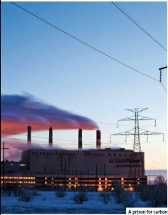Later this year, Kemper County power station in Mississippi will become the second CCS power station. It is a coal gasification plant, so will test CCS on a different energy source. And last week the UK announced funding to draw up detailed plans for full- scale CCS at the Peterhead power plant. That is a significant move: Peterhead is gas-fired and, while coal remains a major source of power in China, Europe and the US have been switching to gas.
“The success [of these projects] is very important for the future of CCS,” says Howard Herzog of MIT.
A key question is whether there is enough room underground to safely store all that CO2. “Curbing CO2 emissions worldwide is a daunting task,” says Juanes. We pump out 30 billion tonnes each year, which amounts to 60 billion cubic metres of compressed CO2 under the typical conditions in Earth's crust, he says. “That's more than 10 times the volume of oil that is transported around the globe on a daily basis. Of course we don't expect that one single technology will take our emissions to zero, but this gives a sense of the scale of the problem.” Juanes and other experts say CCS is only a bridge technology. It could buy time to make the switch from fossil fuels to renewables. The question is, “how long is that bridge”, and will it be enough?
He studied 11 US saline aquifers, geological formations that could store CO2, and calculated that they could hold 100 years' worth of US emissions (PNAS, doi.org/rqs). The North Sea is said to have room for 100 years of European emissions.
The big hurdle for CCS is money. Adding chemical scrubbers to a power station uses about 20 per cent of its power output. Power companies are unlikely to pay that hefty cost without incentives.
For now the cost of electricity from a CCS power plant is higher than normal fossil fuels but close to wind energy, says Haszeldine. The most pricey bit is reheating the solvent to release captured CO2. Researchers are now looking into scrubbing reactions that use less energy. If that works, power plants could use residual heat alone to drive the reaction.
That is still in the R&D phase, with tangible results 10 to 15 years away. But Haszeldine says a similar technology - scrubbing sulphur dioxide pollution from power station emissions - was once dismissed as impossibly expensive, but now runs on most power stations for little extra cost.
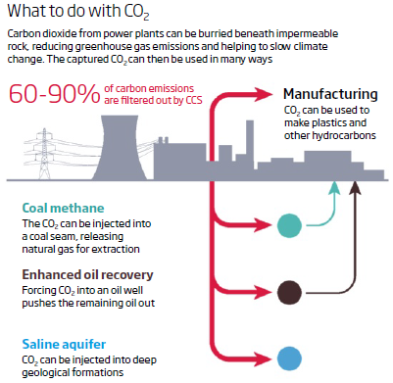We need to do more than CCS to save ourselves from climate change. But, asks Juanes, how many technologies can vanish gigatonnes of CO2each year?
“The answer is none,” he says.
“I think CCS stands alone.”

Don't junk CO2 turn it into bottles and glue

IF HUMANITY is to avoid dangerous climate change, we need to capture hundreds of billions of tonnes of carbon dioxide. But what to do with it all? There is no shortage of places to bury it (see main story), but we can at least put some of it to good use. A few start-up companies view CO2 as a resource rather than a waste product. They are using CO2 as the raw material for making products including superglue and fertiliser.
Liquid Light of Monmouth Junction, New Jersey, showed off its prototype CO2 converter at the ARPA-E Energy Innovation Summit in Washington DC last week. About the length and width of a coffee table, and a few inches thick, the module is a layer cake of steel and plastic. Inside it are catalysts that can produce more than 60 carbon-based chemicals, from just CO2 and electricity. By linking many of these devices together, a chemical plant could convert CO2 into hundreds of thousands of tonnes of products in a year, says co-founder Kyle Teamey.
Helping chemical companies switch their feedstock to CO2 does more than boost their green credentials. "Almost all of their expenses are based on buying oil or natural gas or biomass," says Teamey. So releasing it into the air is perverse. "It's not just pollution, it's actually losing the value of the stuff they bought in the first place."
Liquid Light's first product will be ethylene glycol, the raw material for making polyester fibre, plastic bottles and antifreeze. Teamey estimates the process would trap 31 million tonnes of CO2 per year if the firm took over all global production. It would also avoid the emissions that current processes create, although that figure is not so clear-cut. The company has processes in the pipeline to make everything from superglue to Plexiglas.
Liquid Light is not alone in looking at CO2 as a resource. Dioxide Materials of Champaign, Illinois, is a start-up spun out from the University of Illinois. It will focus on producing acetic acid, a chemical used to make products like paint and glue.
Dioxide Materials has partnered with 3M, the multinational firm that invented Post-It notes. 3M hopes to replace some of the expensive raw materials for its adhesive business.
"The CO2 becomes the feedstock," says Laura Nereng, 3M's sustainability leader. "There are several materials we could make, but for us the most important area of interest is acrylic acid. It's used to make adhesives, and 3M makes a lot of adhesive. Therefore it's an important raw material to our company and we're always looking for lower cost routes to our most important raw materials."
Using CO2 as a feedstock should help lower 3M's carbon footprint, especially if the company can capture and use its own. "The idea of us using our own CO2 emissions to make something that we need is very appealing, but I don't know whether the scale will work out," Nereng says. "Even if it mitigates CO2 at our supplier, that's also a net win."
Both Liquid Light and Dioxide Materials can already produce fuels from CO2. But they will not be bringing them to market yet, as it is cheaper to break down crude oil into petrol and heating oil. That could soon change, though. Teamey says wind power is nearly cheap enough for it to be economic to use it to make fuel.
We won't be able to convert all the CO2 we capture into products, says Pamela Tomski of the Global Carbon Capture and Storage Institute in Docklands, Australia. Liquid Light's 31 million tonnes a year would only use up a fraction. But if ethylene glycol proves successful, and new markets for CO2 can be found, humanity may end up handling its emissions in a whole new way. Hal Hodson

Не выбрасывайте углерод.

Улавливание углерода идет полным ходом. Сможет ли это спасти мир?

Катерина Браик.

Возвышающийся над бескрайними равнинами Саскачевана электростанция Canada's Boundary Dam выглядит как и все привычные электростанции: огромные боксы, высокие красно-белые полосатые трубы, беспорядочная сеть трубопроводов и линий электропередач.
Но внешность может быть обманчива. В ближайшие месяцы она станет единственной электростанцией способной отбирать углекислый газ из дымовых труб, прежде чем он выйдет наружу. Это станет отправной точкой в развитии технологий улавливания и хранения углерода (англ.сarbon capture and storage, CCS) по всему миру. Неплохо для крупнейшей канадской угольной электростанции.
Каждый год блок № 3 SaskPower's Boundary Dam выбрасывал 1.1 млн. тонн углекислого газа. Но с этого лета, 90 процентов выбросов CO2 не увидят дневного света. Вместо этого газ будет поступать в ближайшее Уэйнбергское месторождение нефти и Деадватерский солевой водоносный пласт, и закачиваться под землю на несколько километров.
"Произведенная мощность в 110 мегаватт, будет наиболее экологически чистой энергией в мире полученной от ископаемых видов топлив."- говорит Роберт Уотсон представитель SaskPower.
"2014 год является переломным для технологий УХУ",- говорит Стюарт Хасзельдин из Эдинбургского университета, Великобритания. "Технология разрабатывается с нуля. И это здорово."
Boundary Dam это первый большой успех технологий УХУ, за которым должны последовать следующие. Международное энергетическое агентство (МЭА) сообщает что для сокращения на 50 процентов глобального потепления на 2°C, которое вероятно представляет серьезную угрозу, с 2013 года по 2050 год энергетическому сектору необходимо выбросить не более 884 гигатонн СО2. (Перерисовка энерго-климатической карты, 2013). Сжигание имеющихся запасов угля, нефти, и газа приведет к выбросу 2860 гигатонн СО2. Таким образом мы должны оставить две трети части в земле (Технологический план: улавливания и хранения углерода, 2013).
Но вот незадача: МЭА утверждает, что мы будем построим достаточное количество электростанций к 2020 году, чтобы сжечь наши запасы до 2050 года. "Смягчение последствий изменения климата могут и должны начаться за счет снижения потребления и повышения энергетической эффективности",-говорит Рубен Хуанес из Массачусетского технологического института. "Но реальность такова, что ископаемое топливо будет продолжать преобладать в качестве основного энергоресурса в мире на десятки лет вперед.
Там где применяют технологии УХУ. Выхлопы электростанции пропускают через растворитель, который захватывает CO2. В то время как остальной газ выбрасывается в атмосферу, растворитель, содержащий большое количество CO2, отбирается и подвергается нагреву, чтобы отделить углекислый газ. Затем CO2 может быть использован (см. "Не выбрасывайте CO2, сделайте из него бутылки и клей", справа) либо закачан в подземные хранилища под непроницаемыми пластами породы (см. схему слева ниже).
Boundary Dam будет первым проектом по УХУ реализованным в электростанции промышленного масштаба. Подобные процессы уже запущены и применяются на 12 других промышленных объектах, на заводах по производству удобрений и переработке природного газа. Кроме этого, в течении некоторого периода времени в нефтегазовой промышленности, дымовые газы закачивались в старые месторождения для поднятия из пластов оставшегося количества углеводородов. Но электростанции являются рекордсменами. Они крупнейшие источники выбросов парниковых газов в атмосферу, на их долю приходится 26 процентов всех выбросов.
В том же году, электростанция Кемпер Каунти в штате Миссисипи станет второй электростанцией где будут применяться т. УХУ. Она является заводом по газификации угля и проверит т. УХУ на различных источниках энергии. А на прошлой неделе Великобритания объявила о финансировании подробного плана для полномасштабной реализации т. УХУ на электростанции Питерхед. Это важный этап: Питерхед работает на газообразном топливе, в то время пока основным источником энергии в Китае служит уголь, Европа и США переключились на газ.
"Успех таких проектов является очень важным для будущего УХУ",-говорит Говард Херцог из Массачусетского технологического института.
Ключевой вопрос: хватит ли достаточного количества места в подземных хранилищах для СО2. Сдерживание выбросов СО2 во всем мире, является чрезвычайно сложной задачей",- говорит Хуанес. Мы нагнетаем в земную кору до 30 миллиардов тонн ежегодно, что составляет 60 млрд. кубометров сжатого СО2 при стандартных условиях, говорит он. Это в десятки раз превышает тот объем нефти, который транспортируется по всему миру на ежедневной основе. Конечно, мы не ожидаем, что лишь одна единственная технология позволит снизить уровень выбросов до нуля, но это дает представление о масштабах трагедии.
Хуанес и остальные эксперты утверждают, что УХУ лишь промежуточная технология. Она поможет выиграть некоторое время при переходе от ископаемых видов топлива к возобновляемым. Вопрос в том, какой протяженности этот "мост", и хватит ли его?
Он изучил 11 засоленных водоносных пластов в США, геологических образований которые могли хранить СО2, и подсчитал, что они могут вместить в себя американские выбросы за следующие сто лет. Северное море, как говорят, является потенциальным столетним хранилищем европейских выбросов.
Большим препятствием для внедрения УХУ, это деньги. Дополнительные химические газоочистители для электростанции используют до 20 процентов ее выходной мощности. Энергетические компании вряд ли готовы платить столь не маленькую сумму без определенного стимула.
На данный момент стоимость электроэнергии от электростанций с технологией УХУ выше, чем у обычных электростанций на ископаемых видах топлива. Но близка к ветровой энергии, говорит Хасзелдин. Наиболее затратной частью является подогрев растворителя, для отделения СО2. Исследователи в настоящее время ведут работу по поиску очистных реакций требующих меньшего количества энергии. Если это сработает, то электростанции смогут использовать только остаточное тепло для проведения реакции. Все это еще на стадии НИОКР, с видимыми результатами лишь через 10-15 лет. Но Хасзелдин говорит, что подобная технология очистки выбросов электростанции от диоксида серы была когда-то аналогично отвергнута из-за невероятной дороговизны, но в наши дни применяется на большинстве электростанций при небольших дополнительных затрат.
Мы должны прилагать больше усилий, помимо УХУ, дабы спасти самих себя от изменения климата. Но вопрос Хуанеса таков: Какая технология способна предотвратить выбросы гигатонн СО2 ежегодно? "Ответ никакая",- говорит он. "Я думаю т. УХУ пока единственная.

"Не выбрасывайте CO2, сделайте из него бутылки и клей"
Во избежание человечеством опасного изменения климата, мы должны улавливать сотни миллиардов тонн углекислого газа. Но что со всем этим делать? Можно закачать его под землю, там где нет недостатка места (см. основной сюжет), но мы можем так же использовать его выгодно, по крайней мере некоторую часть. Несколько стартап-компаний рассматривают СО2 в качестве источника, а не отходов. Они используют СО2 в качестве сырья для изготовления различных продуктов, в том числе суперклея и удобрений.
Компания " Liquid Light" из Монмут Джанкшен штат Нью-Джерси, продемонстрировала свой прототип преобразователя СО2 на саммите энергетических инноваций ARPA-E в Вашингтоне на прошлой неделе. Модуль, по размеру напоминающий журнальный столик, и имеющий толщину в несколько дюймов, представляет собой слоеный торт из стали и пластика. Внутри него есть катализатор, который может производить более 60 соединений на базе углерода из СО2 и электричества. Соединив множество таких устройств вместе, химический завод сможет получать сотни тысяч тонн продукции в год, говорит соучредитель Кайл Тими.
Помогая химическим компаниям переходить на СО2 в качестве сырья, они делают больше, чем просто повышают их экологические характеристики. Практически все их расходы основаны на покупке нефти, природного газа или биомассы",-говорит Тими. Просто так выбрасывать их в атмосферу расточительно. "Это не только загрязнение окружающей среды, но и на самом то деле и потеря в стоимости материала, который они приобрели в первую очередь".
Первой продукцией " Liquid Light" будет этиленгликоль, материал для изготовления полиэфирного волокна, пластиковых бутылок и антифриз. По подсчетам Тими данный процесс поможет уловить до 31 млн. тонн СО2 в год, если фирма возьмет на себя все мировое производство. Это также поможет избежать выбросов, которые создают текущие процессы, хотя эта цифра не столь ясно определена. Компания находится на стадии внедрения процесса позволяющего сделать все, от суперклея до оргстекла.
" Liquid Light" не одиноки в том, что касается использования СО2 в качестве ресурса. "Dioxide Materials" из Шампейна штат Иллинойс является стартапом вышедшим из Иллинойского университета. Она будет сосредоточена на производстве уксусной кислоты, химического вещества применяемого для изготовления красок и клея.
"Dioxide Materials" в партнерстве с 3M, многонациональной фирмой, которая изобрела клейкую отрывную бумагу для заметок. 3M надеется заменить некоторые виды дорогостоящего сырья для их "клейкого" бизнеса.
"СО2 переходит в разряд сырья ",-говорит Лаура Неренг, руководитель в сфере устойчивого развития 3М. Мы могли бы изготовить несколько видов материалов, но нашей предпочтительной областью интересов является акриловая кислота. Она используется для изготовления клея, 3М делает много клея. Поэтому это важнейший сырьевой материал для нашей компании, и мы всегда в поиске более дешевых материалов.
Использование СО2 в качестве сырья должно снизить зависимость от углеводородов, особенно когда компания способна самостоятельно добывать и использовать его."Наша идея подкупает тем, что можно использовать наши собственные выбросов СО2, для изготовления того что нам нужно, но я не могу сказать, что это будет применяться масштабно",- говорит Неренг. "Даже если это смягчает зависимость от нашего поставщика, то это тоже только выигрыш.
И " Liquid Light", и "Dioxide Materials" могут уже производить топливо из СО2. Но они не будут выставлять его на продажу сейчас, как дешевое топливо взамен бензину и мазуту. Хотя это может измениться в ближайшее время. Тими говорит, что энергия ветра достаточно дешевая, дабы быть выгодно использованным для изготовления топлива.
Мы не сможем преобразовать все СО2 повторно в сырье, говорит Памела Томски из Института глобального улавливания и хранения углерода в Доклендсе, Австралия. Из 31 млн. тонн " Liquid Light"-а ежегодно будет потребляться только часть. Но если этиленгликоль окажется успешным, и будут найдены новые рынки сбыта, человечество сможет в целом по-новому обрабатовать выбросы. Хал Ходсон

And If All Else Fails
It's 115 degrees. In March. Now what?
STORY BY Damon Tabor ILLUSTRATION BY Graham Murdoch
IT’S IMPOSSIBLE to predict the exact speed and severity with which climate change will unfold, but one thing is clear: if we take no preventive action, eventually we’ll be tempted to take desperate action. And over the decades, as the effects of climate change grow increasingly severe, the amount of risk humankind is willing to bear will increase.
In the next decade, as Dust Bowl-like conditions afflict the American West and it becomes ever more difficult to dismiss the drought as a temporary glitch, low-risk methods for removing carbon dioxide from the atmosphere will start to look attractive. The most benign scheme would be to plant more trees. In 1976, physicist Freeman Dyson proposed planting a tree farm the size of Australia to offset the fossil-fuel emissions of the day. By 2009, NASA climate modelers and biologist Leonard Ornstein estimated that both the Australian outback and the Sahara would have to be transformed into forest to remove meaningful quantities of carbon dioxide. They proposed irrigating both deserts with desalinated seawater and planting them with eucalyptus forests, which could remove as much as 12 billion tons of CO, from the atmosphere every year—about a third of the total global emissions in 2010. Nuclear power plants could generate carbon-free electricity for the network of reverse-osmosis desalination plants. This world- historical landscaping project would carry risks. An afforested Sahara could provide a breeding ground for swarms of crop- destroying locusts and flocks of disease-carrying birds. Because Saharan dust may help suppress Atlantic cyclone formation, the scheme could strengthen hurricanes. The biggest problem, however, may be the $1-trillion-plus annual cost.
A cheaper method would be ocean fertilization—dumping iron dust into the sea to stimulate the growth of C02-breathing phytoplankton. Over the past two decades, scientists have conducted more than a dozen small-scale trials to confirm that iron seeding does indeed stimulate the growth of phytoplankton. Yet ocean fertilization could devastate aquatic life; iron seeding could unintentionally stimulate the growth of algal varieties that are toxic to fish, or create oxygen depleted dead zones. And it might not even remove all that much C02. Researchers with Britain’s Royal Society estimated that even a massive global ocean-fertilization program might reduce atmospheric carbon concentrations by only 10 parts per million, which would have no impact on global temperatures.
When things get worse—when rising seas and worsening storms conspire to flood energy facilities, subway systems and millions of homes in the U.S. alone, and when the Arctic experiences an ice- free season that grows longer every year—schemes for reflecting the sun’s radiation away from Earth may start to look appealing. Some of these plans call for preserving our existing sun-reflecting assets. In 2008, for example, the Dutch science writer Rolf Schuttenhelm proposed building a 180 mile dam across the Bering Sea to prevent warmer, saltier Pacific Ocean water from flowing toward the North Pole, thereby allowing the Arctic ice cap to refreeze. The restored ice would reflect solar energy back into space and help cool the planet.
Other plans involve shielding the Earth from above. In 1989, lames Early, a researcher at Lawrence Livermore National Laboratory, suggested parking a 1,200-mile-wide space shade at the first Lagrangian point (LI, a gravitationally fixed point between the Earth and the sun), where it would block 2 percent of the sun’s radiation. Since then, scientists have updated Early’s plan. In 2006, for example, University of Arizona astronomer Robert Angel proposed sending 16 trillion two-foot-wide mirrors (via 20 million rocket launches) to LI, where they would collectively form a 62,000 mile-long shade.
If humanity holds off even longer, until millions of people are short of food and water—or if it turns out that all previous efforts to stop the warming have been too feeble—the most attractive contingency plan will be the only one that nature has proven to work. In 1991, when Mount Pinatubo, a volcano in the Philippines, spewed some 20 million tons of sulfur dioxide into the atmosphere, the average global temperature dropped by 1°F over the next year. Hence the term “Pinatubo option,” which refers to the process of enshrouding the planet in aerosol particles that reflect sunlight and thus cool the Earth.
Even if it were possible to activate an actual volcano, the cooling effect from a single eruption would be short-lived and impossible to control. Instead, most advocates favor mechanical aerosol-delivery methods. Researchers on a British government- funded project called SPICE (Stratospheric Particle Injection for Climate Engineering) have proposed using stadium-size balloons, tethered to oceangoing ships using 12-mile-long hoses, to deliver sulfate particles into the stratosphere. More-dramatic plans call for dispatching flotillas of Navy warships to fire particle-packed artillery shells into the sky. In 1992, a U.S. government-funded committee calculated that firing five million metric tons of aluminum oxide into the atmosphere every year would require 35 10-barrel gun batteries operating 250 days a year at a cost of $100 billion. Particles tend to fall from the stratosphere after two or three years, so the scheme would have to be conducted continuously, in perpetuity. It would also require unprecedented cooperation among China, the European Union and the U.S.
Even if the project were administered perfectly, the side effects of the Pinatubo option—or, for that matter, of any other solar- radiation-management scheme-could be severe. The sudden drop in temperatures could result in less evaporating water entering the hydrological cycle, which could disrupt the monsoon seasons in India, China and the African Sahel, triggering a drought affecting billions of people. But humankind would have little choice but to endure the side effects. If the sun blocking machine were to stop, temperatures would quickly rebound. At that stage, the side effects of solar-radiation management would seem manageable compared with the alternative—temperatures rising high enough that melting permafrost releases billions of tons of methane, a greenhouse gas 30 times as strong as carbon dioxide, pushing the climate into a state of no return. Damon Tabor is a writer in Brooklyn

Если все попытки окажутся неудачными.
Сюжет от Дамон Табор.
Иллюстрации от Грехем Мурдока.
Невозможно предсказать точно, скорость и последствия с которыми развернется изменение климата, но ясно одно: если не предпринять своевременные меры, в конечном итоге мы будем вынуждены пойти на отчаянный шаг. И на протяжении десятилетий, последствия изменения климата становятся все более серьезными, увеличиваются человеческие риски.
В следующем десятилетии явления на подобии пыльных бурь захлестнут Запад Америки, и приведут все к более устойчивым засухам, малорискованные методы по извлечению диоксида углерода из атмосферы начнут набирать популярность. Наиболее гуманной схемой будет посадка деревьев. В 1976 году физик Фримен Дайсон предложил посадить плантацию деревьев размером с Австралию, дабы компенсировать выбросы от ископаемых видов топлив того времени. К 2009 году разработчики климатических моделей НАСА и биолог Леонард Орнштейн предположили, что незаселенные районы Австралии и Сахары, должны быть превращены в леса, для того чтобы сократить значительные количества диоксида углерода. Они предложили орошать обе пустыни опресненной морской водой и посадить на них эвкалиптовые леса, которые могли бы очищать атмосферу от 12 миллиардов тонн СО2 ежегодно, примерную треть от общих объемов выбросов парниковых газов в 2010 году. Атомные электростанции могут генерировать электроэнергию без использования углерода, для сетей установок обессоливания методом обратного осмоса. Этот всемирно-исторический ландшафтно-архитектурный проект будет сопряжен с рисками. Облесенная Сахара может стать рассадником разрушительного роя саранчи и стай птиц являющихся переносчиками болезней. Потому что сахарская пыль может играть роль в подавлении атлантического циклона, новая схема может усилить ураганы. Однако самой большой проблемой могут стать ежегодные расходы более чем в 1 трлн. долларов.
Более дешевым методом будет сбрасывание в океан металлических стружек для стимуляции роста фитопланктона поглощающих СО2. За последние два десятилетия, ученые провели более десятка небольших испытаний подтверждающих, что железное засевание действительно стимулирует рост фитопланктона. Тем не менее, удобрение океана может опустошить водную жизнь, добавление железа может непреднамеренно стимулировать рост некоторых видов водорослей, являющихся токсичными для рыб, или создать области мертвых зон обедненных кислородом. И это также не может удалить все СО2. Исследователи из Британского Королевского общества вычислили, что даже глобальные программы по обогащению океана могут снизить концентрации углерода лишь на десятую часть каждого миллиона в год, что не будет иметь никакого влияния на глобальные температуры.
Когда ситуация становится хуже повышение уровня океана и увеличения образования штормов приводит к затоплению энергетических объектов, метростанций и миллионов домов только в США, и когда период времени когда Арктика не закованы в льды удлиняется с каждым годом проекты по отражению солнечной радиации от земной поверхности выглядят все более актуальней. Некоторые из этих задумок требуют сохранения отражательной способности. В 2008, например голландский ученый-публицист Рольф Шаттенгельм предложил построить 180 мильную плотину в Беринговом море, чтобы предотвратить сообщения более теплых вод из Тихого океана к северному полюсу, тем самым позволить льдам Арктики замерзнуть. Вновь образованный лед будет отражать солнечную энергию обратно в космос остужая планету.
Иные проекты предполагают защиту Земли с высоты. В 1989 году, Джеймс Эрли исследователь из Ливерморской национальной лаборатории, предложил разместить космическую заслонку шириной 1200 миль на первой точке Лагранжа (L1 гравитационно-неподвижной точке между Землей и Солнцем), который будет блокировать 2 процента излучения Солнца. С тех пор ученые улучшили план Эрли. В 2006 году, например, астроном из университета Аризионы, Роберт Ангел предложил отправить 16 триллион зеркал шириной в два фута ( с помощью 20 миллионов запусков ракет) к точке Лагранжа, где они будут вместе образовывать завесу длиной 62 000 мили.
Если человечество доживет до той поры, когда миллионам людей не будет хватать еды и воды, или, если выяснится что все предыдущие усилия, остановить потепление были слишком недейственными, самым непредвиденным планом может оказаться только одно, то что природа сама себя постоит. В 1991 году когда вулкан Пинатубо на Филиппинах изверг 20 миллионов тонн диоксида серы в атмосферу, глобальная температура снизилась в среднем на 1 °F в течении следующего года. Отсюда и термин "вариант Пинатубо", который относится к процессу окутывания планеты аэрозольными частицами, отражающими солнечный свет и таким образом охлаждающих Землю.
Даже если это было бы возможным, активировать действующий вулкан, эффект понижения температуры от одного извержения будет недолгим, и неконтролируемым. Вместо этого большинство сторонников этой идеи предпочитают механические методы распыления аэрозоля. Исследователи проекта финансируемого правительством Великобритании названный SPICE (стратосферная инжекция климатических частиц) предложили использовать шары размером со стадион, привязанные к океанским судам, с помощью 12-километровых гибких труб, для доставки частиц сульфата в стратосферу. Более эффектный метод предлагают диспетчерские флотилии кораблей ВМФ, стрелять упакованными частицами в небо при помощи артиллерийских снарядов.
В 1992 году, финансируемый правительством США комитет подсчитал, стрельба пятью миллионами тонн оксида алюминия в атмосферу каждый год потребует 35 десяти-баррелевых пушечных батарей, работающих 250 дней в году по цене $100 млрд. Частицы имеют тенденцию оседать после двух или трех лет, так что данная схема должна работать все время и беспрерывно. Это также потребует беспрецедентного сотрудничества между Китаем, Европейским Союзом и США.
Даже если проект заработает прекрасно, побочные эффекты от варианта Пинатубы, или уж на то пошло, на любой другой схеме, могут быть серьезными. Внезапное падение температуры может привести к уменьшению испарения воды, участвующей в круговороте, что может нарушить сезон муссонов в Индии, Китае и Африканского Сахеля, вызвав засухи для миллиардов людей. Но человечество не будет иметь другого выбора, кроме как устранять эти побочные эффекты. Если машины блокирующие солнечную радиацию остановятся, температура быстро подскочит. На той стадии, побочные эффекты от управления солнечной радиацией будут казаться управляемыми по сравнению с альтернативой- температура поднимется до такой отметки, что приведет к таянию вечной мерзлоты и высвобождению 30 миллиардов тонн метана, парниковых газов которые в 30 раз сильнее чем двуокись углерода, что толкнет климат в состояние невозврата.

Proving It

A crowded manifest tests SpaceX’s mettle in satellite launch sector
Amy Svitak Paris and Munich
In the next 10 years, Elon Musk wants to send people to Mars. By the end of this decade, the 42-year-old CEO and chief designer of Space Exploration Technologies (SpaceX) plans to ferry astronauts to the International Space Station (ISS). And next year, with the debut of a new Falcon Heavy rocket, Musk is aiming to fly reusable first-stage cores that could dramatically lower the cost of launch.
But for Musk, who founded SpaceX 12 years ago with the goal of colonizing other planets, the immediate future will be devoted to the more mundane task of launching commercial satellites.
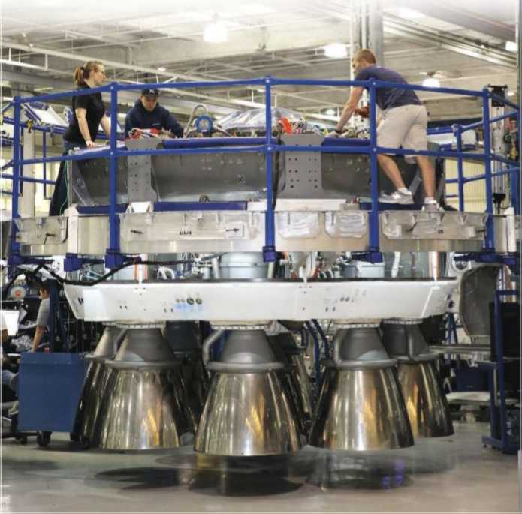
After two flawless missions in December and January, during which the SpaceX Falcon 9 rocket sent its first commercial payloads to geosynchronous transfer orbit (GTO), SpaceX is poised to take on established industry heavyweights, notably the European Ariane 5. The missions could also enable SpaceX to compete this year for launches of national security payloads that, until now, have been the sole proprietorship of the Boeing-Lockheed Martin joint venture United Launch Al liance, which manages government missions of the Delta 4 and Atlas 5 rockets.
SpaceX builds 70% of the Falcon 9 rocket at its headquarters in Hawthorne, Calif.

As a result of the Falcon 9’s recent success, Musk is enjoying a degree of credibility with customers and competitors that he lacked as little as three months ago. At the same time, Musk— who is also the founder and CEO of Tesla Motors—is bracing for a relentless pace of satcom launches over the next 24 months, a manifest that will test SpaceX’s ability to compete seriously for the 20-plus commercial satellites launched to GTO each year.
“We’ve got to build a lot of rockets, and launch a lot of rockets, and do each one as perfectly as possible,” Musk tells Aviation Week, touting SpaceX’s commercial and government missions as a means to fund the company’s loftier ambitions, including reusable rocket cores that could radically lower the cost of launch, and a new staged-combustion engine he hopes to begin testing at NASA’s Stennis Space Center in Mississippi this year. “I want to make sure we don’t lose sight of the reason we’re doing these launches. But at the same time, we’re going to ramp up our operational missions,”he says.
After suffering repeated setbacks in fielding new Merlin 1D engines for the Falcon 9, the SpaceX manifest is loaded with 15 launches this year, four of which are expected to slip into 2015. Next year’s manifest is even heavier, with 15 launches listed, excluding 2014 missions that are likely to shift. With some $5 billion in contracts to date and roughly 70% of the Falcon 9 produced in-house, Musk says one of his biggest challenges will be doubling the company’s current production rate of Falcon 9 cores.
“Within a year, we need to get it from where it is right now, which is about a rocket core every four weeks, to a rocket core every two weeks,” Musk says.
By the end of 2015, says SpaceX President Gwynne Shotwell, the company plans to ratchet up production to 40 cores per year.
“We’re right now on a schedule where we can produce the vehicles every month,” she says. “What we need to do is ramp up so we can meet our manifest for next year in time.”
Advertised at $56.5 million per launch, Falcon 9 missions to GTO cost almost $15 million less than a ride atop a Chinese Long March 3B and are competitive with the cost to launch a midsize satellite in the lower position on a European Ariane 5 ECA (see graphic on page 49).
Built by Airbus Defense and Space and managed by commercial launch service provider Arianespace, the Ariane 5 is arguably the most reliable rocket in the world. With a string of 58 consecutive successes, it commands more than 50% of the global commercial launch market today.
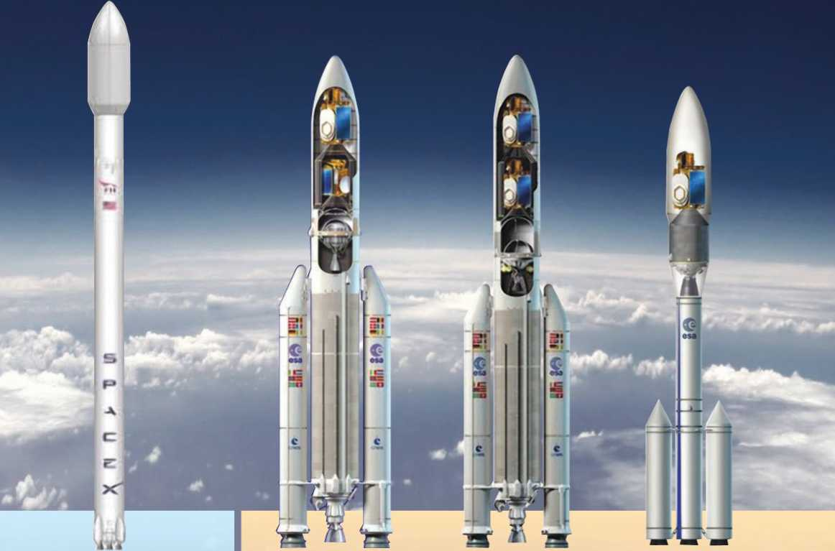

Falcon 9 v1.1

Manufacturer: SpaceX Operator: SpaceX
Payload Capacity to GTO: Up to 5,300 kg (11,685 lb.)
Price: $56.5 million Launches: 3
In December 2013, SpaceX launched its first mission to GTO, the 3,200-kg SES-8 commercial communications satellite, on a Falcon 9 v1.1, putting the low-cost rocket in direct competition for launch customers sized to ride in the lower position on Europe's Ariane 5 ECA. Beginning as early as next year, the larger Falcon Heavy is expected to compete for customers eligible for both the upper position on the Ariane 5 and the Russian Proton M/ Briz M, which is marketed by International Launch Services (ILS) for Moscow-based prime contractor Khrunichev. In the meantime, SpaceX says the Falcon 9 v1.1 will launch two midsize satellites for SES-both weighing around 5,300 kg—in 2015 and 2016, respectively. However, the company says the orbital dynamics of launching the Falcon 9 from Cape Canaveral (versus the Ariane 5 at the Equator) mean the two spacecraft are likely to sacrifice onboard fuel—and corresponding mission life—to reach operational orbit.

Ariane 5 ECA

Manufacturer: Airbus Defense and Space
Operator: Arianespace Payload Capacity to GTO: 10,000 kg (22,000 lb.)
Price: Varies, depending on satellite position Launches: 53
With no launch failures since 2002, the highly reliable Ariane 5 ECA launches two satellites at a time-one medium, one large—for a total capacity of 10,000 kg to GTO at a combined cost of well over $100 million. Launch prices vary, and the customer riding in the lower position generally pays less per kilogram than the larger communications satellite up top. Another factor to consider: The Ariane family of launchers lifts off from French Guiana, 5.3 deg. from the Equator, affording more boost for your buck.

Ariane 5 ME

Manufacturer: Airbus Defense and Space
Operator: Arianespace Payload Capacity to GTO: 11,000 kg (22,200 lb.)
Price: Comparable to Ariane 5 ECA today First flight: Mid-2018
A midlife upgrade to the Ariane 5 ECA is designed to yield a 20% bump in performance with no corresponding increase in cost. Equipped with a restartable upper stage engine, Airbus says the ME will easily be able to loft two 5,500-kg satellites to GTO—and could do more, though a commitment to the European Space Agency to deorbit the upper stage after each mission means diverting power that could otherwise launch heavier spacecraft. In combination with extra room under the payload fairing, the ME is positioned to compete for dual launches of new all-electric satellites, which weigh less than conventional spacecraft but take up more space.

Ariane 6

Manufacturer: TBD Operator: Arianespace Payload Capacity to GTO: 6,500 kg (14,330 lb.)
Price: $95 million First flight: 2021
The next-generation Ariane 6 is Europe's answer to the Falcon 9: With a target price of $95 million per launch, the new vehicle is supposed to keep Arianespace competitive in the global market while reducing Europe's reliance on commercial launches to maintain independent access to space. As a cost-saving measure, the Ariane 6 will share a common upper stage with the Ariane 5 ME. In addition, four identical solid-rocket boosters that make up the first and second stages of the Ariane 6 will help keep production costs low, yet offer the potential to grow in size to launch larger payloads in the future. Although less capable than its predecessor, the Ariane 6 also has the advantage of conducting single-satellite missions, which Arianespace says are easier to coordinate than dual launches required by the Ariane 5 today.
Since 2005, Arianespace has improved its competitiveness to such an extent that some €200 million ($273 million) in annual subsidies from the 20-nation European Space Agency (ESA) have been halved. In addition, the reliability of the Ariane 5 has allowed the company to increase launch prices, though it has also reduced costs as the result of a recent bulk buy of 18 Ariane 5 rockets that saved more than 5% on the order.
As SpaceX and other launch contenders enter the sector—including new rockets in India, China and Russia—Europe is also investing in a midlife upgrade of the Ariane 5, the Ariane 5 ME, which aims to boost performance 20% with no corresponding increase in cost. At the same time, Europe is considering funding a smaller, less capable but more affordable successor to the heavy-lift launcher, the Ariane 6, which would send up to 6,500 kg (14,330 lb.) to GTO for around $95 million per launch.
ESA is expected to decide in December whether to pursue development of the three-stage rocket, which uses three solid boosters as its core, an almost identical solid booster for the second stage and a restartable cryogenic third stage that is now in development for Ariane 5 ME.
But the Falcon 9 is not just changing the way launch-vehicle providers do business; its reach has gone further, prompting satellite makers and commercial fleet operators to retool business plans in response to the low- cost rocket. In March 2012, Boeing announced the start of a new line of all-electric telecommunications spacecraft, the 702SP, which are designed to launch in pairs on a Falcon 9 v1.1. Anchor customers Asia Broadcast Satellite (ABS) of Hong Kong and Mexico’s SatMex plan to loft the first two of four such spacecraft on a Falcon 9 in December in a launch window that opens this year, though SatMex owner Eutelsat said last month that the launch has moved to early 2015.
Using electric rather than chemical propulsion will mean the satellites take months, rather than weeks, to reach their final orbital destination. But because all-electric spacecraft are about 40% lighter than their conventional counterparts, the cost to launch them is considerably less than that for a chemically propelled satellite.
Since unveiling its new line of satellites, Boeing has yet to secure additional customers for an electric 702SP. Nonetheless, other spacecraft manufacturers, some with backing from commercial fleet operators, are following Boeing’s lead. In Europe, ESA and French space agency CNES are investing in the Neosat satellite platform, an electric propulsion system for geostationary missions.
Satellite fleet operator SES is also contracting with ESA and manufacturer OHB AG of Germany to design an all-electric comsat under ESA’s Electra program.
Combined with the low-cost Falcon 9 launches, Boeing’s all-electric spacecraft make for a formidable pairing against the Ariane 5 ECA. But European industry officials argue that the midlife upgrade of the rocket and its new restartable upper stage will position Europe to compete for dual launches of all-electric spacecraft, including the ability to carry electric payloads closer to their operational orbit than the Falcon 9, at no additional cost.
Meanwhile, as ESA ministers mull whether to approve what is expected to be at least €4 billion in new money for the Ariane 6, ESA Director General Jean-Jacques Dordain is aiming to reduce the agency’s development and operational costs in a stark departure from past practice: Until now, the Ariane family of rockets has been built largely with money contributed by ESA governments seeking to participate in the program rather than through competitive industry bids. This means governments commit multiyear funding to the development with the expectation of a roughly 90% return on investment in the form of industrial workshare.
But in July, when Dordain presents ESA’s member states with industry proposals for building the Ariane 6, he will seek government contributions based on the best value for money, not geographic return on investment.
“To have competitive launchers, we need to rethink the launch sector in Europe,” Dordain emphasizes.
Francois Auque, head of the space systems division at Airbus Defense and Space, says if ESA would allow industry to design rockets the same way the French defense ministry allows their contractors to manage the M51 ballistic missile program, “the cost would be much lower.”
Auque says he admires Musk’s approach to manufacturing the Falcon 9, the first stage of which was initially powered by nine Merlin 1 engines developed for the now-retired Falcon 1 light-launcher.
“It’s a classic industrial strategy, rather than a technology strategy” Auque said last December. “In Europe, they would have had a multibillion development program to create a new engine that is nine times the power of the current one.”
Musk agrees that the Falcon 9 has not stretched the envelope to revolutionize rocket technology. Nonetheless, he says the launcher is a leg up over the competition.
“If we’re building a rocket from scratch, in Los Angeles, with extremely high labor rates, and we’re still beating the Chinese and the Russians, there must be something in the technology that’s good,” he says.
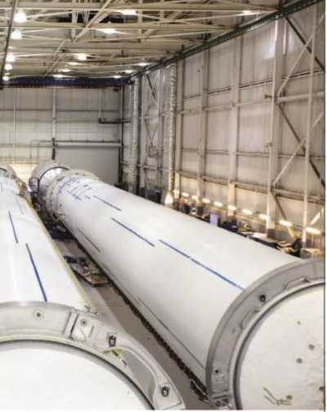
If SpaceX can achieve its shortterm goal of developing a fully and rapidly reusable first-stage booster, “then I think that has revolutionary potential,” Musk says. “I really encourage the other rocket makers to go and re-baseline their plans to include reusability. Otherwise, their rockets are not going to be able to compete.”
That will be no easy task, given the mass tradeoffs associated with protecting rocket hardware from the devastating effects of atmospheric reentry, as well as the damage caused by saltwater during ocean landings.
Last year, SpaceX attempted a propulsively controlled reentry over the Pacific Ocean following the Falcon 9 v1.1’s Sept. 29 qualification flight from Vandenberg AFB, Calif. Part of the company’s longer-term goal of reusing launch stages, Musk gave the attempt only a slim chance of working. The rocket booster re-lit twice, but in a post-launch missive on Twitter, he said the vehicle “spun up due to aero torque, so fuel centrifuged and we flamed out.”
Initial tests of a vertical-landing and recovery system have been conducted at SpaceX’s test site in McGregor, Texas, using the Grasshopper demonstrator, a Merlin lD-powered first stage. More recently, Grasshopper took the vehicle to 820 ft. and included a lateral transfer of some 330 ft. The company plans to move on to tests of a larger version of the Grasshopper, also called the Falcon 9R (reusable). Instead of a single Merlin 1D, the vl.l successor will have nine IDs. Testing will be conducted at a specially constructed site at Spaceport America in New Mexico.
Next week SpaceX plans to fly a set of four new “landing legs” on the Falcon 9’s fourth resupply run to the ISS. The mission is one of a dozen cargo runs the company is conducting for NASA under a $1.6 billion fixed-price contract awarded in December 2008 that calls for the Falcon 9 and its Dragon cargo capsule to deliver 20,000 kg to the orbiting outpost by the end of 2015.
Shotwell says the March 16 mission will see the first stage land in the Atlantic Ocean downrange from the SpaceX launch site at Cape Canaveral. She says the goal is to fly and recover a first- stage booster on land this year.
“We’ll do a lot of incremental testing, and we’ll go from flying downrange, or basically recovering it from the water downrange, to doing some boost-back maneuvers that incrementally get us closer to land,” she says. “We have a goal—I’m not saying we’re going to achieve it, but we’re working toward the goal of landing a first stage on land this year.”
Shotwell said the legs do not weigh much, and that mass trades are negligible on the first stage. “The mass of the recovery hardware is not a dramatic impact on payload performance,” she says. “What impacts is the fuel we need to reserve to execute the reentry and the landing burns.”
Conservatively, she says, the first- stage mass trade is roughly 1:10. “If I put 1,000 pounds on the first stage, I’m only losing 100 pounds of payload or so to orbit,” she notes.
Previously scheduled for Feb. 22, the NASA launch marks the first of four such missions SpaceX will conduct this year. But whether SpaceX can perform under the terms of its NASA cargo resupply agreement without disrupting the flow of its commercial manifest remains to be seen. For comparison, Arianespace typically lofts just one or two government missions annually on the Ariane 5 rocket—missions that often take priority over commercial launches.
However, Shotwell says SpaceX executes its launch schedule on a first- come, first-served basis and is planning to add capacity to its Florida launch site.
“Our customers understand if there’s an emergency on the space station, we may have to move things around,” she says. “But we’re also planning our operations to have extra capacity at our launch site. So if we have to move stuff around, we’re hoping to still get our customers in in the month that they’re looking to fly.”
Whether Musk can continue charging bargain-basement prices for Falcon 9—and ultimately Falcon Heavy—missions is another matter that SpaceX competitors and customers are closely watching.
Arianespace Chairman and CEO Stephane Israel has repeatedly pointed to SpaceX’s $1.6 billion NASA contract as keeping the company’s commercial missions at an artificially low price-point. In January, he questioned whether SpaceX can maintain such pricing when it charges $120-140 for U.S. government missions.
“That’s wishful thinking on their part,” Musk says, adding that the acid test for the NASA contract is whether Arianespace could execute the terms of the NASA agreement for the agreed-to price. “Arianespace would go bankrupt faster if they got our NASA contract.”
Musk says NASA pays $120 million for each SpaceX cargo flight to the space station, which includes launches of the recoverable Dragon cargo ship atop a Falcon 9, as well as the cargoladen spacecraft’s return to Earth. “That is the total cost, there’s not anything additional,” he says.
Last month, SpaceX moved a step closer to bidding for U.S. national security launch contracts when the Air Force announced that the Sept. 29 debut of the Falcon 9 v1.1 will count as the first of three launches needed to qualify the rocket. The Air Force signed a deal in December with ULA for the purchase of up to 50 rocket cores under the service’s Evolved, Expendable Launch Vehicle program; 14 will be open for competition with SpaceX starting this year.
“It should happen this year, in time to compete for the first round of the EELV,” Shotwell says, despite having “much stricter” requirements than the Air Force imposed on Boeing and Lockheed when they sought Air Force certification more than a decade ago for lofting spy satellites into orbit. “We anticipate awards in the fourth quarter of calendar year 2014,” she notes.
In the meantime, SpaceX is preparing to test and qualify the Falcon Heavy next year. The rocket will use Falcon 9 cores for a combined 27 engines to power its first stage. Although slated to debut in 2014, Musk says the company’s production schedule is too tight to support a test flight in 2014.
“We need to find three additional cores that we could produce, send them through testing and then fly without disrupting our launch manifest,” Musk says. “I’m hopeful we’ll have Falcon Heavy cores produced approximately around the end of the year. But just to get through test and qualification, I think it’s probably going to be sometime early next year when we launch.”

Испытание

SpaceX’s и их амбиции в секторе коммерческих запусков и государственных заказов

Эми Свитак Париж и Мюнхен
В ближайшие 10 лет, Илон Маск хочет отправить людей на Марс. К концу этого десятилетия, 42-летний генеральный директор и главный конструктор компании SpaseX, планирует отправить астронавтов на Международную космическую станцию (МКС). А в следующем году, с первым запуском новой ракеты Falcon Heavy, Маск нацеливается на использование многоразовых блоков первой ступени, которые могли бы существенно снизить стоимости запусков ракет.
Но для Маска, который основал SpaceX 12 лет назад с целью колонизация других планет, ближайшее будущее будет посвящено более обыденной задаче, запуску коммерческих спутников.
После двух успешнейших миссий в декабре и январе, в течении которых ракета-носитель SpaceX Falcon 9 отправила на геостационарную переходную орбиту (ГПО) первые коммерческие полезные грузы, SpaceX готова наравне тягаться, с другими крупными ракетами, в частности с европейской Ариан 5. Эти миссии также могут позволить SpaceX конкурировать за запуски грузов государственной обороны, до нынешнего момента исключительным правом на это, обладала созданная совместно с Боинг и Локхид Мартин компания United Launch Alliance (ULA). Которая совершает полеты по заказу государства на ракето-носителях Дельта-4 и Атлас 5.

После недавнего успеха Falcon 9, Маск остался удовлетворенным степенью доверия проявленного клиентами и конкурентами компании, которого так не хватало каких-то 3 месяцев назад. В то же время, Маск который также является основателем и генеральным директором Tesla Motors, готовится к стремительному росту запусков с системами спутниковой связи на борту в течении следующих 24 месяцев, текущий план запусков SpaseX оценит ее возможности претендовать на право проведения запусков более 20 коммерческих спутников на ГПО ежегодно.

"Мы должны строить и запускать много ракет, и делать каждую из них совершенной насколько это можно."-сообщил Маск Aviation Week, совершая коммерческие и государственные миссии, SpaceX получает средства для реализации собственных, более высоких амбиций, и в том числе разработки многоразовых блоков ускорителя, которые снизят стоимость запусков и новых двигателей со ступенчатым сгоранием. Он надеется начать его испытание в космическом центре НАСА им. Стенниса в штате Миссисипи уже в этом году. "Я хочу убедить, что мы не имеем никаких оснований, по которым эти запуски могут не состояться. Но в то же время мы собираемся нарастить количество наших запусков."-говорит он.

Потерпев повторные неудачи по оснащению Falcon 9 новыми двигателями Merlin 1D. План запусков SpaceX на нынешний год рассчитан на 15 пусков, 4 из которых как ожидается могут состояться в 2015 г. План на следующий год еще более насыщен: 15 запусков за исключением запусков 2014 года, которые скорее всего будут передвинуты по графику. В настоящее время имея 5 миллиардные контракты и то, что Falcon 9 приблизительно на 70 % изготавливается самим предприятием , одной из наиболее больших проблем будет удвоение текущих темпов производства блоков Falcon 9.

"В течении года нам потребуется изготовлять по одному блоку каждые две недели, вместо четырех недель."-говорит Маск.

К концу 2015 года, как заявляет президент SpaceX Гвинн Шотуэлл, компания намерена нарастить производство до 40 блоков ежегодно.

При наших темпах производства, мы можем производить по одной ракете каждый месяц."- говорит она. Необходимо увеличить ее таким образом, чтобы удовлетворить план запусков по времени на следующий год.

Falcon 9 v1.1
Изготовитель: SpaceX.
Эксплуатирующая компания: SpaceX.
Масса полезной нагрузки на ГПО: до 5300 кг (11685 фунтов).
Стоимость: $56.5 миллионов.
Количество запусков: 3.
В декабре 2013, SpaceX произвела ее первый запуск на ГПО, с коммерческим спутником связи SES-8 массой 3200 кг. Что сделало ее дешевым конкурентом европейской Ariane 5 ECA, за право запускать грузы заказчиков на низкие орбиты. В начале следующего года, ожидается что больший по размерам ракета-носитель Falcon Heavy сможет конкурировать за полеты на более высокие орбиты с Ariane 5 и российским Proton M/ Briz M , которые сбываются на рынке компанией International Launch Services (ILS) для московского предприятия им. Хруничева. Между тем, SpaceX сообщает что Falcon 9 v1.1 запустит два среднеразмерных спутника для SES, оба весом около 5300 кг 2015 году и 2016, соответственно. Тем не менее, как утверждает компания, орбитальная динамика полета Falcon 9 с мыса Канаверал (по сравнению с Ariane 5 на экваторе), потребует от двух космических кораблей большего количества топлива на борту, и соответствующей надежности для достижения рабочей орбиты.

Ariane 5 ECA
Изготовитель: Airbus Defense and Space.
Эксплуатирующая компания: Arianespace.
Масса полезной нагрузки на ГПО: 10000 кг (22000 фунтов).
Стоимость: варьируется, в зависимости от положения спутника .
Количество запусков: 53.
В отсутствии неудачных запусков, начиная с 2002 года, надежный Ariane 5 ECA, доставляет по два спутника за полет один средний и один большой, общей массой 10000 кг на ГПО, общие расходы значительно превышают $100 миллионов. Цена одного запуска за кг доставляемого груза различная, в зависимости от массы и высоты полета. Еще один фактор по которой стоит рассматривать семейство ракет Ариан состоит в том, что они стартуют из Французской Гвианы, 5,3 град. от экватора, что удешевляет запуск.

Ariane 5 ME
Изготовитель: Airbus Defense and Space.
Эксплуатирующая компания: Arianespace.
Масса полезной нагрузки на ГПО: 11000 кг (22200 фунтов).
Стоимость: на сегодняшний день цена сопоставима с Ariane 5 ECA.
Первый запуск: намечен на середину 2018.
Промежуточная модернизация Ariane 5 ECA, позволила повысить eе производительность на 20% при неизменной стоимости. Оснащенный многоразовыми двигателями верхней ступени он сможет легко запустить два 5500 кг спутника на ГПО, по заявлению Airbus, и мог бы больше, если не обязательства перед Европейским космическим агентством, об уводе с орбиты верхней ступени после каждого запуска, что означает, отбор энергии, которая могла бы пойти на запуск более тяжелого космического аппарата. В сочетании с дополнительным отсеком под головным обтекателем, ME позиционируют в качестве кандидата на право запуска новых полностью электрических спутников, которые весят меньше обыкновенного космического аппарата, но занимают больше места.

Ariane 6
Изготовитель: TBD.
Эксплуатирующая компания: Arianespace.
Масса полезной нагрузки на ГПО: 6500 кг (14330 фунтов).
Стоимость: $95 миллионов.
Первый запуск: намечен на 2021 г.
Ракета-носитель нового поколения Ariane 6, ответ Европы на американский Falcon 9 с прогнозируемой ценой в $95 миллионов за один запуск, который должен поддержать конкурентоспособность Arianespace на мировом рынке при одновременном снижении зависимости Европы от коммерческих запусков и сохранить независимый доступ в космическое пространство. В экономических соображениях, Ariane 6 будет иметь общую верхнюю ступень с Ariane 5 ME. К тому же, четыре одинаковых твердотопливных ускорителя, составляющую первую и вторую ступени Ariane 6 помогут сохранить низкую себестоимость продукции, и потенциально могут быть увеличены для запуска все более крупных грузов в будущем. Хотя, и менее грузоподъемный по сравнению с предшественником, Ariane 6 также имеет преимущество, касательно проведения миссий с одним спутником на борту, подобные миссии координируются легче, чем с двумя спутниками, требующие на сегодняшний день Ariane 5, сообщает Arianespace.

Объявленная стоимость одного запуска Falcon 9 оценивается в $56.5 миллион на ГПО, это почти на $15 млн. дешевле стоимости запуска китайского Chinese Long March 3B и составляет конкуренцию за право доставки спутников среднего размера на низкую орбиту с европейской Ariane 5 ECA. (смотри стр.49)

Построенный компанией "Airbus Defense and Space" и эксплуатируемая Arianespace, Ariane 5 является, пожалуй, самым надежной ракетой в мире. Имея на счету череду из 58 успешных запусков, она контролирует более 50% мировых коммерческих запусков на сегодняшний день.
Начиная с 2005 года, Arianespace повысила свою конкурентоспособную позицию настолько, что около €200 миллионов ($ 273 млн.) ежегодных субсидий от Европейского космического агентства (ЕКА) состоящий из 20 стран были сокращены наполовину. Вдобавок, надежность Ariane 5 позволило компании повысить цены на запуск, хотя они также сократили расходы в результате большой закупки сразу 18-ти ракет Ariane 5, это помогло сэкономить более 5% от общего заказа.

Как и SpaceX, другие претенденты вступают в борьбу за право проведения космических запусков, включая новые ракеты из Индии, Китая, и России- Европа также инвестирует в промежуточную модернизацию Ariane 5 и Ariane 5 ME, которые направлены на повышение характеристик ракеты на 20 %, без увеличения стоимости. В то же время, Европа рассматривает финансирование меньшего по размерам и грузоподъемности, но более доступного тяжелого носителя Ariane 6, который сможет доставить груз массой от 6500 кг (14330 фунтов) на ГПО, примерно за $95 млн. за один полет.

В декабре ЕКА примет решение, о том следует ли продолжать разработку трехступенчатой ракеты Ariane 5 ME, использующей три твердотопливных ускорителя в качестве стартового разгонного блока, почти идентичную ему вторую ступень, и многоразовую третью ступень на криогенных компонентах.

Falcon 9 не только изменил механизмы ведения коммерческой деятельности производителей ракеты-носителей, но и пошел дальше, побудив производителей спутникового оборудования и коммерческих грузовых операторов, изменить планы производства в связи с уменьшением цены ракеты-носителей. В марте 2012 года, компания Boeing объявила о старте новой линейки полностью электрифицированного телекоммуникационного космического корабля, 702SP, который разработан для запуска в паре с Falcon 9 v1.1. Якорные клиенты: гонконгская компания Asia Broadcast Satellite (ABS) и мексиканская SatMex планируют отправить первые два подобных космических аппарата на Falcon 9 в декабре во время стартового периода, который открывается в этом году, хотя Eutelsat владелец компании Satmex заявил, что перенес дату запуска на 2015 г.

Использование электрических двигателей, а не химических означает что спутникам для достижения необходимой орбиты потребуются месяцы, а не недели. Но поскольку все электрические космические аппараты примерно на 40% легче, чем их привычные аналоги, стоимость их доставки, значительно меньше, чем в случае со спутниками на химическом топливе.

С момента открытия новой линейки спутников, Boeing успел найти дополнительных клиентов на электрический спутник 702SP. Тем не менее, другие производители космических аппаратов, некоторые с поддержкой коммерческих грузовых операторов, стремятся за лидерством Boeing. В Европе ЕКА и Национальный центр космических исследований (CNES) вкладываются в спутниковые платформы Neosat на базе электрических двигателей для геостационарных миссий.

Оператор спутниковой системы SES также сотрудничает с ЕКА и с компанией OHB AG из германии для разработки полностью электрифицированного спутника связи в рамках программы ЕКА Electra.

В сочетании с низкой стоимостью запусков Falcon 9, полностью электрифицированные космические летательные аппараты Boeing-а составляют серьезную конкуренцию Ariane 5 ECA. Но европейские отраслевые чиновники утверждают, что промежуточная модернизация ракеты и ее новая многоразовая верхняя ступень сделает Европу конкурентоспособной для двойных запусков полностью электрифицированных космических летательных аппаратов, в том числе включая возможность доставки электрооборудования ближе к их рабочей орбите чем Falcon 9, без добавочной стоимости.

В то время как, руководство ЕКА ведет переговоры по выделению предполагаемой суммы в €4 млрд. на развитие ракеты-носителя Ariane 6, генеральный директор ЕКА Жан-Жак Дорден стремится уменьшить посредничество и эксплуатационные расходы, решительно отказавшись от предыдущих практик: До сих пор, семейство ракет Ariane строились в большинстве своем за счет средств полученных от руководства ЕКА, стремящегося принять участие в программе, а не за счет средств полученных на конкурсной основе. Это означает, что правительство берет на себя обязанности многолетнего финансирования развития в перспективе возвращения примерно 90% средств в виде прибыли от инвестиций.

Но в июле, когда Дорден будет выступать перед государствами-членами ЕКА с промышленным предложением о строительстве ракеты-носителя Ariane 6, он будет рассматривать только те правительственные взносы, которые лучше по соотношению цена-качество, а не на географическом доходе на инвестированный капитал.

"Для совершения конкурентных запусков, нам необходимо переосмыслить сектор запусков в Европе."-подчеркивает Дорден.

Франсуа Акве, начальник отдела космических систем подразделения Airbus Defense and Space, говорит, что во Франции министерство обороны позволяет своим разработчикам самим распоряжаться M51, программой разработки баллистических ракет, если ЕКА позволит своей отрасли сделать то же самое, то "стоимость будет значительно ниже".

Акве говорит, что восхищается подходами Маска, при производстве Falcon 9, первая ступень которого первоначально приводилась в движение девятью двигателями Merlin 1, разработанных для ныне не эксплуатируемой легкой пусковой установки Falcon 1.

"Это классическая промышленная стратегия, а не техническая". Сказал Акве в декабре прошлого года. "В Европе, они имели бы многомиллиардную программу развития, для создания новых двигателей, которые в девять раз превышали бы нынешних по мощности.

Маск соглашается, что Falcon 9 далеко не революция в ракетной технике. Тем не менее, по его словам его ускорители на порядок превосходят конкурентов.

"Если мы строим ракету с нуля в Лос-Анджелесе, хоть и с чрезвычайно высокими темпами труда и тем не менее опережаем китайцев и русских, должно быть это связано с технологиями и это здорово."-говорит он.

Если SpaceX может достичь своей краткосрочной цели развития многоразового ускорителя первой ступени полностью и быстро, "то я думаю, что это революционный потенциал,"- говорит Маск. "Я действительно призываю других производителей ракет пойти на изменение своих планов и заняться изготовлением многоразовых систем. В противном случае, их ракеты не будут конкурентоспособны."

Это будет не простой задачей, учитывающая массу компромиссных решений связанных с защитой спускаемых элементов ракеты от разрушительного атмосферного влияния, а также повреждений при посадки на океаническую соленую воду.

В прошлом году, SpaceX провела пробный спуск в атмосфере над Тихим океаном управляемый при помощи корректирующих двигателей после квалификационного полета Falcon 9 v1.1 29 сентября стартовавшего от калифорнийской военно-воздушной базы в Ванденберге. Часть долгосрочной цели компании по многоразовым разгонным блокам, попытка по словам Маска имела лишь небольшие шансы на успех. Ракетный ускоритель дважды загорелся, но в последовавшем сообщении в Twitter-е, он рассказал что летательный аппарат загорелся в следствии аэро-крутящего момента, который центрифугировал горючее.

Первоначальное испытание вертикальной посадки и системы возвращения были проведены в полигоне SpaceX в Макгрегоре, штат Техас, используя демонстратор Grasshopper с двигателем Merlin lD на первой ступени. Совсем недавно, Grasshopper поднял аппарат на 250 метров. И включая боковые ускорители на высоте 100 метров. Компания планирует перейти на тесты более крупной Grasshopper, также называемой Falcon 9R (многоразовая). Вместо одного Merlin 1D, 1.1 будет иметь девять двигателей lD. Тестирование будет проводиться в специально построенном космопорте "Америка" в Нью-Мехико.

На следующей неделе SpaceX планирует облет комплекта новых четырех опорных стоек на четвертой снаряженной миссии Falcon 9 на МКС. Это одна из дюжины миссий, которые проводятся компанией совместно с НАСА по контракту с фиксированной стоимостью в $1,6 млрд. подписанному в декабре 2008 г. SpaceX должна доставить на ракетоносителях Falcon 9 и на грузовом контейнере Dragon груз массой 20000 кг на заданную орбиту до 2015 г. Шотуэлл говорит что 16 марта можно будет увидеть приземление первой ступени в заданное место в Атлантическом океане. Запуск будет произведен с мыса Канаверал. Она говорит, что целью в этом году является полет и спуск ускорителя первой ступени на землю.

"Наша компания будет проводить все большее количество испытаний, начав c направленных спусков на определенные расстояния, или в основном на воду, и продолжит уже испытания выполняя маневрирование назад при помощи ускорителей, постепенно приближаясь к земле."-говорит она. "У нас есть цель, и я не говорю что мы достигнем ее этим, но будем работать в этом направлении, добиваясь посадки первой ступени на землю в этом году."

Шотуэлл сказала стойки не весят много, и что борьба с лишней массой для первой ступени не имеет столь существенного значения. "Масса возвращающих устройств серьезно не скажется на показателях грузоподъемности."-говорит она. "Вопрос в количестве топлива которое мы должны зарезервировать для посадки блоков на землю."

По ее словам это соотношение для первой ступени равно 1:10. "Если я закачаю 450 кг топлива для первой ступени, я потеряю 45 кг в качестве полезной нагрузки, или для вывода на орбиту,"-отмечает она.

Сообщается что по предварительным планам пусков от NASA составленных на 22 февраля первый из четырех таких миссий SpaceX пройдет в этом году. Но сможет ли SpaceX выполнить контрактные обязательства перед NASA по доставке грузов, не нарушая планы запусков коммерческих, вопрос остается не решенным. Для сравнения, Arianespace как правило совершает одну или две государственных миссии ежегодно на ракете Ariane 5, которые как правило приоритетнее коммерческих запусков.

Тем не менее, как говорит Шотуэлл, SpaceX выполняет свой график запусков по принципу "в порядке очереди" и планирует увеличить пропускную способность своего космодрома во Флориде.

"Наши клиенты понимают, если есть чрезвычайная ситуация на космической станции, нам, возможно, придется все пересмотреть,"-говорит она. "Но мы также планируем наши действия так, чтобы мы имели дополнительные возможности на нашем космодроме. Так что если все придется сдвинуть, мы надеемся все еще получить наших клиентов в течении месяца.

Сможет ли Маск продолжать выполнять заказы по бросовым ценам на Falcon 9, а в последующем на Falcon Heavy-совсем иной вопрос за которым внимательно наблюдают и конкуренты и сами клиенты.

Председатель и главный исполнительный директор Arianespace Стефан Израел неоднократно указывал на $1.6 миллиардный контракт между SpaceX и NASA в качестве гаранта низких цен коммерческих миссий. В январе, он задался вопросом, сможет ли SpaceX поддерживать подобные цены, когда они взимают по $120-140 за правительственные миссии США.

"С их стороны это попытка выдать желаемое за действительное", говорит Маск, и добавляет, а смог бы Arianespace сам выполнить условия по договору NASA по нынешней цене. "Arianespace незамедлительно обанкротился бы."

Маск говорит, что НАСА платит $120 миллионов за каждый грузовй рейс SpaceX доставленный к МКС, включая запуски грузового Dragon на Falcon 9, также за возвращения летательного аппарата на Землю. "Это общая стоимость, нет ничего дополнительного."-говорит он.

В прошлом месяце, SpaceX приблизился на шаг к соглашению запусков для министерства обороны США, когда ВВС объявили, что 29 сентября станет дебютной для Falcon 9 v1.1 и будет одной из трех квалификационных запусков. ВВС подписали контракт в декабре с ULA на покупку до 50 блоков ракет для программ Evolved, Expendable Launch Vehicle и 14 других программ.

"Это должно произойти в этом году, в первом туре конкурса EELV," Шотуэлл говорит, несмотря на то, что требования гораздо более строгие чем ВВС предъявляла Boeing и Lockheed-у, когда они добивались сертификации ВВС более десяти лет назад для выведения спутников-шпионов. "Мы рассчитываем на награды в четвертом квартале 2014 календарного года",- отмечает она.

В то же время, SpaceX готовиться проверить и квалифицировать Falcon Heavy в следующем году. Ракета будет использовать разгонный блок от Falcon 9 объединенных с 27 двигателями на первой ступени. Хотя дебют ракеты должен состояться в 2014 году, как заявляет Маск график компании слишком туг для осуществления испытательного полета в 2014 году.

"Нам нужно еще три дополнительных блока, для того чтобы мы смогли испытать и запустить не нарушая остальной план запусков",-говорит Маск. Я надеюсь, мы будем иметь возможность изготовить блоки для Falcon Heavy к концу года. Но в связи с ее испытаниями и квалификацией, вероятно, что ее запуск произойдет лишь в начале следующего года."

Russian Rockets

ISS is unaffected by Crimea sanctions and international saber-rattling

Frank Morring, Jr. Washington
The U.S.-Russian chill over Moscow’s invasion of Ukraine’s Crimean Peninsula so far has not extended to civil space operations, including last week’s launch of another NASA astronaut to the International Space Station (ISS) on a Russian Soyuz rocket.
Steve Swanson lifted off on Soyuz TMA-12M alongside cosmonauts Alexander Skvortsov and Oleg Artemyev March 25 for the trip to the ISS (see photo), after autographing their doors in the crew quarters at Baikonur Cosmodrome and carrying out other Russian spaceflight rituals.
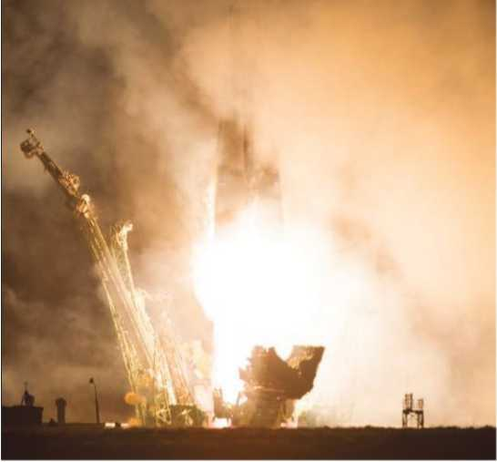
As Western leaders plot new ways to sanction their Russian counterparts over Crimea, U.S. companies that depend on Russia—and Ukraine—for space hardware are conducting business as usual. The U.S. government is as well, at least as represented by NASA. Swanson’s ride and training cost the U.S. space agency $70.6 million as part of a six-seat-per-year deal that runs through 2016. As it prepares to shift to U.S.-built commercial vehicles for transporting U.S. and non-Russian crew to the station, NASA is negotiating with Russian space agency Roscosmos for enough Soyuz seats to bridge the gap through 2017, including return and rescue flights into 2018.
“NASA and Roscosmos will continue to work with each other to maintain the space station, where humans have lived continuously for more than 13 years, and we are confident that our two space agencies will continue to work closely as they have throughout various ups and downs of the broader U.S.- Russia relationship,” NASA says when asked if the geopolitical tensions have hampered its work with Russia.
The Soyuz docking with the ISS was delayed when a planned rendezvous maneuver failed to occur, and U.S. and Russian flight controllers tackled the problem together. As they worked, a classified National Reconnaissance Office payload was in final preparation for its launch from Cape Canaveral on a United Launch Alliance (ULA) Atlas V with a Russian- built RD-180 kerosene-fueled rocket engine as its main-stage propulsion system. The two-nozzle engine, a variant of the four-nozzle RD-170 built by NPO Energomash, has been powering Atlas launch vehicles since 2000, and ULA intends to keep using Energomash-built engines as long as possible.
Air Force Secretary Deborah Lee James says a review of RD-180 availability is underway, with results expected “by the end of May.” A ULA spokeswoman notes the company and the RD Amross joint venture of United Technologies Corp. and Energomash that supplies the Atlas V engines “have a 20-year relationship for which all commitments have been honored.” RD Amross maintains a two-year supply of RD- 180s “to minimize potential supply disruptions,” it says, and could acquire U.S.-produced versions of the engines if necessary (AW&ST March 24, p. 28). It also could launch “critical national security payloads” on its Delta IV rocket, ULA says.
Orbital Sciences Corp. uses the AJ-26, a Russian-built, U.S.-modified, kerosene-fueled rocket engine as main-stage propulsion for its new Antares rocket, which flies with a first stage developed and built in eastern Ukraine under NASA’s
Commercial Orbital Transportation Services development and Commercial Resupply Services ISS cargo-delivery efforts. Orbital says it has the necessary Russian and Ukrainian hardware on hand to fly cargo to the space station into early 2015 (AW&ST March 3, p. 12) and is looking for an alternative to the AJ-26, which is based on the out-of-production Russian NK-33.
Orbital reports it has enough AJ-26 engines to support launches through 2016, and David Thompson, Orbital chairman, president and CEO, says the “process of assessing alternatives is well underway.” In a Feb. 13 conference call, Thompson told analysts he should have more to say on the search for alternatives to the AJ-26 subject in April. One of those alternatives is the RD-180, and Orbital has dropped an anti-trust lawsuit it filed against ULA and AD Amross over access to the engine.
“The parties will not undertake to negotiate a business resolution for Orbital’s access to the RD-180 rocket engine, subject to all necessary approvals from the U.S. and Russian governments,” Orbital says in a March 30 Securities and Exchange Commission filing.

Российские ракеты
МКС не зависит от крымских санкций и международного разжигания войны
Френк Морринг, Jr. Washington
Взаимная неприязнь между США и Россией возникшая в результате вторжения Москвы на Крымский полуостров Украины до сих пор никак не отразилась на гражданские космические операции, включая запуск российской ракеты-носителя "Союз" для доставку астронавта НАСА на Международную космическую станцию (МКС).
Стив Суонсон стартовал на ракете "Союз ТМА-12М" к МКС наряду с космонавтами Александром Скворцовым и Олегом Артемьевым 25 марта (см. фото), после того как оставил свой автограф на двери каюты экипажа в Байконуре с соблюдением других предполетных российских традиций.
В то время, пока западные лидеры планируют воздействовать на своих российских коллег из-за ситуации в Крыму, американские компании зависят от России и Украины и продолжают вести бизнес в космической отрасли. Также как и правительство США, в лице НАСА. Полет и обучение Суонсона стоили Американскому космическому агенству в 70.6 миллионов долларов, в рамках сделки по доставке ежегодно шести мест, действующая до 2016 года. В то время пока планируется перейти на использование собственных космических кораблей для доставки американского и не российского экипажа на станцию, НАСА ведет переговоры с российским космическим агентством Роскосмос по поводу получения достаточных мест на Союзах, чтобы преодолеть отставание к 2017 году, в том числе обратных полетов и спасательных рейсов в 2018.
"Наса и Роскосмос продолжают работать друг с другом для поддержания космической станции, где на протяжении более 13 лет живут люди, и мы уверены, что два наших космических агентства будут продолжать работать в тесном контакте, как это было несмотря на взлеты и падения российско-американских отношений."-отвечает НАСА на вопрос о том что, если геополитическая обстановка воспрепятствует их работе Россией.
Стыковка Союза с МКС была отложена, когда запланированного маневра сближения не произошло, и летным диспетчерам США и России пришлось решать проблему вместе. Как они работали над предстартовой подготовкой секретного груза Национального управления военно-космической разведки США, запуск которого состоялся с мыса Канаверал на ракете-носителе компании United Launch Alliance (ULA) Атлас V с российским двигателем РД-180 на керосине в качестве основного разгонного блока. Двигатель с двумя соплами, один из вариантов двигателя с четырьмя соплами РД-170, построенный НПО "Энергомаш", используется на ракета-носителях Атлас с 2000 года, и ULA намеревается продолжить использование двигателей Энергомаша как можно дольше.
Министр ВВС Дебора Ли Джеймс говорит что обзор доступности РД-180 на стадии реализации и будет закончено к концу мая. Представительница ULA отмечает что компания и предприятие RD Amross образованное совместно с United Technologies Corp. и Энергомашем, который поставляет двигатели для Atlas V "имеют 20-летние отношения, в которых все обязательства были выполнены." RD Amross будет продолжать поставку РД 180s следующие два года, "чтобы минимизировать потенциальные сбои поставок,"-говорит он, и может приобрести сделанные в США версии двигателей если это потребуется (AW&ST 24 марта стр. 28). Он также может начать запуски "критических грузов" национальной безопасности на ракета-носителях Дельта IV, сообщает ULA.
Orbital Sciences Corp. использует двигатели AJ-26 на керосине в качестве главной ступени для их новой ракеты-носителя Антарес, которые построены в России и модифицированы в США. Антарес использует первую ступень разработанную и построенную в восточной Украине в рамках программ НАСА по проведению коммерческих услуг орбитальной транспортировки и услуг снабжения МКС и усилий по доставке грузов. Orbital Sciences сообщает, что у них под рукой имеются все необходимые российские и украинские аппаратные средства для доставки грузов до МКС на начало 2015 года (AW&ST март 3, стр. 12) и ведутся поиски альтернативы AJ-26, который базируется на выведенном из эксплуатации российском двигателе NK-33.
Orbital Sciences сообщает также, что у них в наличии достаточно двигателей AJ-26 для осуществления запусков до 2016 года, и Дэвид Томпсон председатель, президент и главный исполнительный директор, говорит, что "процесс рассмотрения альтернативы идет полным ходом". В телефонной конференции 13 февраля, Томпсон потребовал от аналитиков более подробно отнестись к теме поиска альтернативы AJ-26 в апреле. Одним из этих вариантов является РД-180, и Orbital Sciences подала антимонопольный иск против ULA и AD Amross по поводу получения права на пользование двигателем.
"Стороны не возьмутся вести переговоры по поводу доступа Orbital Sciences к ракетному двигателю РД-180, пока не получат все необходимые разрешения от правительств России и США", сообщает Orbital Sciences при подаче документов комиссии по ценным бумагам и биржам 30 марта.

Глоссарий
№ п/п | Термин | Перевод | Определение
1 | Anti-trust | антимонопольный | относящийся к борьбе против чрезмерной монополизации рынка
2 | Absorptance | поглощательная способность | доля поглощаемого излучения на данной частоте при падении электромагнитного излучения на некоторое тело
3 | Acetic acid | уксусная кислота | органическое вещество с формулой CH3COOH
4 | Acrylic acid | акриловая кислота | СН2=СН−СООН — простейший представитель одноосновных непредельных карбоновых кислот
5 | Administrative area | административный округ | единица административно-территориального деления
6 | Aero torque | аэро-крутящий момент | крутящий момент возникающий при движении летательного аппарата в воздушном пространстве
7 | Aerospace engines | ракетно-космический двигатель | тип двигателя освоенный для вывода полезной нагрузки на орбиту и применения в условиях безвоздушного космического пространства
8 | Aerospike nozzle | сопло с центральным телом и дожиганием горючего в подводимом воздухе | сопло в котором газ течет по кольцевому каналу (между центральным телом и обечайкой) критическое сечение может регулироваться либо продольным перемещением центрального тела, либо поворотом створок на обечайке
9 | Air Force | военно-воздушные силы | вид Вооруженных сил (ВС) государства, в функции которого входит борьба с противником, находящимся в космосе, воздушном пространстве, на земле, на поверхности моря
10 | Air passage | воздухопровод | канал для перемещения воздуха
11 | AJ-26 | AJ-26 | семейство разработанных компанией Аэроджет и лицензированных в США модификаций двигателя НК-33
12 | Aluminum oxide | оксид алюминия | Al2O3 — бинарное соединение алюминия и кислорода
13 | Anchor customer | якорный клиент | клиент который позволяет прочно занять некоторую нишу в которой ведется предпринимательская работа
14 | Aniline | анилин | органическое соединение с формулой C6H5NH2, простейший ароматический амин
15 | Antifreeze | незамерзающая жидкость | общее название для жидкостей, не замерзающих при низких температурах
16 | Antimatter | антивещество | вещество, состоящее из античастиц, реально стабильно не образующееся в природе
17 | Antiproton | антипротон | античастица по отношению к протону
18 | Around the World in Eighty Days | название книги "Вокруг света за 80 дней" | популярный приключенческий роман французского писателя Жюля Верна
19 | Asteroid | астероид | относительно небольшое небесное тело Солнечной системы, движущееся по орбите вокруг Солнца
20 | Autoclave | автоклав | аппарат для проведения различных процессов при нагреве и под давлением выше атмосферного
21 | Baikonur Cosmodrome | космодром Байконур | крупнейший в мире космодром, расположенный на территории Казахстана
22 | Ballistic missile program | программа разработки баллистических ракет | программа реализуемая государством в целях повышения собственной обороноспособности
23 | Bearing | подшипник | сборочный узел, являющийся частью опоры или упора и поддерживающий вал, ось или иную подвижную конструкцию с заданной жёсткостью
24 | Beeswax | пчелиный воск | продукт жизнедеятельности пчёл
25 | Benzene | бензол | органическое химическое соединение, бесцветная жидкость со специфическим сладковатым запахом
26 | Biot number | число Био | один из критериев подобия стационарного теплообмена между твёрдым телом и окружающей средой, численно равный отношению коэффициента теплоотдачи к поверхности тела, умноженного на толщину тела, к коэффициенту его теплопроводности
27 | Blade | лопатка | деталь лопаточных машин, предназначенная для изменения в них параметров газа или жидкости
28 | Bloodstream | кровообращение | процесс циркуляции крови по организму
29 | Boiler | бойлер | водонагревающее устройство в системе снабжения теплом и горячей водой
30 | Boiling | кипение | процесс интенсивного парообразования, который происходит в жидкости, как на свободной её поверхности, так и внутри её структуры
31 | Boundary layer | пограничный слой | тонкий слой на поверхности обтекаемого тела или летательного аппарата (ЛА), в котором проявляется эффект вязкости
32 | Braze | припой | металл или сплав, применяемый при пайке для соединения заготовок и имеющий температуру плавления ниже, чем соединяемые металлы
33 | Brazing | пайка | технологическая операция, применяемая для получения неразъёмного соединения деталей из различных материалов путём введения между этими деталями расплавленного материала (припоя), имеющего более низкую температуру плавления, чем материал (материалы) соединяемых деталей
34 | Brazing filler | твёрдый припой | припой, в котором наполняющие металлы прочнее и плавятся при больших температурах
35 | Buoyancy | архимедова сила | подъемная сила возникающая в следствии закона Архимеда
36 | Caloric fluid | калорическая жидкость | термин применявшийся при описании тепловых явлений в восемнадцатом веке
37 | Cape Canaveral | мыс Канаверал | мыс на атлантическом побережье штата Флорида, на нём расположена станция ВВС США «Мыс Канаверал»
38 | Carbon dioxide | двуокись углерода | углеки́слый газ, окси́д углеро́да (IV), у́гольный ангидри́д
39 | Casting process | процесс литья | операция получения изделий, заключающийся в заполнении специальной емкости (формы), формирующей поверхность или часть поверхности изготавливаемого изделия, жидким материалом (металлы и неметаллы) с дальнейшим переходом жидкого материала в твердое агрегатное состояние
40 | Cathode | катод | электрод некоторого прибора, присоединённый к отрицательному полюсу источника тока.
41 | Ceramic core | керамический заполнитель | формообразующий элемент применяемый при литье
42 | Ceramics | керамика | изделия из неорганических материалов (например, глины) и их смесей с минеральными добавками, изготавливаемые под воздействием высокой температуры с последующим охлаждением
43 | Chemical reaction | химическая реакция | превращение одного или нескольких исходных веществ (реагентов) в другие вещества
44 | Chief executive officer | главный исполнительный директор | высшее должностное лицо компании
45 | Chrome bearing steel | хромистая сталь | сталь имеющая в своем составе примеси хрома
46 | Cire-perdue | фр. сир пердю | высококачественный способ отливки из бронзы скульптурных произведений
47 | Clausius’s statement | постулат Клау-зиуса | второе начало термодинамики по Клаузиусу
48 | Clay | глина | мелкозернистая осадочная горная порода
49 | Closed system | закрытая система | термодинамическая система, которая может обмениваться с окружающей средой теплом и энергией, но не веществом
50 | Coal | уголь | полезное ископаемое, вид топлива, образовавшийся из частей древних растений под землей без доступа кислорода
51 | Combustion | горение | сложный физико-химический процесс превращения исходных веществ в продукты сгорания в ходе экзотермических реакций, сопровождающийся интенсивным выделением тепла
52 | Combustion chamber | камера сгорания | объём, образованный совокупностью деталей двигателя или печи (в последнем случае камера сгорания называется топкой) в котором происходит сжигание горючей смеси или твёрдого топлива
53 | Compressor | компрессор | энергетическая машина или устройство для повышения давления (сжатия) и перемещения газообразных веществ
54 | Condensation | конденсация | переход вещества из газообразного в жидкое состояние
55 | Condenser | конденсатор | Прибор для конденсации жидкости
56 | Constant pressure process | изобарный процесс | термодинамический процесс, происходящий в системе при постоянном давлении и постоянной массе идеального газа
57 | Constant volume process | изохорный процесс | термодинамический процесс, который происходит при постоянном объёме
58 | Consumption | расход | количество жидкости (газа), протекающее в единицу времени через поперечное сечение потока
59 | Convection | конвекция | вид теплопередачи, при котором внутренняя энергия передается струями и потоками
60 | Convective-boiling | конвективное кипение | конвективные процессы сопровождающиеся кипением жидкости
61 | Convective motion | конвективное движение | вертикальное движение воздуха, обусловленное плавучестью, т. е. в конечном счете температурными условиями
62 | Cooling channels | охлаждающий канал | канал для протока охладителя в авиационной и автомобильной промышленности и др.
63 | copper | медь | Пластичный металл золотисто-розового цвета
64 | Corrosion resistance | коррозионная стойкость | способность материалов сопротивляться коррозии, определяющаяся скоростью коррозии в данных условиях
65 | Cosmic rays | космическое излучение | электромагнитное или корпускулярное излучение, имеющее внеземной
66 | Crimean Peninsula | полуостров Крым | полуостров в северной части Чёрного моря
67 | Cross-sectional area of molecule | площадь поперечного сечения молекулы | Площадь сечения сферы ограждения молекулы по большому кругу
68 | Carbon capture and storage | улавливание и хранение углерода | комплекс технологий, обеспечивающих снижение выбросов углекислого газа в атмосферу для снижения воздействия на климат
69 | Deforestation | обезлесивание | процесс превращения земель, занятых лесом, в земельные угодья без древесного покрова
70 | Density | плотность | скалярная физическая величина, определяемая как отношение массы тела к занимаемому этим телом объёму
71 | Deorbit | увод с орбиты | вывод с околоземной орбиты космического мусора и вышедших из строя космических аппаратов
72 | Differential equation | дифференциальное уравнение | уравнение, связывающее значение производной функции с самой функцией, значениями независимой переменной, числами
73 | Diffuse intense heat flows | рассеивание интенсивных тепловых потоков | по своей сути и есть процесс охлаждения
74 | Dissolve | расплавляться | приводить в расплавленное, жидкое агрегатное состояние
75 | distortion | искажение формы | изменения форм заготовок, часто носящие негативный характер
76 | Dropwise condensation | капельная конденсация | Конденсация при котором значительная часть поверхности охлаждения свободна от макроскопических слоев жидкости
77 | Electrical charge | электрический заряд | физическая скалярная величина, определяющая способность тел быть источником электромагнитных полей и принимать участие в электромагнитном взаимодействии
78 | Electrical insulation | электрическая изоляция | элемент конструкции оборудования, препятствующий прохождению через него электрического тока
79 | Electrical refrigerator | электрический холодильник | устройство, поддерживающее низкую температуру в теплоизолированной камере
80 | Electrical supply system | система электроснабжение | совокупность источников и систем преобразования, передачи и распределения электрической энергии
81 | Electromagnetic spectrum | электромагнитный спектр | совокупность всех диапазонов частот электромагнитного излучения
82 | Electron | электрон | стабильная, отрицательно заряженная элементарная частица
83 | Emission | выброс | выброс загрязняющего вещества
84 | Emittance | степень черноты (излучательности) | отношение энергии теплового излучения серого тела согласно Закону Стефана Больцмана, к излучению абсолютно черного тела при той же температуре
85 | Empirical law | эмпирический закон | закон, справедливость которого была установлена не из теоретических соображений, а из опытных данных
86 | Engine efficiency | коэффицие́нт поле́зного де́йствия двигателя | характеристика эффективности системы (устройства, машины) в отношении преобразования или передачи энергии
87 | Engine monitoring | контроль технического состояния двигателя | диагностирование состояния двигателя на предмет его неправильной работы или поломки
88 | English units | британская единица | единица измерения тепловой энергии в английской системе мер
89 | Enthalpy | энтальпия | термодинамический потенциал, характеризующий состояние системы
90 | Entropy | энтропия | функция состояния термодинамической системы, определяющая меру необратимого рассеивания энергии; в статистической физике энтропия является мерой вероятности осуществления какого-либо макроскопического состояния
91 | Equilibrium | равновесие | состояние системы, описываемой в естественных и гуманитарных науках
92 | Erosion | эрозия | разрушение поверхности металла механическими воздействиями
93 | Ethylene glycol | этиленгликоль | гликоль; 1,2-диоксиэтан; этандиол-1,2), HO—CH2—CH2—OH — двухатомный спирт, простейший представитель полиолов (многоатомных спиртов)
94 | Evaporation | испарение | процесс фазового перехода вещества из жидкого состояния в парообразное или газообразное
95 | Expendable | одноразовый | используемый единожды
96 | Fatigue crack | усталостная трещина | разрушение материала под действием повторно-переменных (часто циклических) напряжений
97 | Fission | распад | спонтанное изменение состава (заряда Z, массового числа A) или внутреннего строения нестабильных атомных ядер
98 | Flow-boiling | кипение в потоке | двухфазный поток жидкости, по-другому кавитация
99 | Forced convection | вынужденная конвекция | конвекция жидкости или газа в результате внешнего воздействия
100 | Fossil energy | ископаемое топливо | горючие соединения образованные в земной коре и добываемые в промышленных масштабах
101 | Fourier series | ряды Фурье | представление произвольной функции с периодом в виде рядов используемых для их анализа
102 | Fourier’s law | закон Фурье | закон теплопроводности сформулированный Фурье для установившегося режима плотности потока энергии
103 | Fourth of July | четвертое июля | здесь, день празднования независимости США
104 | Fuel efficiency | эффективность топлива | отношение расхода топлива (на единицу расстояния или времени) к мощности или к тяге
105 | Fuel system | топливная система | топливная система (другое наименование система питания топливом) предназначена для питания двигателей топливом, а также его хранения и очистки
106 | Fuel-gas | газообразное горючее | газообразные вещества, окисление которых сопровождается значительным выделением теплоты
107 | Fused silica | ква́рцевое стекло́, пла́вленый кварц | однокомпонентное стекло из чистого оксида кремния, получаемое плавлением природных разновидностей кремнезёма
108 | Gamma rays | гамма-излучение | вид электромагнитного излучения с чрезвычайно малой длиной волны — менее 2·10−10 м — и, вследствие этого, ярко выраженными корпускулярными и слабо выраженными волновыми свойствами
109 | Generator | генератор | устройство, производящее какие-либо продукты, вырабатывающее электроэнергию или преобразующее один вид энергии в другой
110 | Geostationary orbit | геостационарная орбита | круговая орбита, расположенная над экватором Земли
111 | Geosynchronous transfer orbit | геопереходная орбита | орбита, являющаяся переходной между низкой опорной орбитой (НОО) (высота порядка 200 км) и геостационарной орбитой (ГСО) (35 786 км); орбита, на которую помещается спутник при двухимпульсной схеме выведения его на заданную орбиту
112 | Gold | золото | благородный металл жёлтого цвета
113 | Gravity | гравитационная сила | сила, с которой притягиваются друг к другу тела определённой массы, находящиеся на определённом расстоянии друг от друга
114 | Heat capacities at constant pressure | изобарная теплоёмкость | теплоемкость в процессе, происходящем при постоянном давлении
115 | Heat capacities at constant volume | изохорная теплоёмкость | теплоемкость в процессе, происходящем при постоянном объеме
116 | Heat capacity | теплоёмкость | физическая величина, определяемая отношением бесконечно малого количества теплоты δQ, полученного телом, к соответствующему приращению
117 | Heat conduction | теплопроводность | способность материальных тел к переносу энергии (теплообмену) от более нагретых частей тела к менее нагретым телам, осуществляемому хаотически движущимися частицами тела (атомами, молекулами, электронами и т. п.); такой теплообмен может происходить в любых телах с неоднородным распределением температур, но механизм переноса теплоты будет зависеть от агрегатного состояния вещества
118 | Heat flow | тепловой поток | количество теплоты, переданное через изотермическую поверхность в единицу времени
119 | Heat flux | плотность теплового потока | величина теплового потока, проходящего через единицу площади поверхности
120 | Heat insulation | теплоизоляция | элементы конструкции, уменьшающие процесс теплопередачи и выполняющие роль основного термического сопротивления в конструкции
121 | Heat resistance | жаростойкость | сопротивление металла окислению при высоких температурах
122 | Heat transfer | теплообмен | необратимый процесс передачи теплоты от более нагретых тел к менее нагретым
123 | Heat transfer coefficient | коэффициент теплопроводности | величина, характеризующая теплопроводящие свойства материала и определяемая плотностью теплового потока при единичной разности температур между поверхностями слоя материала единичной толщины
124 | High purity alumina ceramic | керамика высокой чистоты на основе окиси алюминия | высокопрочный, износоустойчивы промышленный материал
125 | High resolution | высокое разрешение | термин обычно применяется к изображениям в цифровой форме
126 | Hohlraum | хольраум | устройство, в должной мере удовлетворяющее модели абсолютно черного тела
127 | Horsepower | мощность в лошадиных силах | внесистемная единица мощности
128 | Hot-tearing | образование горячих трещин | хрупкие межкристаллические разрушения металла шва и зоны термического влияния, возникающие в твёрдо-жидком состоянии при завершении кристаллизации
129 | Hybrid rocket | комбинированный ракетный двигатель | химический ракетный двигатель, использующий компоненты ракетного топлива в разных агрегатных состояниях — жидком и твёрдом
130 | Idol | идол | изображение божества или духа, служащее образной визуальной интерпретацией духовной силы
131 | Igniter | воспламенитель | устройство служащее для воспламенения, зажигания топливных компонентов, или порохового заряда
132 | Incompressible liquid | несжимаемая жидкость | математическая модель сплошной среды, плотность которой сохраняется при изменении давления
133 | Infrared radiation | инфракрасное излучение | электромагнитное излучение, занимающее спектральную область между красным концом видимого света и микроволновым излучением
134 | Injection molding process | способ литья под давлением | способ изготовления отливок, при котором сплав приобретает форму отливки, быстро заполняя пресс-форму
135 | Integrand | подынтегральная функция | функция находящаяся между знаком интеграла и знаком дифференциала
136 | Internal thermal energy | внутренняя энергия | название для той части полной энергии термодинамической системы, которая не зависит от выбора системы отсчета и которая в рамках рассматриваемой проблемы может изменяться
137 | International Space Station (ISS) | международная космическая станция (МКС) | пилотируемая орбитальная станция, используемая как многоцелевой космический исследовательский комплекс
138 | Investment casting | литьё по выплавляемым моделям | метод для изготовления тонкостенных сложных по конфигурации отливок, является наиболее распространенным методом получения мелких художественных отливок
139 | Ion | ион | электрически заряженная неэлементарная частица
140 | Ion beam | ионный пучок | направленный поток положит. (одно- или многозарядных) или отрицат. ионов, имеющий обычно малые поперечные размеры по сравнению с длиной и движущийся со скоростью
141 | Irreversibly process | необратимый процесс | процесс, который нельзя провести в противоположном направлении через все те же самые промежуточные состояния, все реальные процессы необратимы
142 | Isotherma | изотерма | линия, изображающая на термодинамической диаграмме один из изопроцессов (одинаковых по температуре)
143 | Jewelry | ювелирные изделия | изделия носящие декоративный характер
144 | Joule | джоуль | единица измерения работы, энергии и количества теплоты в СИ
145 | Kinetic energy | кинетическая энергия | скалярная функция, являющаяся мерой движения материальной точки
146 | Lagrangian points | точки Лагранжа | точки либра́ции, L-точки — точки в системе из двух массивных тел, в которых третье тело с пренебрежимо малой массой, на которое не действуют никакие другие силы, кроме гравитационных сил со стороны двух первых тел, может оставаться неподвижным относительно этих тел
147 | Landing leg | опорная стойка | здесь, стойки используемые для посадки космических летательных аппаратов
148 | Lawsuit | судебный иск | требование, предъявляемое истцом в судебном порядке
149 | Lead | свинец | ковкий, сравнительно легкоплавкий металл серебристо-белого цвета
150 | Light bulb | лампа накаливания | искусственный источник света, в котором свет испускает тело накала, нагреваемое электрическим током
151 | Longwave radio | длинные волны | диапазон радиоволн с частотой от 30 кГц (длина волны 10 км) до 300 кГц (длина волны 1 км)
152 | Lost-wax casting | литьё по восковым моделям | тоже самое, что и литье по выплавляемым моделям
153 | Maintenance repair and overhaul | техническое обслуживание и ремонт | комплекс операций по поддержанию работоспособности или исправности производственного оборудования
154 | Manifest of launches | план запусков | намеченное расписание космических пусков
155 | Manually-operated | имеющий ручное управление | управляемый вручную оператором
156 | Mechanical shock | механический удар | кратковременное механическое воздействие твердых тел при их столкновении между собой
157 | Metal alloy | металлический сплав | макроскопически однородный металлический материал, состоящий из смеси двух или большего числа химических элементов с преобладанием металлических компонентов
158 | Metal-to-metal bonding | сварка металла | соединение металла с металлом
159 | Methanol | метанол | метиловый спирт, CH3OH, простейший одноатомный спирт, бесцветная ядовитая жидкость
160 | Microcrack | микротрещина | трещина, имеющая микроскопические размеры
161 | Microwaves | микроволно́вое излуче́ние | электромагнитное излучение, включающее в себя дециметровый, сантиметровый и миллиметровый диапазон радиоволн (длина волны от 1 м — частота 300 МГц до 1 мм — 300 ГГц)
162 | Midlife upgrade | промежуточная модернизация | усовершенствование имеющейся технической базы по истечению определенного срока
163 | Millimeter waves | миллиметровые волны | радиоволны в диапазоне частот от 30 до 300 ГГц (длины волн -1-10 мм)
164 | Molar specific heat | удельная молярная теплоёмкость | отношение теплоёмкости к количеству вещества
165 | Mold | форма | для отливки и формования изделий
166 | Monochromatic emissive power | монохроматическая мощность излучения | плотность распределения излучения по длинам волн
167 | NASA | национа́льное управле́ние по воздухопла́ванию и иссле́дованию косми́ческого простра́нства (НАСА) | ведомство, принадлежащее федеральному правительству США
168 | National Reconnaissance Office | национальное управление воздушно-космической разведки | разведывательная служба, отвечающая за программы космической разведки для всего сообщества разведслужб США
169 | Natural convection | естественная конвекция | свободная конвекция жидкости или газа в отсутствии какого-либо внешнего воздействия
170 | Natural man | естественный человек | гуманистическое представление о человеке, согласно которому природа человека изначально добра и она - одинакова у всех людей
171 | Newton’s law | здесь: закон теплоотдачи Ньютона | описывает процесс теплообмена между теплоносителем (жидкостью или газом) и твёрдым телом
172 | Nitrous oxide | оксид азота(I) | закись азота, веселящий газ— соединение с химической формулой N2O
173 | NK-33 | двигатель НК-33 | российский жидкостный ракетный двигатель
174 | Non-black body | серое тело | тело, коэффициент поглощения которого меньше 1
175 | Nonrenewable fossil energy source | невозобновляемые ископаемые источники энергии | ископаемые источники энергии характеризующиеся невозможностью его восполнения после использования
176 | Nozzle | сопло | канал переменного поперечного сечения, предназначенный для разгона жидкостей или газов до определённой скорости и придания потоку требуемого направления
177 | Nuclear fission | ядерное деление | процесс расщепления атомного ядра на два (реже три) ядра с близкими массами, называемых осколками деления, результате деления могут возникать и другие продукты реакции: лёгкие ядра, нейтроны и гамма-кванты
178 | Nuclear fusion | термоядерный синтез | реакция слияния легких атомных ядер в более тяжелые ядра, происходящая при сверх высокой температуре и сопровождающаяся выделением огромного количества энергии, ядерный синтез реакция, обратная делению атомов
179 | Nuclear power plant | атомная станция | ядерная установка служащая для пpоизводства электрической энергии и используемая для этого ядерный реактор (реакторы) и комплекс необходимых систем, устройств, оборудования и сооружений с необходимыми работниками
180 | Nuclear reactor | ядерный, атомный реактор | установка, в которой осуществляется самоподдерживающаяся управляемая цепная ядерная реакция деления
181 | Nuclear-thermal rocket | термоядерная ракета | ракетный двигатель используемый тягу полученную в результате термоядерного синтеза
182 | Nusselt number | число Нуссельта | один из основных критериев подобия тепловых процессов, характеризующий соотношение между интенсивностью теплообмена за счёт конвекции и интенсивностью теплообмена за счёт теплопроводности (в условиях неподвижной среды)
183 | One-dimensional heat diffusion equation | одномерное уравнение теплопроводности | уравнение описывающее нестационарный тепловой поток в одномерной постановке
184 | Ornament | украшение | объект имеющий эстетическую цель
185 | Oven | духовой шкаф | Устройство для приготовления пищи
186 | Overheating | перегрев | нагрев механизма или иного устройства до температуры, вредящей его нормальной работе
187 | Oxidizer | окислитель | вещество, в состав которого входят атомы, присоединяющие во время химической реакции электроны
188 | Palladium | палладий | пластичный переходный металл серебристо-белого цвета
189 | Passageway | газовоздушный тракт | единая система воздушных коробов и газоходов, обеспечивающая подачу воздуха
190 | Pattern | модель | образец применяемый при литье
191 | Payload fairing | головной обтекатель | передняя часть ракеты или самолёта; на ракетах головной обтекатель состоит из камеры, в которой содержится полезная нагрузка
192 | Perfect thermal black body | абсолютно черное тело | физическая абстракция (модель), под которой понимают тело, полностью поглощающее всё падающее на него электромагнитное излучение
193 | Pipe-delivery | подача труб | процесс прокладывания труб для различных нужд
194 | Plasma | плазма | частично или полностью ионизированный газ, образованный из нейтральных атомов (или молекул) и заряженных частиц (ионов и электронов)
195 | Platinum | платина | блестящий благородный металл серебристо-белого цвета
196 | Plexiglas | оргстекло | органи́ческое стекло́ (оргстекло́), или полиметилметакрилат (ПММА) —  термопластичный  прозрачный пластик, продаваемый под торговыми марками плексиглас
197 | Plug nozzle | сопло с центральным телом | сопло с внутренним сердечником определенной формы
198 | Pool-boiling | кипение в большом объёме | кипение при свободном движении в объёме жидкости, при котором диаметр пузырей значительно превышает отрывной диаметр
199 | Power | мощность | физическая величина, скорости изменения, преобразования, передачи или потребления энергии системы
200 | Power line | линия энергоснабжения | элементы подводящие внешнюю электроэнергию
201 | Power plant | электростанция | электрическая станция, совокупность установок, оборудования и аппаратуры, используемых непосредственно для производства электрической энергии
202 | Precious alloy | драгоценные сплавы | сплавы имеющие в своем составе редкоземельные и драгоценные элементы (золото, серебро, платина, палладий и др.)
203 | Prefect | префект | должностное лицо в ряде стран
204 | Pre-sintered preforms | предварительно спеченная заготовка | заготовка для последующей обработки, получаемая из порошка специального состава термообработкой
205 | Pressure | давление | физическая величина, численно равная силе F, действующей на единицу площади поверхности S перпендикулярно этой поверхности
206 | Propellant | топливо для реактивных двигателей | включает в себя горючее о окислитель
207 | Propulsion | реактивная тяга | сила, возникающая в результате взаимодействия двигательной установки с истекающей из сопла струёй расширяющейся жидкости или газа, обладающих кинетической энергией
208 | Pulse Detonation System | импульсный детонационный двигатель (пульсирующий детонационный двигатель) | тип двигателя, в котором горение смеси топлива и окислителя происходит путём детонации, а не дефлаграции, как в обычных двигателях, двигатель является импульсным, так как после прохождения детонационной волны по камере сгорания требуется обновление топливно-окислительной смеси
209 | Quantum mechanics | квантовая механика | раздел теоретической физики, описывающий физические явления, в которых действие сравнимо по величине с постоянной Планка
210 | Quantum of radiant energy | энергии кванта излучения | значение энергии соответствующая излучению с определенной длиной волны
211 | Quasistatic process | квазистатический процесс | идеализированный процесс, состоящий из непрерывно следующих друг за другом состояний равновесия
212 | Radiation | излучение | процесс испускания и распространения энергии в виде волн и частиц
213 | Radiation shielding | экранирование от излучений | метод защиты от электромагнитных излучений
214 | Radiative cooling | радиационное охлаждение | понижение температуры вследствие отрицательного радиационного баланса
215 | RD-170 | двигатель РД-170 | жидкостный ракетный двигатель, разработанный КБ «Энергомаш»
216 | RD-180 | двигатель РД-180 | жидкостный ракетный двигатель закрытого цикла
217 | Reassembly | повторная сборка | вторичная сборка следующая после разборки
218 | Recovery system | система спасения | бортовая система для спасения экипажа космического корабля в случае возникновения аварийной ситуации
219 | Recrystallization | перекристаллизация | повторная кристаллизация вещества
220 | Reflectance | отражательная способность | величина, описывающая способность какой-либо поверхности или границы раздела двух сред отражать падающий на неё поток электромагнитного излучения
221 | Refrigerator | рефрижератор | холодильно-отопительная установка
222 | Resistance to heat | жаропрочность | способность конструкционных материалов работать под напряжением в условиях повышенных температур
223 | Restartable cryogenic stage | многоразовый двигатель на криогенных компонентах | двигатель многократного включения использующий низкотемпературное горючее и окислитель
224 | Rstage core | многоразовый блок первой ступени | многократный разгонный блок ракеты-носителя используемый в качестве первой ступени
225 | Reverse osmosis desalination | обессоливание методом обратного осмоса | технология очистки воды от солей
226 | Reversible process | обратимый процесс | Термодинамический процесс, который может проходить как в прямом, так и в обратном направлении
227 | Robert Hutchings Goddard | ученый Ро́берт Ха́тчингс Го́ддард | выдающийся американский учёный, один из пионеров современной ракетной техники
228 | Roscosmos | федеральное космическое агентство, Роскосмос | федеральный орган исполнительной власти в сфере космической деятельности
229 | Rotating part | подвижная часть | деталь изделия меняющая свое положение в зависимости от времени
230 | Saline aquifer | минерализованный водоносный пласт | осадочная горная порода, представленная одним или несколькими переслаивающимися подземными слоями горных пород с различной степенью водопроницаемости и засоленности
231 | Satcom | центр связи со спутником | центр координирующий работу спутника и обрабатывающие полученные результаты
232 | Scalar | скаляр | величина, каждое значение которой может быть выражено одним (действительным) числом
233 | Securities and Exchange Commission | комиссия по ценным бумагам и биржам | агентство являющееся главным органом, осуществляющим функции надзора и регулирования американского рынка ценных бумаг
234 | Sensor | датчик | средство измерений, предназначенное для выработки сигнала измерительной информации
235 | Shell process | процесс построения оболочки для восковой модели | технология применяемая в металлургии
236 | Shortwave | короткая волна | диапазон радиоволн с частотой от 3 МГц (длина волны 100 м) до 30 МГц (длина волны 10 м)
237 | Silver | серебро | ковкий, пластичный благородный металл серебристо-белого цвета
238 | Slurry coating | шликерное покрытие | КОРРОЗИОННОСТОЙКОЕ ПОКРЫТИЕ ДЛЯ ЗАЩИТЫ ДЕТАЛЕЙ ГТД
239 | Sodium | натрий | мягкий щелочной металл серебристо-белого цвета
240 | Solid-fuel rocket | твердотопливный ракетный двигатель | реактивный двигатель,работающий на твёрдом ракетном топливе
241 | Solidification process | процесс затвердевания | процесс перехода из жидкого агрегатного состояния в твердое
242 | Solid-rocket booster | твердотопливный ускоритель | дополнительное, обычно одноразовое и сбрасываемое, реактивное устройство, включаемое при старте ракеты, работающее на твердом топливе
243 | Solvent | растворитель | жидкое, твёрдое или газообразное вещество, способное растворять другие твёрдые, жидкие или газообразные вещества
244 | Space probe | космический зонд | автоматических межпланетных станций, предназначенных для глубокого исследования межпланетного пространства
245 | spacecraft | космический корабль | пилотируемый космический аппарат, предназначенный для выполнения полётов людей в космическом пространстве
246 | Spaceport | космодром, космопорт | территория, на которой размещается комплекс сооружений, предназначенный для запуска космических аппаратов
247 | Specific impulse | удельный импульс | показатель эффективности реактивного двигателя
248 | Spy satellite | спутник-разведчик | искусственный спутник Земли, предназначенный для наблюдения Земли в целях обеспечения разведывательной деятельности
249 | Staged-combustion engine | двигатель со ступенчатым сгоранием | двигатель в котором происходит ступенчатое сгорание топлива
250 | Stainless steel | нержавеющая сталь | легированная сталь, устойчивая к коррозии в атмосфере и агрессивных средах
251 | Static part | неподвижная часть | деталь, остающаяся неподвижной при работе агрегата
252 | Statuary art | скульптура | вид изобразительного искусства, произведения которого имеют объёмную форму
253 | Steady-state heat conduction | стационарный процесс теплопроводности | установившееся постоянная разница температур в ходе которого, количество тепла, входящего и выходящего из тела на единицу времени, одинаково
254 | Steam engine | паровая машина | тепловой двигатель внешнего сгорания, преобразующий энергию водяного пара в механическую работу
255 | Steam power plant | теплоэлектростанция | электростанция, вырабатывающая электрическую энергию за счет преобразования химической энергии топлива
256 | Stefan-Boltzmann law | закон Стефана-Больцмана | интегральный закон излучения абсолютно чёрного тела
257 | Stratosphere | стратосфера | слой атмосферы, располагающийся на высоте от 11 до 50 км
258 | Stream | поток жидкости | течение жидкости (газа) в канале, то есть в проточной системе
259 | Structural bond | структурная связь | упорядоченная организация молекул, ионов в веществах
260 | Sulfate | сульфат | минералы, соли серной кислоты H2SO4
261 | Sulphur dioxide | диоксид серы | соединение серы с кислородом состава SO2
262 | Superinsulation | высококачественная изоляция | изоляция с особыми свойствами теплозащиты
263 | Systeme International d’Unites | международная система единиц (СИ) | система единиц физических величин, современный вариант метрической системы
264 | Technological man | человек технический | человек использующий и изобретающий новые технические новшества
265 | Temperature | температура | физическая величина, характеризующая термодинамическую систему
266 | Temperature capability | максимально допустимая температура | свойство тела оставаться в твердом состоянии как можно при высокой температуре
267 | Temperature gradient | градиент температур | вектор, направленный по нормали к изотермической поверхности в сторону увеличения температуры
268 | The First Law of Thermodynamics | первое начало термодинамики | один из трёх основных законов термодинамики, представляет собой закон сохранения энергии
269 | Thermal conductivity | коэффициент теплопроводности | величина характеризующая теплопроводность тела
270 | Thermal diffusivity | температуропроводность | физическая величина, характеризующая скорость изменения (выравнивания) температуры вещества в неравновесных тепловых процессах
271 | Thermal gradient | перепад тепла | разность теплосодержания 1 кг пара при входе в паровую машину или турбину и при выходе из нее
272 | Thermocouple | термопара | устройство, применяемое для измерения температуры
273 | Thermodynamics | термодинамика | раздел физики, изучающий наиболее общие свойства макроскопических систем
274 | Thermostatics | термостатика | то же, что и термодинамика равновесных (квазистатичных) процессов
275 | Three-stage rocket | трехступенчатая ракета | ракета разгоняющаяся последовательно тремя ступенями
276 | Thrust | тяга | кинетическая энергия реактивной струи
277 | Tolerances | допуск | разность между наибольшим и наименьшим предельными значениями параметров
278 | Transfer factor | фактор переноса | величина характеризующая излучаемость тела
279 | Transformer | трансформатор | это статическое электромагнитное устройство
280 | Transient heat conduction | нестационарная теплопроводность | теплопроводность связанная с определением скоростей изменения температурных профилей внутри нагреваемых ( охлаждаемых) тел
281 | Transmittance | пропускающая способность | свойство тела поглощать излучаемое тепло
282 | Turbine | турбина | ротационный двигатель с непрерывным рабочим процессом и вращательным движением рабочего органа
283 | Ultraviolet light | ультрафиолетовое излучение | электромагнитное излучение, занимающее спектральный диапазон между видимым и рентгеновским излучениями
284 | Upper stage | верхняя ступень | основной разгонный блок на ракеты-носителях
285 | Vacuum furnace | вакуумная электропечь | печь предназначенная для проведения различных термических процессов
286 | Vane | крыльчатка | вращающаяся часть различных механизмов, часто имеющая лопасти
287 | Vapor degreaser | установка для обезжиривания паром | оборудование предназначенное для очистки металлических поверхностей от загрязнений
288 | Variable | переменная величина | атрибут физической или абстрактной системы, который может изменять своё, как правило численное, значение
289 | Vehicle | ракета-носитель | многоступенчатая баллистическая ракета, предназначенная для выведения полезной нагрузки в космическое пространство
290 | Vibration | вибрация | механические колебания
291 | View factor | формфактор | величина характеризующая радиационное излучение
292 | Visible light | видимый свет | диапазон видимого света — самый узкий во всем спектре
293 | Volumetric heat capacity | объёмная теплоёмкость | способность данного объёма данного конкретного вещества увеличивать свою внутреннюю энергию при изменении температуры вещества
294 | Wear | износ | изменение размеров, формы, массы или состояния поверхности изделия или инструмента вследствие разрушения поверхностного слоя изделия
295 | Welding process | процесс сварки | процесс получения неразъёмных соединений посредством установления межатомных связей между свариваемыми частями при их местном или общем нагреве
296 | Wernher von Braun | ученый Вернер фон Браун | немецкий, а с конца 1940-х годов — американский конструктор ракетно-космической техники
297 | Wien’s law | закон смещения Вина | Величина устанавливающая зависимость длины волны, на которой поток излучения энергии чёрного тела достигает своего максимума, от температуры чёрного тела
298 | Winding | обмотка трансформатора | часть трансформаторного устройства
299 | World War II | вторая мировая война | война двух мировых военно-политических коалиций (1 сентября 1939 — 2 сентября 1945)
300 | X rays | рентгеновское излучение | электромагнитные волны, энергия фотонов которых лежит на шкале электромагнитных волн между ультрафиолетовым излучением и гамма-излучением

Библиография
- Lienhard, John H., A heat transfer textbook / John H. Lienhard IV and John H. Lienhard V — 3rd ed. — Cambridge, MA : Phlogiston Press, c2004.-731 с.
- Miller, Ron, Rockets / by Ron Miller—Twenty-First Century Books A division of Lerner Publishing Group, Inc., 2008-141 с.
- Elizabeth Engler Modic, Improving Aerospace Engines with Advanced Materials // Aerospace Manufacturing and Design/March 2010, c. 42-48
- Amy Svitak, Proving It // AVIATION WEEK & SPACE TECHNOLOGY/MARCH 10, 2014, c. 48-51
- Frank Morring, Russian Rockets// AVIATION WEEK & SPACE TECHNOLOGY/MARCH 31, 2014, c. 33
- Catherine Brahic, Lock up your carbon// New Scientist/8 March 2014, c. 8-9
- Damon Tabor, And If All Else Fails// Popular Science/ July 2012, c. 54-56
- Мюллер B.K. Англо-русский словарь. 24-е изд. - М.: Русский язык, 1995; Электронная версия:"Палек", 1998. - 2106 с
- Апресян Ю.Д.. Медникова Э.М. "Новый большой англо-русский словарь"
- Алемасов В. Е., Дрегалин А. Ф., Тишин А. П. Теория ракетных двигателей.— М.: Машиностроение, 1969.— 547 с.
- Добровольский М. В. Жидкостные ракетные двигатели. Основы проектирования: Учебник для вузов.-2-е изд., перераб. и доп. М.: Изд-во МГТУ им. Н. Э. Баумана, 2005.-488 с.
- Михеев М. А., Михеева И. М. Основы теплопередачи. Изд. 2-ое, стереотип. М., "Энергия", 1977.- 344с
- Болгарский А. В. Термодинамика и теплопередача. Учебн. для вузов. Изд. 2-е, перераб. и доп. М., "Высш. школа", 1975.-495с.
- Smith, J.M. Introduction to Chemical Engineering Thermodynamics. — McGraw Hill, 2005. — ISBN 0-07-310445-0.
- Р. Кубо. Термодинамика. — М.: Мир, 1970. — С. 12. — 307 с.
- Седов Л. И. Механика сплошной среды. Том 1. М.: Наука, 1970. 492 c
Использованные электронные ресурсы
- multitran.ru
- wikipedia.org
- ru.wiktionary.org/wiki/
- электронный словарь ABBYY Lingvo
- translate.google.ru

